



**CC4057/58NI Introduction to Information System**

**60% Group Coursework**

**Submission: Final Submission**

**Academic Semester: Autumn Semester 2025**

**Credit: 15 Credit Semester Long Module**

|  |  |  |  |
| --- | --- | --- | --- |
|  | **Group Name:** | |  |
| **SN** | **Student Name** | **College ID** | **University ID** |
| **1** | **Arjan Upadhayaya Timalsina (N6)** | **NP01NT4A250057** | **25029344** |
| **2** | **Shuvam Bhakta Adhikari (N6)** | **NP01NT4A250129** | **25029424** |
| **3** | **Riwaz Thapa (N6)** | **NP01NT4A250086** | **25029529** |
| **4** | **Purushowttam Sapkota (N6)** | **NP01NT4A250062** | **25029399** |
| **5** | **Aarju Dahal (N6)** | **NP01NT4A250113** | **25029325** |

|  |
| --- |
| https://drive.google.com/file/d/1P-6OJKMSfF1p9U5UZEEIPJg6VFy5PFdO/view?usp=sharing |

**Google Drive Link:**

**Assignment Due Date: 30th January, 2026**

**Assignment Submission Date: 16th January, 2026**

***I confirm that I understand my coursework needs to be submitted online via MST Classroom under the relevant module page before the deadline for my assignment to be accepted and marked. I am fully aware that late submissions will be treated as non-submission and a mark of zero will be awarded.***

Table of Contents

**1. Introduction** 1

1.1 Introduction to the Project 1

1.2 Goals and Objectives 1

1.3 Technologies Used (HTML, CSS, JavaScript) 1

1.4 Verdict 2

**2. Documentation: Discussion & Analysis** 3

2.1 Selected Text Editor (NeoVim) 3

2.2 Wireframe Development Tool (Balsamiq) 3

2.3 Individual Page Documentation 4

2.3.1 Home Page 4

2.3.2 Product Page 7

2.3.3 Research Page 8

2.3.4 Blog Page 11

2.3.5 Contact Us 13

2.3.6 About Us 15

3. Website Testing 16

3.1 Test 1: Internal Link 16

3.2 Test 2: External Link 17

3.3 Test 3: Hover Effect 19

3.4 Test 4: Form Validation 20

3.5 Test 5: Order Placed Alert (JavaScript Test 2) 22

3.5 Test 6: (JavaScript Test 3) 22

4. Conclusion 24

4.2 Research & Findings 24

5. Appendix 25

5.1 Home Page 25

5.2 Product Page 41

5.3 Contact Page 51

5.4 Research Page 60

5.5 Blog Page 73

5.6 About Us 87

5.7 Individual Product Pages 101

5.7.1 Bags 101

5.7.2 Basket 106

5.7.3 Chopsticks 112

5.7.4 Cocopeat 117

5.7.5 Glass 122

5.7.6 FlowerPot 128

5.7.7 Forks 133

5.7.8 Vase 139

5.8 CV 144

5.8.1 Arjan CV 144

5.8.2 Shuvam CV 154

5.8.3 Purushotttam CV 161

5.8.4 Riwaz CV 165

5.8.5 Aarju CV 168

5.9 CSS 170

5.9.1 Product CSS 170

5.9.2 Style CSS 176

References 181

Table Of Figures

Figure 1 Home Page Wireframe 4

Figure 2 Final Home Page 6

Figure 3 Product Page Wireframe 7

Figure 4 Final Product Page 8

Figure 5 Research Page Wireframe 8

Figure 6 Final Research Page 10

Figure 7 Blog Page Wireframe 11

Figure 8 Final Blog Page 12

Figure 9 Contact Us Page Wireframe 13

Figure 10 Final Contact Us Page 14

Figure 11 About Us Page Wireframe 15

Figure 12 Final About Us Page 15

Figure 13 Before Clicking Link 17

Figure 14 After Clicking Link 17

Figure 15 Before Clicking External Link 18

Figure 16 After Clicking External Link 18

Figure 17 Before Hover 19

Figure 18 After Hover: Button Changed Colour 20

Figure 19 Form Validation 21

Figure 20 Alert for Empty Message 21

Figure 21 Alert for Valid Message 22

Figure 22 Before Clicking Buy 22

Figure 23 Alert for clicking Buy 22

Figure 24 Before Increasing Quantity 23

Figure 25 After Increasing Quantity (Maxes at 5) 23

Table of Tables

Table 1 Test 1: Internal Link 17

Table 2 Test 2: External Link 18

Table 3 Test 3: Hover Effect 19

Table 4 Test 4: Form Validation 20

Table 5 Test 5: JavaScript Test 2 22

Table 6 Test 6: JavaScript Test 3 23

# **1. Introduction**

## Introduction to the Project

This project focuses on developing and designing a multi-page static website for an e-commerce platform called EcoMart, which sells sustainable lifestyle products such as bamboo bottles, organic tote bags, and reusable kitchen items. The website will also include blogs/articles on eco-friendly living and research summaries to educate visitors about sustainability and raise awareness about sustainability and eco-friendly practices.

The main purpose of our website is to provide a user-friendly platform that eases the process of purchasing sustainable products, while also raising awareness among our visitors regarding sustainability and eco-friendly practices.

## 1.2 Goals and Objectives

The main goals of this project are:

* Provide customers with modern and user-friendly shopping experience.
* Promote eco-friendly lifestyle through this e-commerce website.
* Spread awareness among people about the advantages of use of eco-friendly products and lifestyle.

The main objectives of this project are:

* Creating a website with user-friendly controls and attractive visuals.
* To provide wide range of eco-friendly products to the customers.
* Helping users to indulge in sustainable habits by showing them the benefits of such habits and products.
* To create blogs that are educational and highlight the advantages of an eco-friendly lifestyle.

## 1.3 Technologies Used (HTML, CSS, JavaScript)

The following technologies were used to develop this website:

* HTML: To give structure to our website.
* CSS: To style, format, and control visuals of our website.
* JavaScript: To provide interactivity and responsiveness to our website.

**HTML:**

HTML (Hyper Text Markup Language) is the core language used to create and structure web pages on the internet. It uses a system of tags and elements to organize content such as headings, paragraphs, images, links, and other components that web browsers display to users. As the foundation of all websites, HTML provides the basic structure that allows other technologies like CSS and JavaScript to enhance design and interactivity. It is platform-independent and supported by all major browsers, ensuring that web pages can be accessed consistently across different devices and operating systems. (GeeksForGeeks, HTML, n.d.)

**Cascading Style Sheet (CSS):**

CSS (Cascading Style Sheets) is a styling language used to enhance the visual appearance of web pages and make them more attractive and organized. It works alongside HTML by controlling design elements such as colours, fonts, spacing, layout, and positioning. One of its main benefits is separating content from presentation, allowing HTML to handle structure while CSS manages styling. The same CSS rules can be reused across multiple pages, improving consistency and reducing repetition. CSS applies styles to HTML elements through rule sets that use selectors to target specific parts of a web page. (GeeksForGeeks, CSS, n.d.)

**JavaScript:**

JavaScript is a flexible and powerful programming language that adds interactivity and dynamic behaviour to web pages. It is widely used to create interactive web applications and supports both client-side and server-side development while working smoothly with HTML, CSS, and an extensive standard library. JavaScript is single-threaded, meaning it processes one task at a time, and it is an interpreted language that runs code line by line. Its variables are dynamically typed, with data types determined at runtime, allowing for greater flexibility during development. (GeeksForGeeks, JavaScript, n.d.)

## 1.4 Verdict

This project made us indulge into the world of web development by developing an e-commerce website focused on selling eco-friendly lifestyle items. The EcoMart website highlights eco-friendly living by using web technologies to promote sustainable products and raise environmental awareness. It also provided valuable experience in web development. This project shows how the combination of HTML, CSS, and JavaScript can give a beautiful outcome in web development. Our website includes six webpages that have received equal contributions from all our five team members.

# **2. Documentation: Discussion & Analysis**

## 2.1 Selected Text Editor (NeoVim)

**NeoVim:**

For this project, NeoVim was used. Neovim is a text editor built on Vim that focuses on improved usability and easy extensibility, making it easier to create new features, develop applications, and encourage community contributions. It is built for users who want the good parts of Vim. (NeoVim, n.d.)

Why we chose NeoVim:

* NeoVim is lightweight and faster than other text-editors.
* NeoVim is highly customizable, hence it makes it easier to add plugins if needed as well.

How It Helped Development

* NeoVim plugin support provided features like syntax highlighting and autocompletion, making development efficient and easy.
* Git plugins made commits and modifications tracking easier directly in the editor.
* Integrated terminals helped run commands easily for better workflow.

## 2.2 Wireframe Development Tool (Balsamiq)

**Balsamiq:**

Balsamiq is a UI design tool used to create wireframes. It allows you to visually sketch ideas and concepts for websites or applications in a digital format, making it easier to communicate and discuss designs before development begins. These wireframes can then be used for user testing, refining ideas, collecting stakeholder feedback, or gaining approval before moving into the coding phase. (Balsamiq, n.d.)

We used Balsamiq to create all wireframes for this project. The simplicity and intuitive UI of Balsamiq help drastically in wireframing.

Balsamiq was used in this project to create wireframe for each page. It was used to visualize the structure of every webpage before we started their construction. Balsamiq also came in handy in coming up with suitable designs

## 2.3 Individual Page Documentation

### 2.3.1 Home Page

The homepage showcases a minimalist navigation bar with EcoMart logo and essential navigation buttons. Below the navigation bar, a few pictures of advertisements are displayed. Products that are on sale, and available are listed in various containers. At the bottom of the page is the footer with a map of the shop, contact details, useful links and the logo.

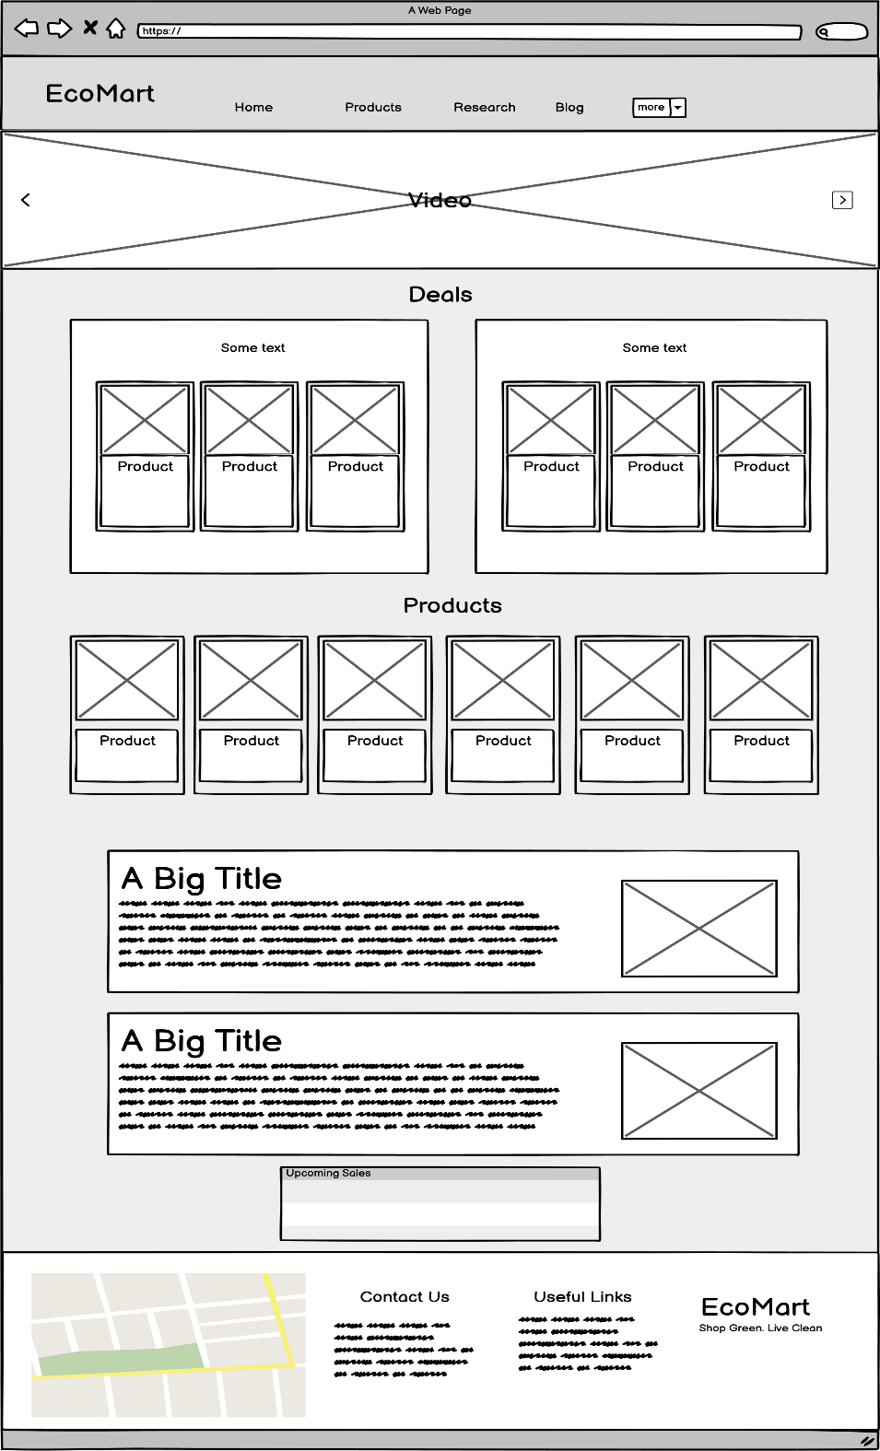

Figure 1 Home Page Wireframe

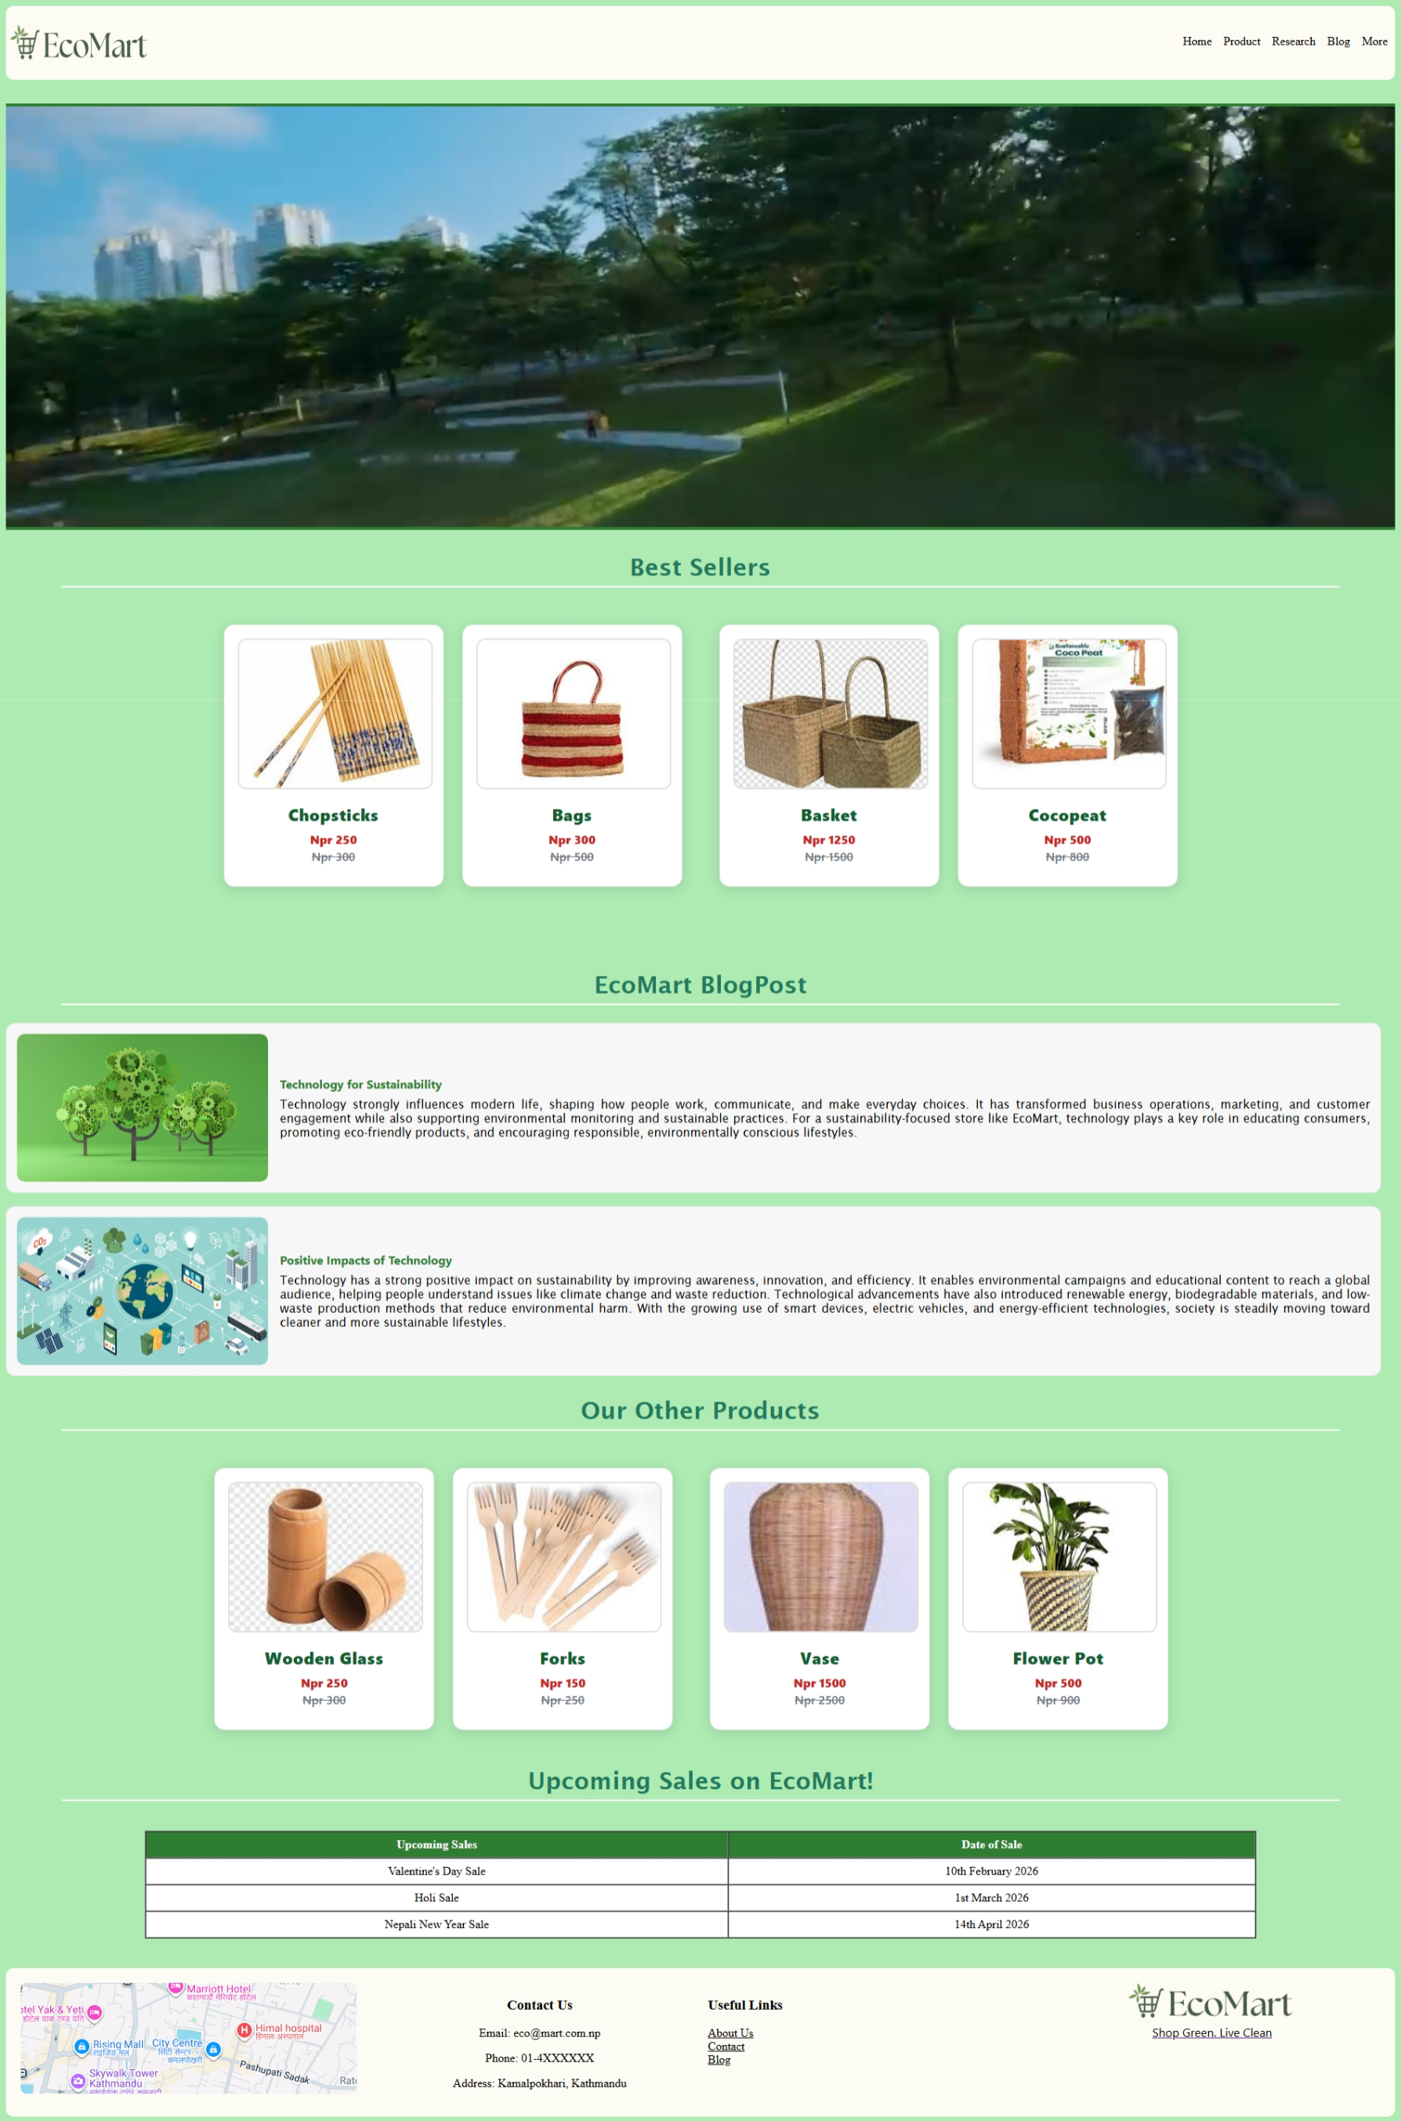

Figure 2 Final Home Page

### 2.3.2 Product Page

The product page showcases a minimalist navigation bar with EcoMart logo and essential navigation buttons. A header tells users about the wide selection of products. Below that a few rows of products are listed for sale. At the bottom of the page is the footer with a map of the shop, contact details, useful links and the logo.

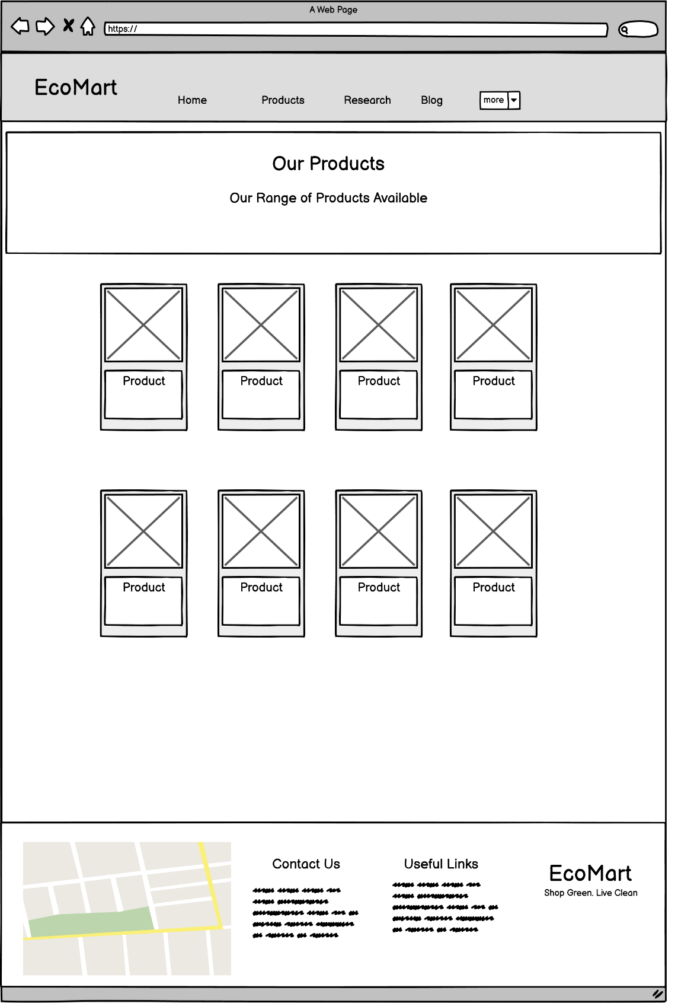

Figure 3 Product Page Wireframe

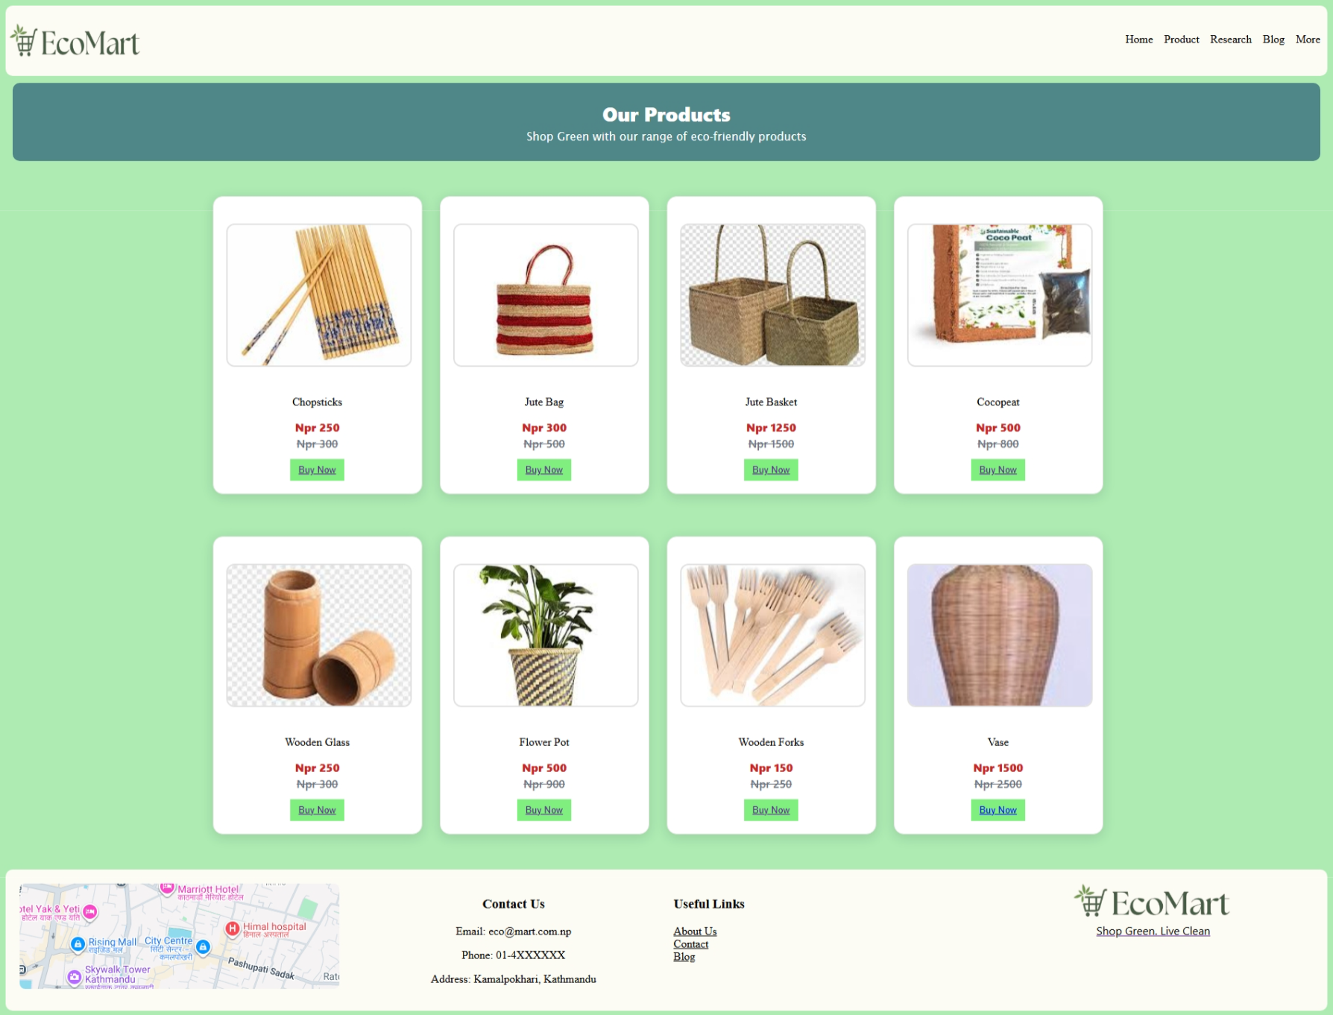

Figure 4 Final Product Page

### 2.3.3 Research Page

The research page showcases a minimalist navigation bar with EcoMart logo and essential navigation buttons. The research page shows side by side description each for inspiration and result. At the bottom of the page is the footer with a map of the shop, contact details, useful links and the logo.

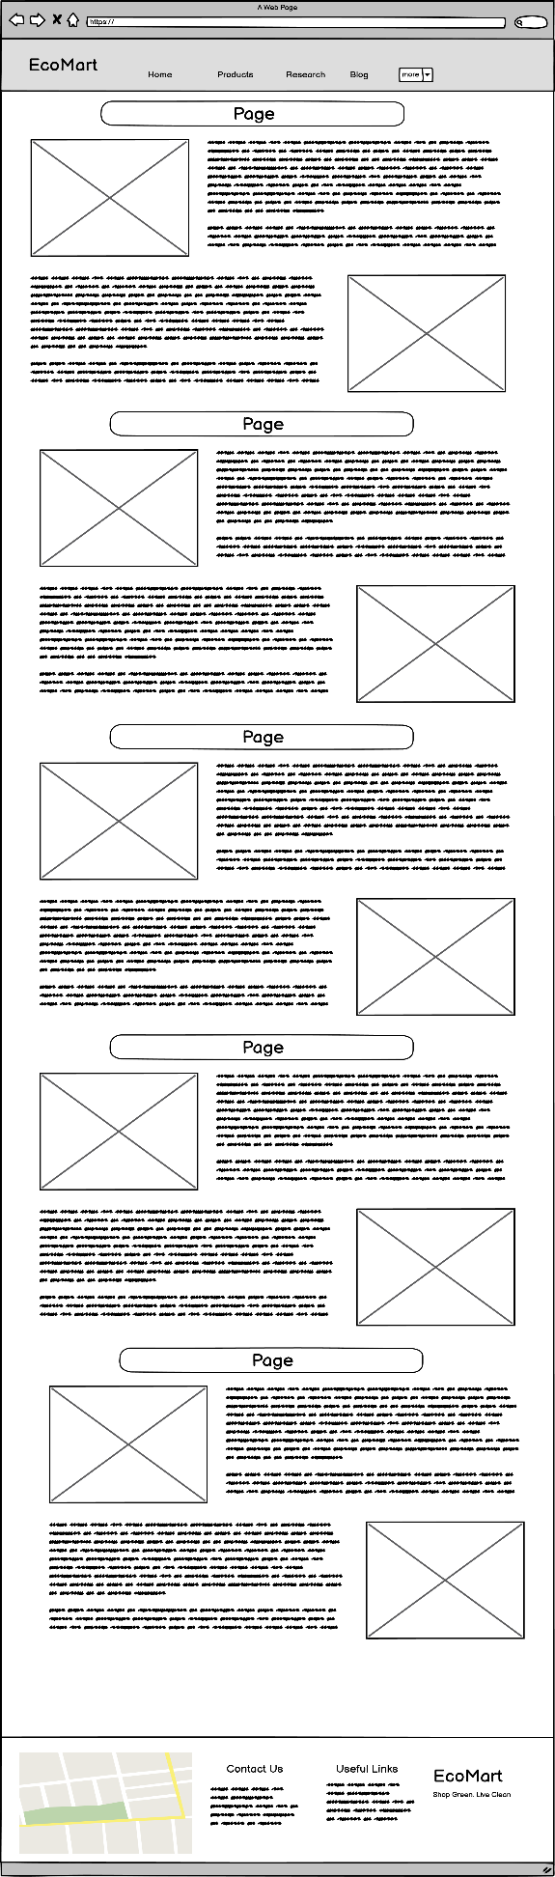

Figure 5 Research Page Wireframe

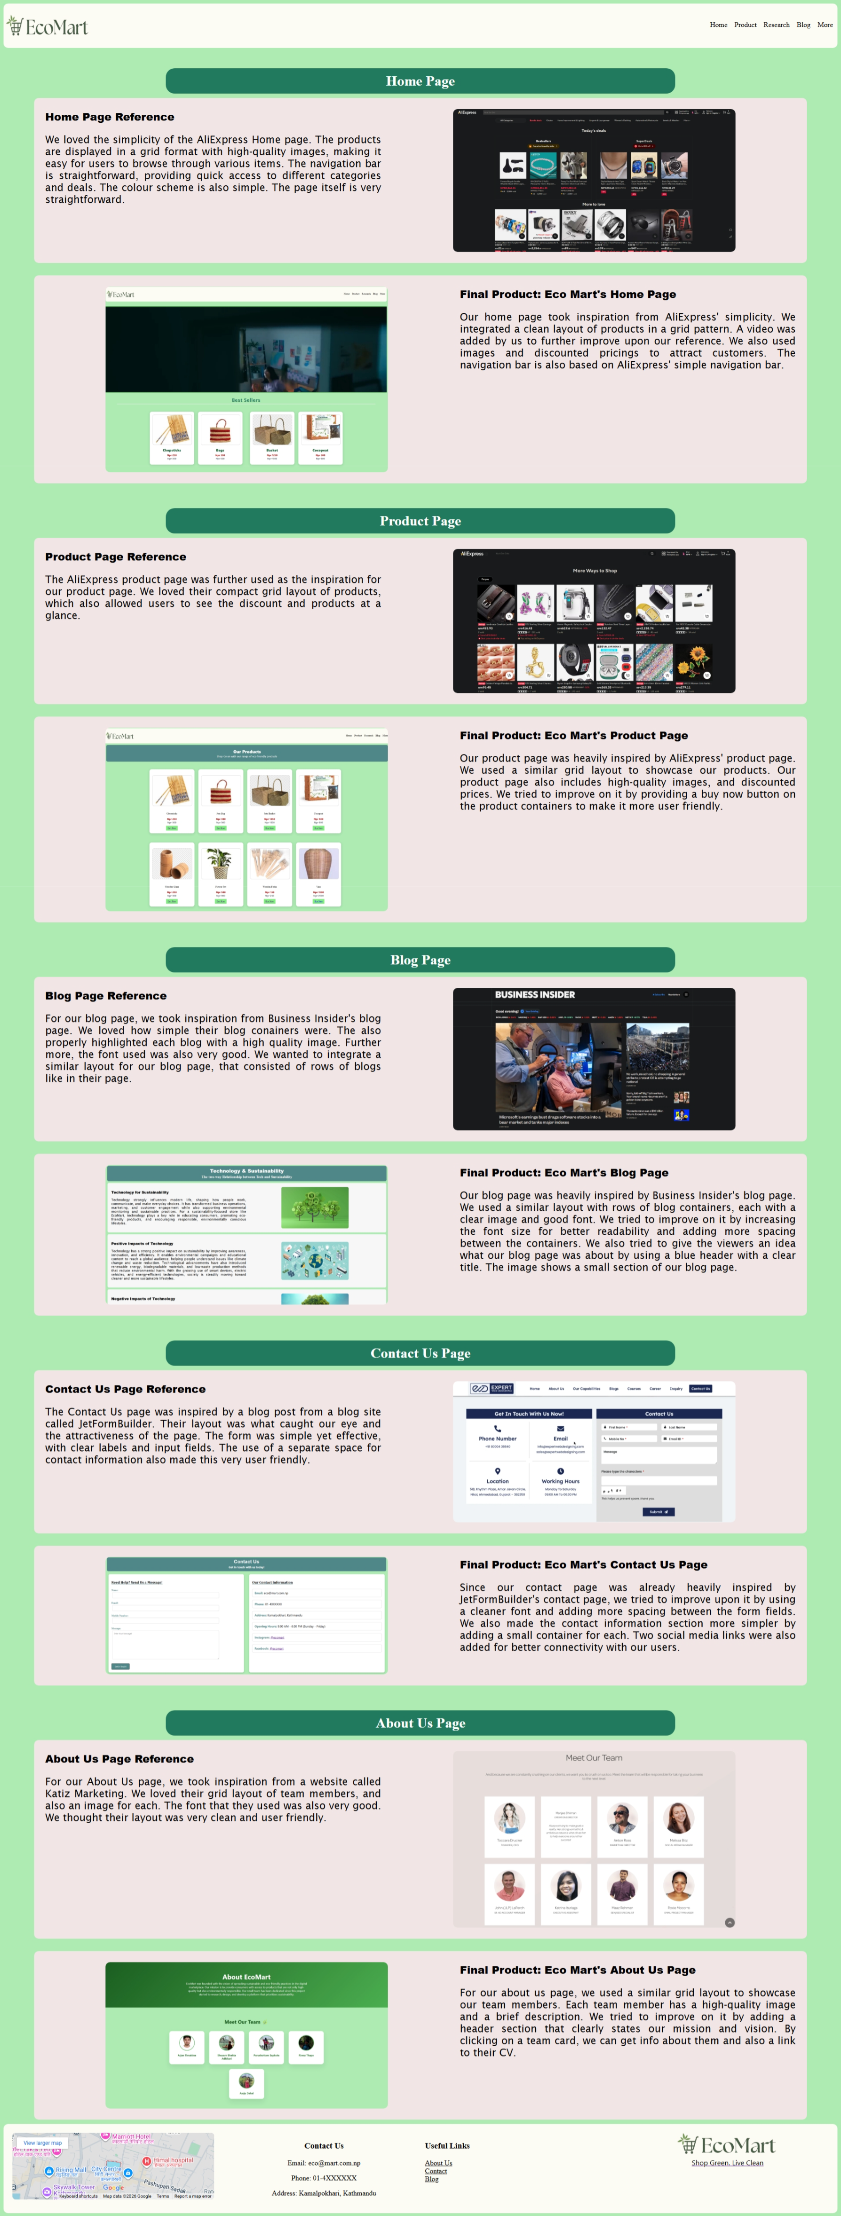

Figure 6 Final Research Page

### 2.3.4 Blog Page

The Blog page showcases a minimalist navigation bar with EcoMart logo and essential navigation buttons. A header shows the users what the blog’s main idea/topic is i.e technology and sustainability. Below that various blogs are showcased in rectangular containers in a column format. At the bottom of the page is the footer with a map of the shop, contact details, useful links and the logo.

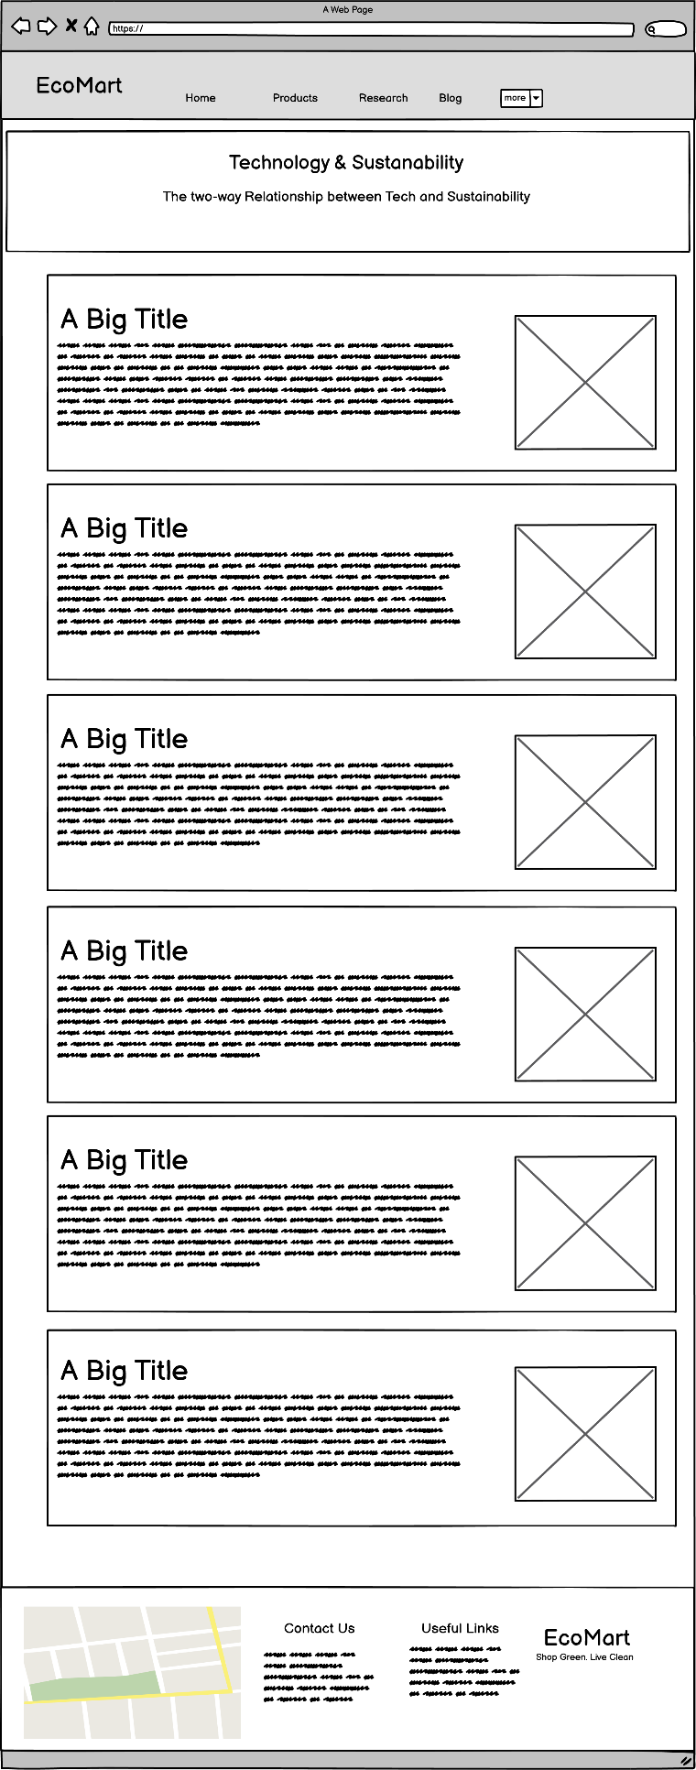

Figure 7 Blog Page Wireframe

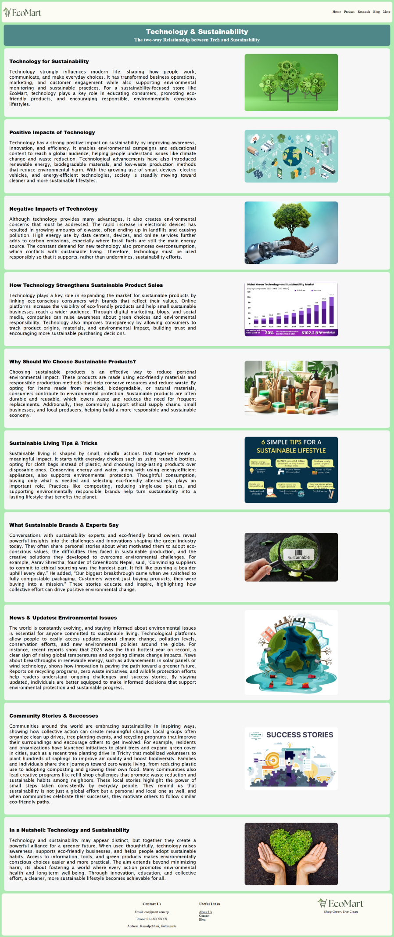

Figure 8 Final Blog Page

### 2.3.5 Contact Us

The about us page showcases a minimalist navigation bar with EcoMart logo and essential navigation buttons. The contact us page consists of two containers, a contact form and another for contact information. The form has various fields and a working submit button at the bottom. The contact form showcases various information and also two social media links. At the bottom of the page is the footer with a map of the shop, contact details, useful links and the logo.

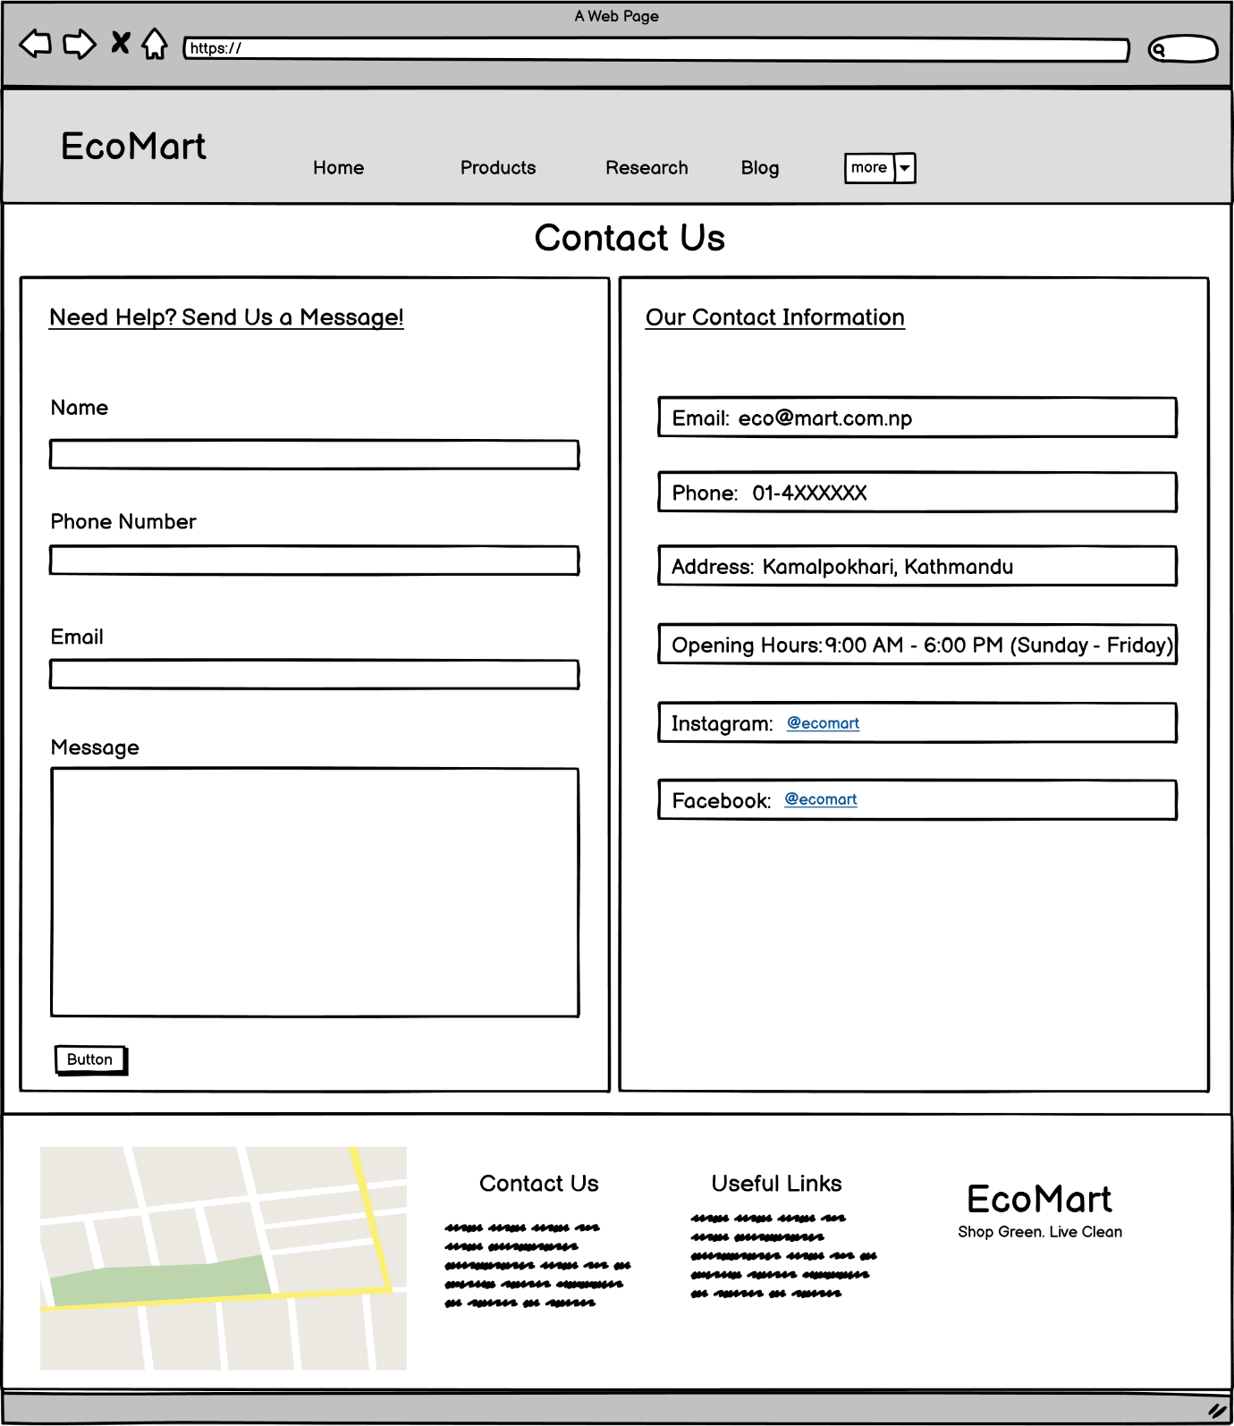

Figure 9 Contact Us Page Wireframe

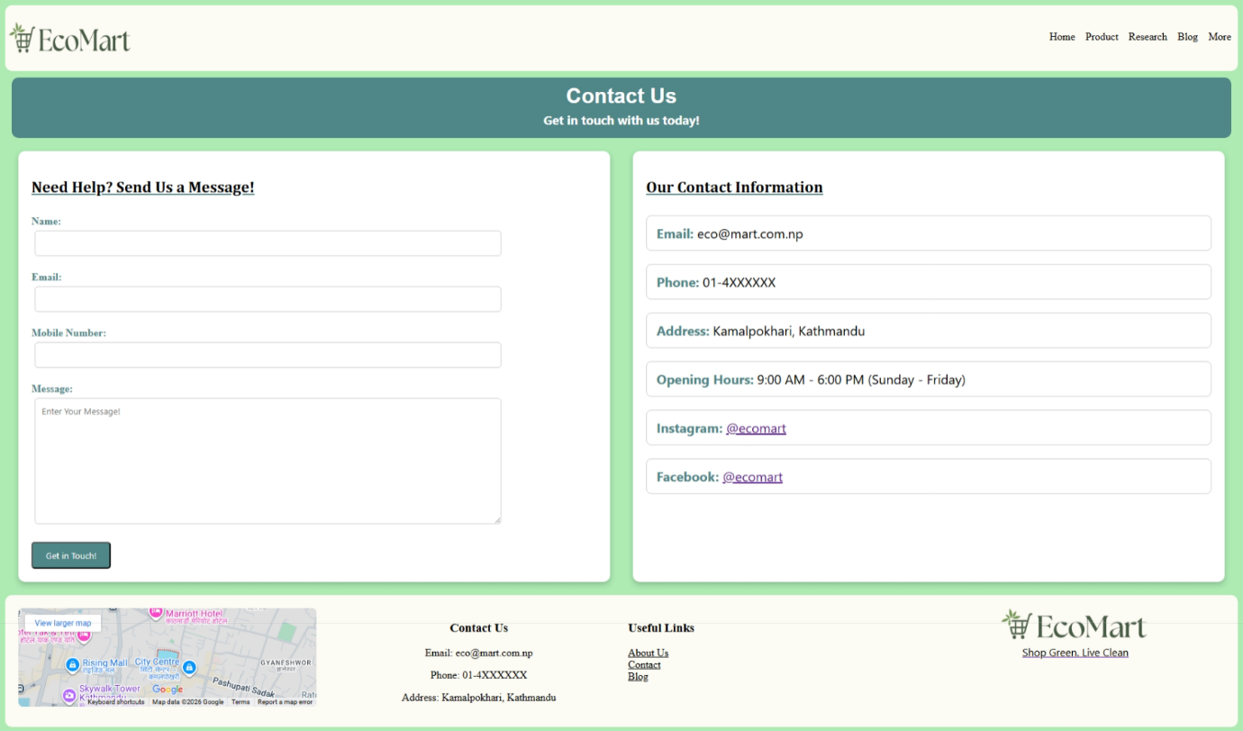

Figure 10 Final Contact Us Page

### 2.3.6 About Us

The about us page showcases a minimalist navigation bar with EcoMart logo and essential navigation buttons. The about us page showcases each team member in a container, with their CV linked at the bottom of each container that links to their own page with their CV. At the bottom of the page is the footer with a map of the shop, contact details, useful links and the logo.

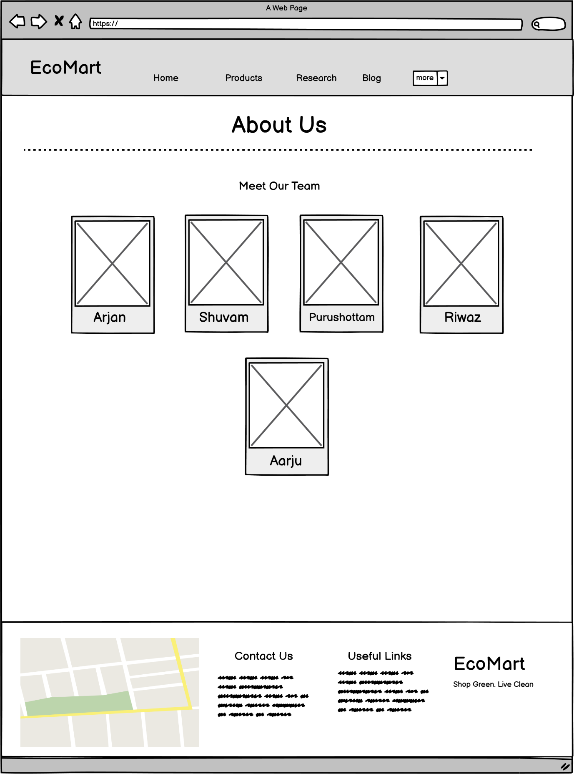

Figure 11 About Us Page Wireframe

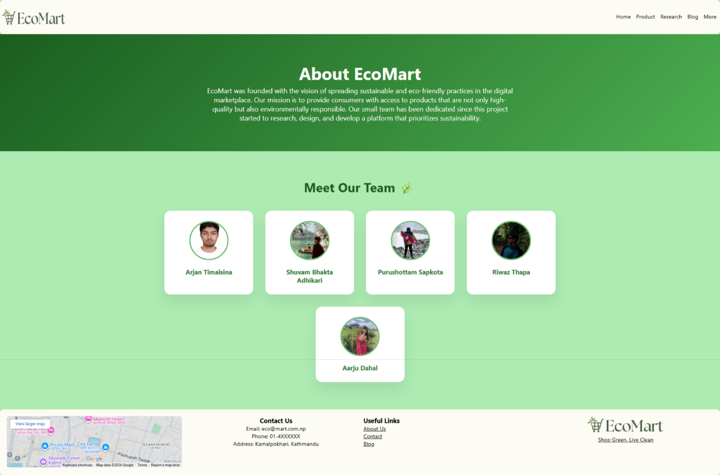

Figure 12 Final About Us Page

## 3. Website Testing

### 3.1 Test 1: Internal Link

|  |  |
| --- | --- |
| **Objective** | Internal Link to go to different webpages of the website. |
| **Action** | Click a link to switch webpage. |
| **Expected Result** | Webpage should change after clicking link. |
| **Actual Result** | Webpage changed. |

Table 1 Test 1: Internal Link

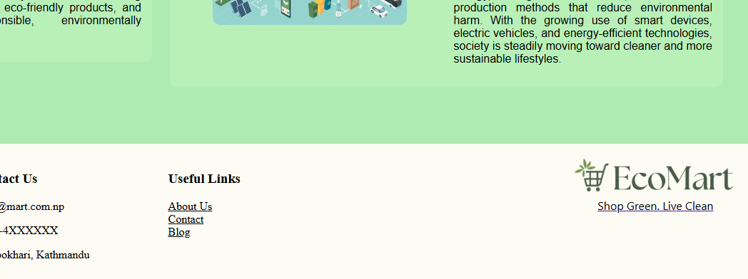

Figure 13 Before Clicking Link

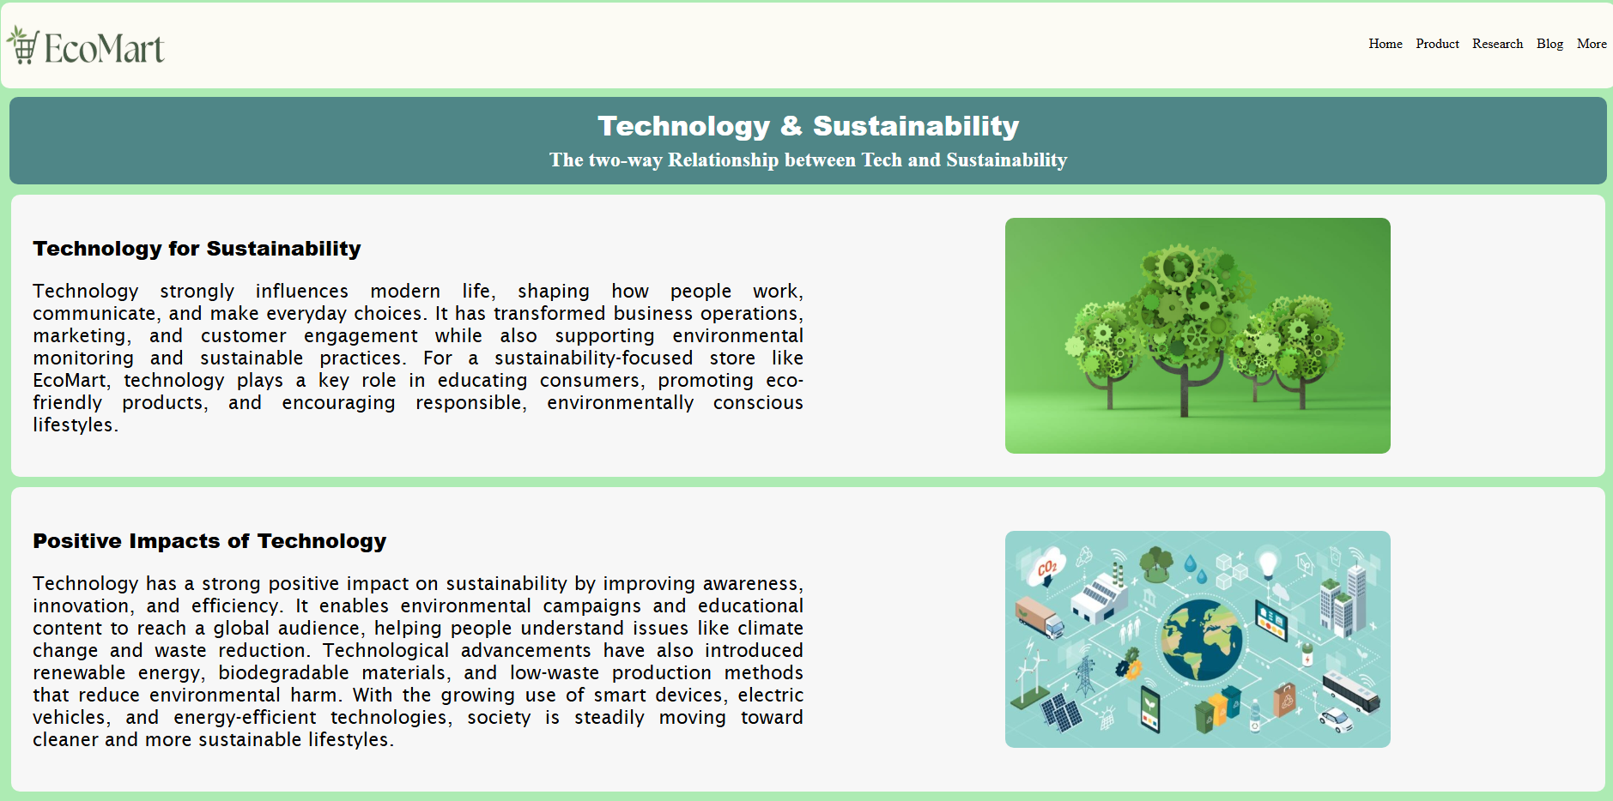

Figure 14 After Clicking Link

### 3.2 Test 2: External Link

|  |  |
| --- | --- |
| **Objective** | External Link to go to a different website. |
| **Action** | Click a link to go to another page. |
| **Expected Result** | Page should change after clicking link. |
| **Actual Result** | Page changed. |

Table 2 Test 2: External Link

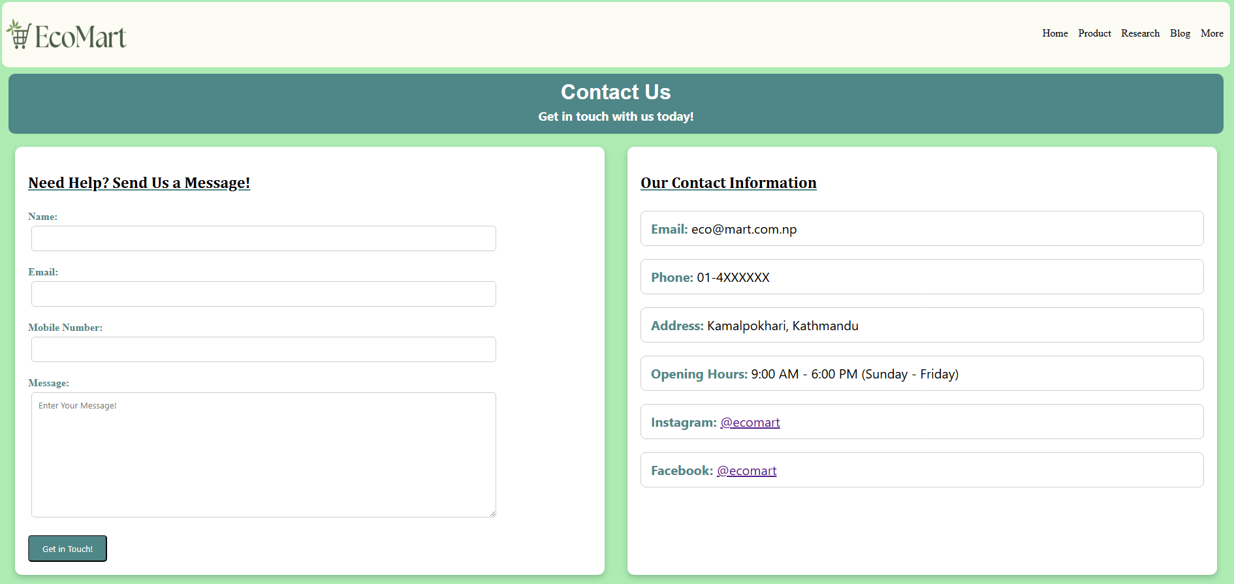

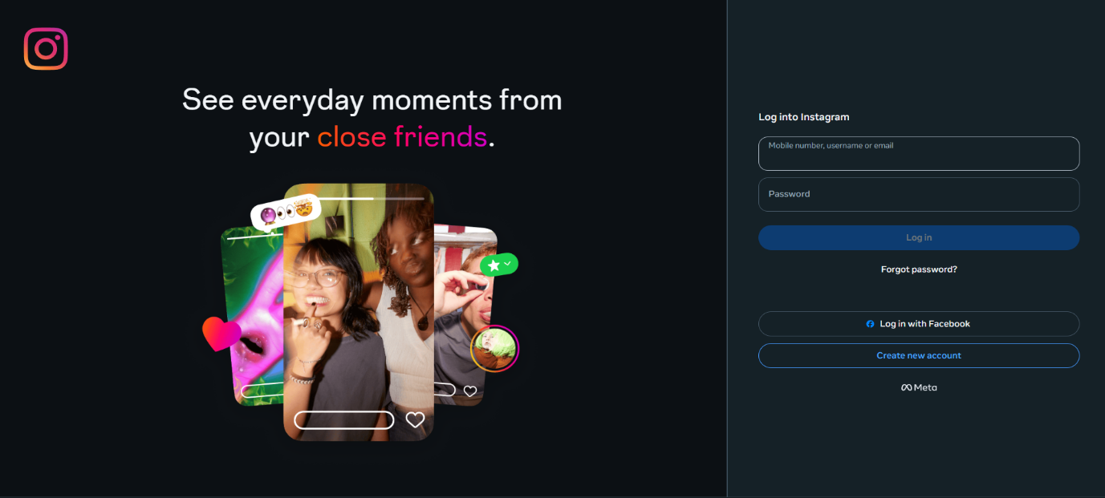Figure 15 Before Clicking External Link

Figure 16 After Clicking External Link

### 3.3 Test 3: Hover Effect

|  |  |
| --- | --- |
| **Objective** | Hover effect to show responsive UI. |
| **Action** | Hover over buy button in product. |
| **Expected Result** | When hovered the button changes colour. |
| **Actual Result** | Button colour changed to a different shade. |

Table 3 Test 3: Hover Effect

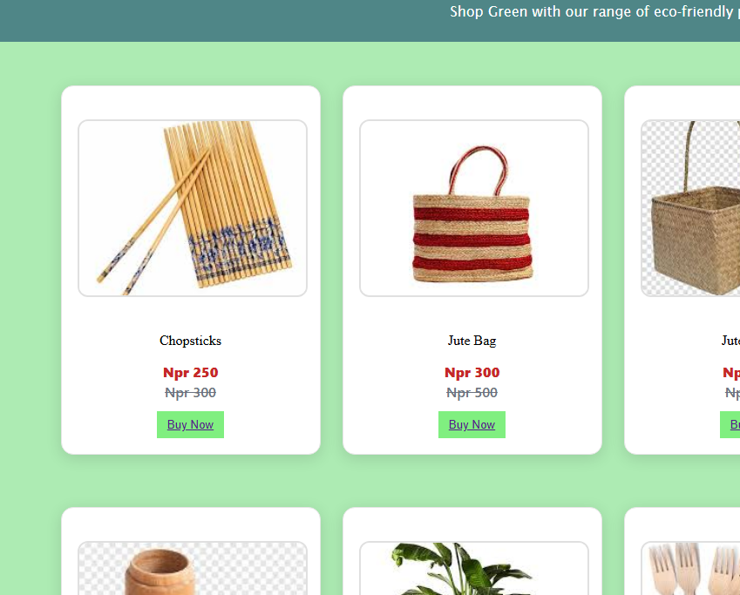

Figure 17 Before Hover

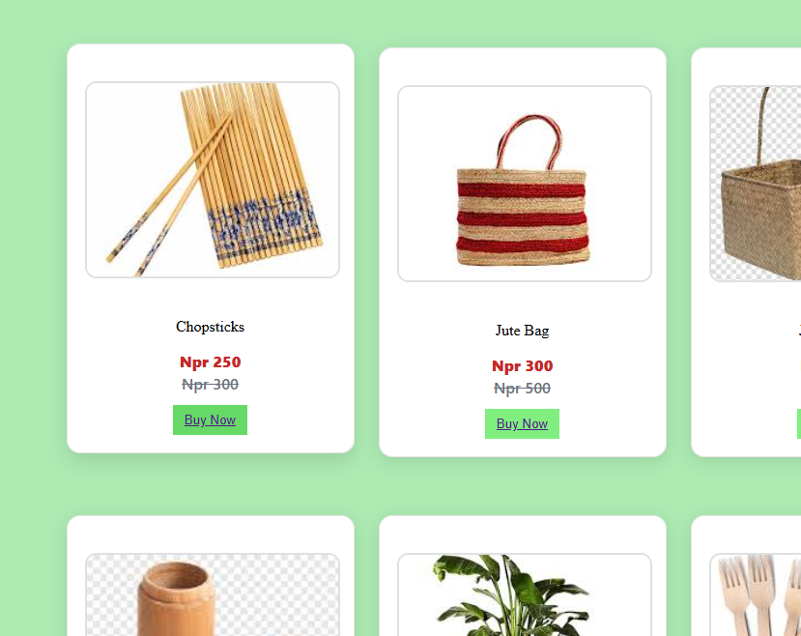

Figure 18 After Hover: Button Changed Colour

### 3.4 Test 4: Form Validation

|  |  |
| --- | --- |
| **Objective** | Form Validation for a valid message with valid details. |
| **Action** | Invalid info submission gives error and valid gives alert. |
| **Expected Result** | Alert if message is valid or error if not. |
| **Actual Result** | Error was given when info was invalid and alert when valid. |

Table 4 Test 4: Form Validation

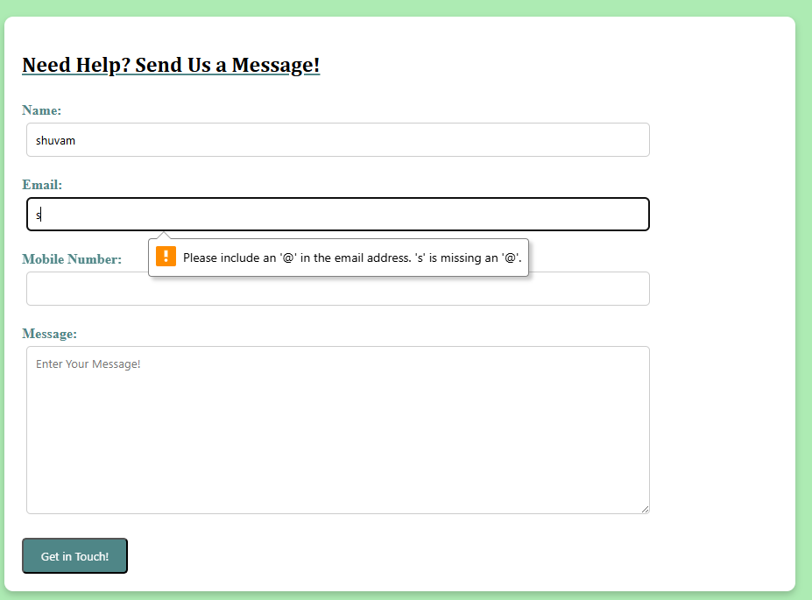

Figure 19 Form Validation

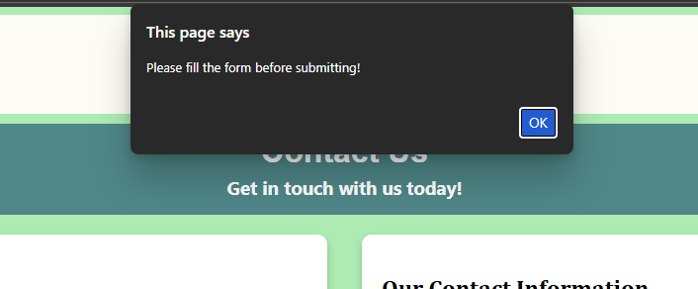

Figure 20 Alert for Empty Message

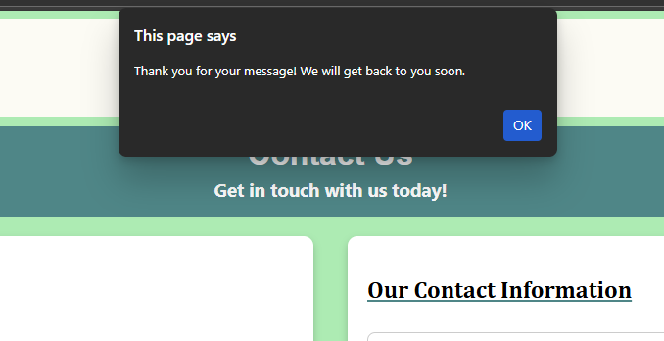

Figure 21 Alert for Valid Message

### 3.5 Test 5: Order Placed Alert (JavaScript Test 2)

|  |  |
| --- | --- |
| **Objective** | Alert to showcase order placed message. |
| **Action** | Button clicked to order, and alert to confirm. |
| **Expected Result** | Alert to let user know that product has been ordered. |
| **Actual Result** | Alert was sent. |

Table 5 Test 5: JavaScript Test 2

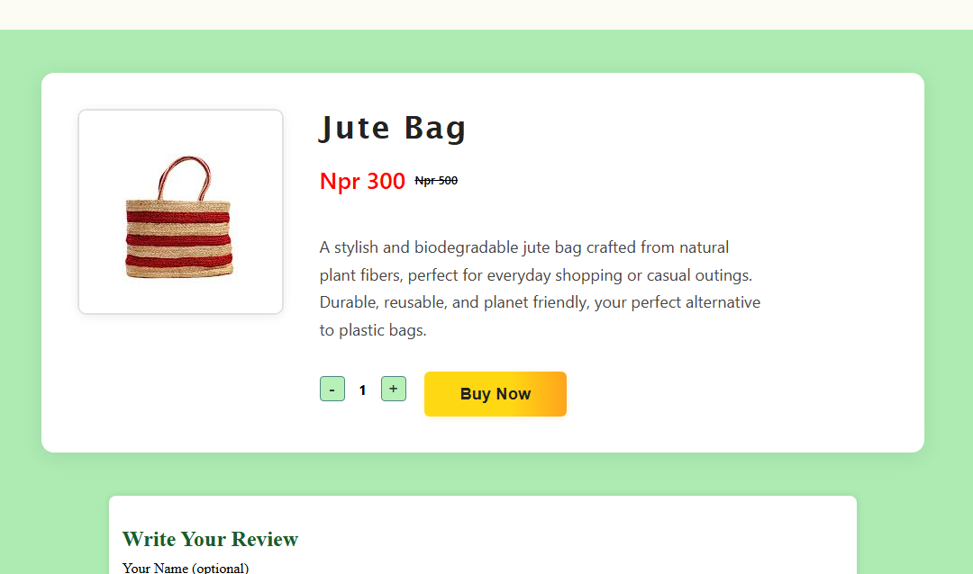

Figure 22 Before Clicking Buy

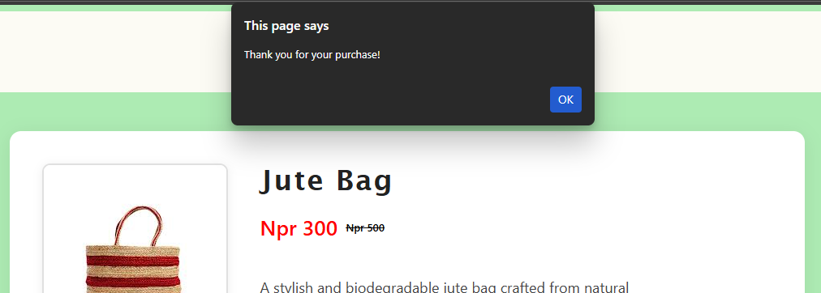

Figure 23 Alert for clicking Buy

### 3.5 Test 6: (JavaScript Test 3)

|  |  |
| --- | --- |
| **Objective** | Quantity Counter with max quantity 5. |
| **Action** | Quantity increases and decreases as per required. |
| **Expected Result** | Quantity increases with 1 and maxes at 5. |
| **Actual Result** | Quantity increased and maxed out at 5. |

Table 6 Test 6: JavaScript Test 3

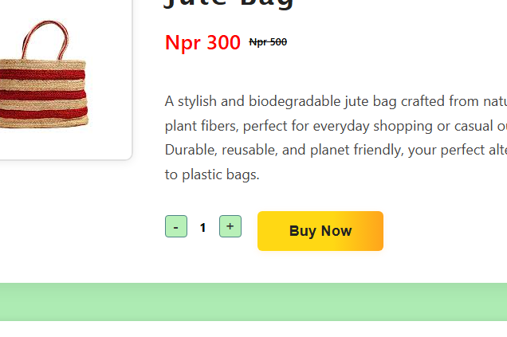

Figure 24 Before Increasing Quantity

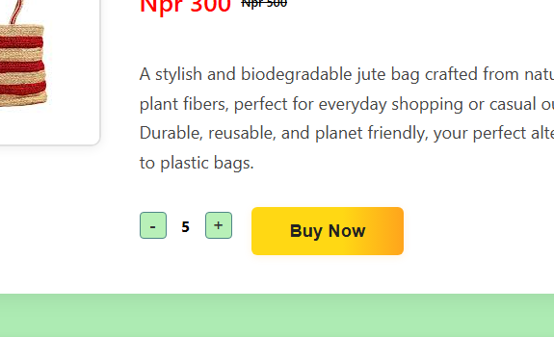

Figure 25 After Increasing Quantity (Maxes at 5)

# 4. Conclusion

This project was a great learning point for our team. With the use of HTML, CSS, and JavaScript we learnt from our classes, we were able to craft a beautiful website. The e-commerce website EcoMart, delivers its message strongly through the use of various web pages from a home page to a blog page. We think our work strongly sends the message of promoting use of eco-friendly and sustainable product from this website.

4.1 Tasks Completed

* Added a working navigation bar and footer.
* Made a home page, research page, about us page, product page contact page and blog page.
* Made working forms where needed.
* Attached a CV to each team members card on the about us page.
* Added alerts when placing orders, or filling any forms on the website.
* Used HTML to give the main structure and idea to the website.
* Used CSS to style the website.
* Used JavaScript to make the website reactive and responsive.

## 4.2 Research & Findings

The research carried out for this project provided important insights into web development and the role of sustainability-focused digital platforms. By analysing real eco-friendly websites, we learned how design choices, navigation, and interactivity impact user behaviour. We also learned how eco-friendly products greatly benefit our planet. Research about proper layouts and formatting from popular websites. Did our based to research the most fitting colour scheme for our site. We also analysed a good navigation layout as well.

Some of our findings:

* Simple layouts improve user friendliness and easiness.
* A good color scheme can strengthen the goal of your site.
* Website structure and design should be good and consistent to improve usability and to get good feedback.
* A blog page is very useful to raise awareness among your users.
* Responsiveness and interactivity in a website using JavaScript make a website more unique and good.

# 5. Appendix

### 5.1 Home Page

<!DOCTYPE html> <!-- Declares the document type and version of HTML -->

<html lang="en"> <!-- Root element with language set to English -->

<head>

  <meta name="author" content="EcoMart Team"> <!-- Author of the webpage -->

  <meta name="keywords"

    content="EcoMart, Eco-friendly products, Sustainable shopping, Green living, Biodegradable items">

  <!-- SEO keywords -->

  <meta name="description"

    content="EcoMart, Shop green, live clean with our range of biodegradable and environmentally friendly items.">

  <!-- SEO description -->

  <meta charset="UTF-8"> <!-- Sets character encoding -->

  <meta name="viewport" content="width=device-width, initial-scale=1"> <!-- Responsive design for mobile devices -->

  <title>Home</title> <!-- Title of the page shown in browser tab -->

  <link href="css/style.css" rel="stylesheet"> <!-- External CSS file for styling -->

  <link rel="icon" type="image/png" href="./images/slogo.png"> <!-- Favicon for the website -->

  <style>

    /* Inline CSS for page-specific styles */

    .heading {

      width: 92%;

      min-width: 1000px;

      margin: 28px auto 12px;

      padding-bottom: 6px;

      font-family: 'Lucida Sans', 'Lucida Sans Regular', 'Lucida Grande', 'Lucida Sans Unicode', Geneva, Verdana, sans-serif;

      font-size: 32px;

      font-weight: 800;

      color: #217a5d;

      border-bottom: 2px solid #fff;

      letter-spacing: 0.2px;

      text-align: center;

    }

    /* video banner styling */

    .video-banner {

      width: 100%;

      overflow: hidden;

      border-top: 4px solid #2e7d32;

      border-bottom: 4px solid #2e7d32;

      margin: 32px 0;

      background: #eafbe7;

    }

    /* video element styling */

    .full-video {

      width: 100%;

      height: 60vh;

      display: block;

      object-fit: cover;

    }

    /* Product list container: flex layout, centered, with spacing */

    .product-list {

      display: flex;

      flex-wrap: wrap;

      justify-content: center;

      gap: 25px;

      margin: 40px auto;

      padding: 10px;

    }

    /* Individual product card styling */

    .product-card {

      background: #ffffff;

      width: 260px;

      padding: 18px;

      border-radius: 14px;

      box-shadow: 0 4px 18px rgba(0, 0, 0, 0.12);

      transition: transform 0.2s ease, box-shadow 0.25s ease;

      cursor: pointer;

      text-align: center;

      border: 1px solid #e6e6e6;

      text-decoration: none;

    }

    .product-card:hover {

      transform: translateY(-6px);

      box-shadow: 0 8px 24px rgba(0, 0, 0, 0.16);

    }

    /* Product image styling */

    .product-image {

      width: 100%;

      height: 200px;

      object-fit: cover;

      border-radius: 12px;

      margin-bottom: 15px;

      border: 2px solid #e0e0e0

    }

    /* Product name styling */

    .product-name {

      font-size: 22px;

      font-weight: 900;

      color: #145c32;

      letter-spacing: 0.6px;

      margin-bottom: 8px;

      font-family: "Segoe UI", Arial, sans-serif;

    }

    /* Product product-price styling */

    .product-price {

      color: #c62828;

      font-weight: 800;

      font-size: 16px;

      margin: 6px 0 2px;

      font-family: "Segoe UI", Arial, sans-serif;

    }

    .product-old-price {

      color: #6b7280;

      text-decoration: line-through;

      font-weight: 600;

      font-size: 16px;

      margin-bottom: 12px;

      font-family: "Segoe UI", Arial, sans-serif;

    }

    /* Blog list container: flex layout, spacing, centered */

    .blog-list {

      display: flex;

      flex-wrap: wrap;

      gap: 18px;

      justify-content: center;

      margin: 24px auto;

    }

    /* Blog link styling: removes underline, inherits color, block display */

    .blog-link {

      text-decoration: none;

      color: inherit;

      display: block;

    }

    /* Blog post card: flex row, spaced, background color, rounded corners */

    .blog-post {

      display: flex;

      align-items: center;

      gap: 16px;

      background: #f7f7f7;

      border: 1px solid #e8e8e8;

      border-radius: 12px;

      padding: 14px;

      width: 99%;

      min-width: 1000px;

      min-height: 220px;

      box-sizing: border-box;

    }

    /* Blog picture container: centers image vertically and horizontally */

    .blog-pic {

      width: 340px;

      height: 200px;

      overflow: hidden;

      border-radius: 10px;

      flex: 0 0 auto;

    }

    /* Blog image styling: max width and rounded corners */

    .blog-pic img {

      width: 100%;

      height: 100%;

      object-fit: cover;

      object-position: center;

      display: block;

      border-radius: 10px;

    }

    /* Blog text container: takes up remaining space, margin to left */

    .blog {

      flex: 1 1 auto;

      display: flex;

      flex-direction: column

    }

    /* Blog post title styling */

    .blog h2 {

      margin: 0 0 8px;

      color: #2e7d32;

      font-family: "Segoe UI", Arial, sans-serif;

      font-size: 16px;

    }

    /* Blog post paragraph styling */

    .blog p {

      margin: 0;

      text-align: justify;

      font-family: 'Lucida Sans', 'Lucida Sans Regular', 'Lucida Grande', 'Lucida Sans Unicode', Geneva, Verdana, sans-serif;

      font-size: medium;

    }

  </style>

</head>

<body style="background-color: #adebb3;"> <!-- Sets background color for the page -->

  <!-- Navigation bar-->

  <nav class="navbar">

    <a href="index.html">

      <img src="./images/logo-nobackground.png" alt="Logo" class="logo"> <!-- Website logo -->

    </a>

    <ul class="nav-list"> <!-- Navigation links list -->

      <li><a href="./index.html" class="nav-link">Home</a></li>

      <li><a href="./webpages/product.html" class="nav-link">Product</a></li>

      <li><a href="./webpages/research.html" class="nav-link">Research</a></li>

      <li><a href="./webpages/blog.html" class="nav-link">Blog</a></li>

      <li class="dropdown"> <!-- Dropdown menu for more links -->

        <a href="#" onclick="return false;" class="nav-link">More</a>

        <ul class="dropdown-menu">

          <li><a href="./webpages/contact.html" class="dropdown-link">Contact</a></li>

          <li><a href="./webpages/aboutus.html" class="dropdown-link">About</a></li>

        </ul>

      </li>

    </ul>

  </nav>

  <div class="video-banner">

    <video class="full-video" src="./videos/gogreen.mp4" autoplay muted loop playsinline></video>

  </div>

  <script>

    // Dropdown toggle with viewport adjustment

    document.querySelectorAll('nav li').forEach(function (li) {

      li.addEventListener('mouseenter', function () {

        var dropdown = li.querySelector('ul');

        if (dropdown) {

          dropdown.style.display = 'block';

          dropdown.style.left = '0';

          dropdown.style.right = 'auto';

          // Adjust position if cropped by the right edge

          var rect = dropdown.getBoundingClientRect();

          if (rect.right > window.innerWidth) {

            dropdown.style.left = 'auto';

            dropdown.style.right = '0';

          }

          // Adjust position if cropped by the left edge

          if (rect.left < 0) {

            dropdown.style.left = '0';

            dropdown.style.right = 'auto';

          }

        }

      });

      li.addEventListener('mouseleave', function () {

        var dropdown = li.querySelector('ul');

        if (dropdown) dropdown.style.display = 'none';

      });

    });

    // This script handles showing/hiding dropdown menus and ensures they stay within the viewport

  </script>

  <h2 class="heading">Best Sellers</h2>

  <div class="product-list">

    <!-- Product 1: Chopsticks -->

    <a href="./webpages/product_pages/chopsticks.html" title="Product 1" class="product-card">

      <img src="./images/chopsticks.jpg" alt="Product 1" class="product-image">

      <div class="product-name">Chopsticks</div>

      <div>

        <div class="product-price">Npr 250</div>

        <div class="product-old-price">Npr 300</div>

      </div>

    </a>

    <!-- Product 2: Bags -->

    <a href="./webpages/product_pages/bags.html" title="Product 2" class="product-card">

      <img src="./images/bags.jpg" alt="Product 2" class="product-image">

      <div class="product-name">Bags</div>

      <div>

        <div class="product-price">Npr 300</div>

        <div class="product-old-price">Npr 500</div>

      </div>

    </a>

    <br><br>

    <!-- Product 3: Basket -->

    <a href="./webpages/product_pages/basket.html" title="Product 3" class="product-card">

      <img src="./images/basket.jpg" alt="Product 3" class="product-image">

      <div class="product-name">Basket</div>

      <div>

        <div class="product-price">Npr 1250</div>

        <div class="product-old-price">Npr 1500</div>

      </div>

    </a>

    <!-- Product 4: Cocopeat -->

    <a href="./webpages/product_pages/cocopeat.html" title="Product 4" class="product-card">

      <img src="./images/Cocopeat.jpg" alt="Product 4" class="product-image">

      <div class="product-name">Cocopeat</div>

      <div>

        <div class="product-price">Npr 500</div>

        <div class="product-old-price">Npr 800</div>

      </div>

    </a>

  </div>

  <br><br>

  <h2 class="heading">EcoMart BlogPost</h2>

  <div class="blog-list">

    <!-- Blog post 1 preview -->

    <a href="blog.html" class="blog-link">

      <article class="blog-post">

        <div class="blog-pic">

          <img src="./images/blogpost1.jpeg" alt="Technology for Sustainability">

        </div>

        <div class="blog">

          <h2>Technology for Sustainability</h2>

          <p>

            Technology strongly influences modern life, shaping how people work, communicate, and make everyday choices.

            It has

            transformed business operations, marketing, and customer engagement while also supporting environmental

            monitoring and

            sustainable practices. For a sustainability-focused store like EcoMart, technology plays a key role in

            educating

            consumers, promoting eco-friendly products, and encouraging responsible, environmentally conscious

            lifestyles.

          </p>

        </div>

      </article>

    </a>

    <!-- Blog post 2 preview -->

    <a href="blog.html" class="blog-link">

      <article class="blog-post">

        <div class="blog-pic">

          <img src="./images/blogpost2.jpg" alt="Positive Impacts of Technology">

        </div>

        <div class="blog">

          <h2>Positive Impacts of Technology</h2>

          <p>

            Technology has a strong positive impact on sustainability by improving awareness, innovation, and

            efficiency. It

            enables environmental campaigns and educational content to reach a global audience, helping people

            understand issues

            like climate change and waste reduction. Technological advancements have also introduced renewable energy,

            biodegradable materials, and low-waste production methods that reduce environmental harm. With the growing

            use of

            smart devices, electric vehicles, and energy-efficient technologies, society is steadily moving toward

            cleaner and

            more sustainable lifestyles.

          </p>

        </div>

      </article>

    </a>

  </div>

  <h2 class="heading">Our Other Products</h2>

  <div class="product-list">

    <!-- Duplicate product list  -->

    <a href="./webpages/product_pages/container.html" title="Product 1" class="product-card">

      <img src="./images/container.jpg" alt="Product 1" class="product-image">

      <div class="product-name">Wooden Glass</div>

      <div>

        <div class="product-price">Npr 250</div>

        <div class="product-old-price">Npr 300</div>

      </div>

    </a>

    <a href="./webpages/product_pages/forks.html" title="Product 2" class="product-card">

      <img src="./images/forks.jpg" alt="Product 2" class="product-image">

      <div class="product-name">Forks</div>

      <div>

        <div class="product-price">Npr 150</div>

        <div class="product-old-price">Npr 250</div>

      </div>

    </a>

    <br><br>

    <a href="./webpages/product_pages/vase.html" title="Product 3" class="product-card">

      <img src="./images/vase.jpg" alt="Product 3" class="product-image">

      <div class="product-name">Vase</div>

      <div>

        <div class="product-price">Npr 1500</div>

        <div class="product-old-price">Npr 2500</div>

      </div>

    </a>

    <a href="./webpages/product_pages/flowerpot.html" title="Product 2" class="product-card">

      <img src="./images/flowepot.jpg" alt="Product 2" class="product-image">

      <div class="product-name">Flower Pot</div>

      <div>

        <div class="product-price">Npr 500</div>

        <div class="product-old-price">Npr 900</div>

      </div>

    </a>

    <br><br>

  </div>

  <h2 class="heading">Upcoming Sales on EcoMart!</h2>

  <!-- Table showing upcoming sales -->

  <table border="1" cellpadding="8" cellspacing="0" style="margin: 40px auto; width: 80%; text-align: center;">

    <tr style="background-color: #2e7d32; color: white;">

      <th>Upcoming Sales</th>

      <th>Date of Sale</th>

    </tr>

    <tr style="background-color: #fff;">

      <td>Valentine's Day Sale</td>

      <td>10th February 2026</td>

    </tr>

    <tr style="background-color: #fff;">

      <td>Holi Sale</td>

      <td>1st March 2026</td>

    </tr>

    <tr style="background-color: #fff;">

      <td>Nepali New Year Sale</td>

      <td>14th April 2026</td>

    </tr>

  </table>

  <!-- Footer section with map, contact info, links, and logo -->

  <footer class="footer">

    <!-- Google Map (Leftmost) -->

    <div class="footer-map">

      <iframe

        src="https://www.google.com/maps/embed?pb=!1m18!1m12!1m3!1d3532.047187704176!2d85.32414031506134!3d27.70903198279159!2m3!1f0!2f0!3f0!3m2!1i1024!2i768!4f13.1!3m3!1m2!1s0x39eb190f7e7c7e6d%3A0x7e1b7e736d9193c2!2sKamalpokhari%2C%20Kathmandu%2044600!5e0!3m2!1sen!2snp!4v1680000000000!5m2!1sen!2snp"

        width="100%" height="150" class="footer-iframe" allowfullscreen="" loading="lazy"

        referrerpolicy="no-referrer-when-downgrade"></iframe>

    </div>

    <!-- Contact Info (Right to Map) -->

    <div class="footer-contact">

      <h3>Contact Us</h3>

      <p>Email: eco@mart.com.np</p>

      <p>Phone: 01-4XXXXXX</p>

      <p>Address: Kamalpokhari, Kathmandu</p>

    </div>

    <!-- Useful Links (Right to Contact) -->

    <div class="footer-links">

      <h3>Useful Links</h3>

      <ul>

        <li><a href="./webpages/aboutus.html" class="footer-link">About Us</a></li>

        <li><a href="./webpages/contact.html" class="footer-link">Contact</a></li>

        <li><a href="./webpages/blog.html" class="footer-link">Blog</a></li>

      </ul>

    </div>

    <!-- Logo and Caption (Rightmost) -->

    <div class="footer-logo">

      <a href="./index.html" class="footer-logo-link">

        <img src="./images/logo-nobackground.png" alt="Logo" class="footer-logo-img">

        <span class="footer-caption">Shop Green. Live Clean</span>

      </a>

    </div>

  </footer>

</body>

</html>

### 5.2 Product Page

<!DOCTYPE html> <!-- Declares the document type and version of HTML -->

<html lang="en"> <!-- Root element with language set to English -->

<head>

  <meta name="author" content="EcoMart Team"> <!-- Author of the webpage -->

  <meta name="keywords"

    content="EcoMart, Eco-friendly products, Sustainable shopping, Green living, Biodegradable items">

  <!-- SEO keywords -->

  <meta name="description"

    content="EcoMart, Shop green, live clean with our range of biodegradable and environmentally friendly items.">

  <!-- SEO description -->

  <meta charset="UTF-8"> <!-- Sets character encoding -->

  <meta name="viewport" content="width=device-width, initial-scale=1"> <!-- Responsive design for mobile devices -->

  <title>Products</title> <!-- Title of the page shown in browser tab -->

  <link href="../css/style.css" rel="stylesheet"> <!-- External CSS file for styling -->

  <link rel="icon" type="image/png" href="../images/slogo.png"> <!-- Favicon for the website -->

</head>

<body style="background-color: #adebb3;"> <!-- Sets background color for the page -->

  <nav class="navbar">

    <a href="index.html">

      <img src="../images/logo-nobackground.png" alt="Logo" class="logo"> <!-- Website logo -->

    </a>

    <ul class="nav-list"> <!-- Navigation links list -->

      <li><a href="../index.html" class="nav-link">Home</a></li>

      <li><a href="./product.html" class="nav-link">Product</a></li>

      <li><a href="./research.html" class="nav-link">Research</a></li>

      <li><a href="./blog.html" class="nav-link">Blog</a></li>

      <li class="dropdown"> <!-- Dropdown menu for more links -->

        <a href="#" onclick="return false;" class="nav-link">More</a>

        <ul class="dropdown-menu">

          <li><a href="./contact.html" class="dropdown-link">Contact</a></li>

          <li><a href="./aboutus.html" class="dropdown-link">About</a></li>

        </ul>

      </li>

    </ul>

  </nav>

  <script>

    // Dropdown toggle with viewport adjustment

    document.querySelectorAll('nav li').forEach(function (li) {

      li.addEventListener('mouseenter', function () {

        var dropdown = li.querySelector('ul');

        if (dropdown) {

          dropdown.style.display = 'block';

          dropdown.style.left = '0';

          dropdown.style.right = 'auto';

          // Adjust position if cropped by the right edge

          var rect = dropdown.getBoundingClientRect();

          if (rect.right > window.innerWidth) {

            dropdown.style.left = 'auto';

            dropdown.style.right = '0';

          }

          // Adjust position if cropped by the left edge

          if (rect.left < 0) {

            dropdown.style.left = '0';

            dropdown.style.right = 'auto';

          }

        }

      });

      li.addEventListener('mouseleave', function () {

        var dropdown = li.querySelector('ul');

        if (dropdown) dropdown.style.display = 'none';

      });

    });

    // This script handles showing/hiding dropdown menus and ensures they stay within the viewport

  </script>

  <header class="title">

    <h1>Our Products</h1>

    <p>Shop Green with our range of eco-friendly products</p>

  </header>

  <style>

    /* Header styling */

    header {

      background-color: #92ff90;

      color: black;

      text-align: center;

      padding: 25px;

    }

    .title {

      background-color: #4f8687;

      text-align: center;

      padding: 25px 15px;

      margin: 10px;

      border-radius: 10px;

    }

    .title h1 {

      margin: 0;

      font-size: 28px;

      font-weight: 800;

      color: #fff;

      font-family: 'Segoe UI', Tahoma, Geneva, Verdana, sans-serif;

    }

    .title p {

      margin: 5px 0 0;

      font-size: 16px;

      color: #fff;

      font-family: 'Lucida Sans', 'Lucida Sans Regular', 'Lucida Grande', 'Lucida Sans Unicode', Geneva, Verdana, sans-serif;

    }

    /* Products container: flex layout, centered, with spacing */

    .products {

      display: flex;

      flex-wrap: wrap;

      justify-content: center;

      gap: 25px;

      margin: 40px auto;

      padding: 10px;

      display: flex;

      flex-wrap: wrap;

      justify-content: center;

      gap: 25px;

      margin: 40px auto;

      padding: 10px;

    }

    /* Individual product card styling */

    .product {

      background: #ffffff;

      width: 260px;

      padding: 18px;

      border-radius: 14px;

      box-shadow: 0 4px 18px rgba(0, 0, 0, 0.12);

      transition: transform 0.2s ease, box-shadow 0.25s ease;

      cursor: pointer;

      text-align: center;

      border: 1px solid #e6e6e6;

      text-decoration: none;

    }

    .product p {

      font-size: 22px;

      font-weight: 900;

      color: #145c32;

      letter-spacing: 0.6px;

      margin-bottom: 8px;

      font-family: "Segoe UI", Arial, sans-serif;

    }

    .product:hover {

      transform: translateY(-4px);

      box-shadow: 0 8px 22px rgba(0, 0, 0, 0.12);

    }

    .product img {

      width: 100%;

      height: 200px;

      object-fit: cover;

      border-radius: 12px;

      margin-bottom: 15px;

      border: 2px solid #e0e0e0

    }

    /* Product product-price styling */

    .product-price {

      color: #c62828;

      font-weight: 800;

      font-size: 16px;

      margin: 6px 0 2px;

      font-family: "Segoe UI", Arial, sans-serif;

    }

    .product-old-price {

      color: #6b7280;

      text-decoration: line-through;

      font-weight: 600;

      font-size: 16px;

      margin-bottom: 12px;

      font-family: "Segoe UI", Arial, sans-serif;

    }

    /* Button styling */

    button {

      background-color: #80ef80;

      color: black;

      border: none;

      padding: 8px 12px;

      cursor: pointer;

    }

    /* Button hover effect */

    button:hover {

      background-color: #66d966;

    }

  </style>

  <!-- First row of products -->

  <main class="products">

    <div class="product">

      <h2><img src="../images/chopsticks.jpg" alt="Product Image"></h2>

      <p>Chopsticks</p>

      <div>

        <div class="product-price">Npr 250</div>

        <div class="product-old-price">Npr 300</div>

      </div>

      <button><a href="./product_pages/chopsticks.html">Buy Now</a></button>

    </div>

    <div class="product">

      <h2><img src="../images/bags.jpg" alt="Product Image"></h2>

      <p>Jute Bag</p>

      <div>

        <div class="product-price">Npr 300</div>

        <div class="product-old-price">Npr 500</div>

      </div>

      <button><a href="./product_pages/bags.html">Buy Now</a></button>

    </div>

    <div class="product">

      <h2><img src="../images/basket.jpg" alt="Product Image"></h2>

      <p>Jute Basket</p>

      <div>

        <div class="product-price">Npr 1250</div>

        <div class="product-old-price">Npr 1500</div>

      </div>

      <button><a href="./product_pages/basket.html">Buy Now</a></button>

    </div>

    <div class="product">

      <h2><img src="../images/Cocopeat.jpg" alt="Product Image"></h2>

      <p>Cocopeat</p>

      <div>

        <div class="product-price">Npr 500</div>

        <div class="product-old-price">Npr 800</div>

      </div>

      <button><a href="./product_pages/cocopeat.html">Buy Now</a></button>

    </div>

    <br>

  </main>

  <!-- Second row of products -->

  <main class="products">

    <div class="product">

      <h2><img src="../images/container.jpg" alt="Product Image"></h2>

      <p>Wooden Glass</p>

      <div>

        <div class="product-price">Npr 250</div>

        <div class="product-old-price">Npr 300</div>

      </div> <button><a href="./product_pages/container.html">Buy Now</a></button>

    </div>

    <div class="product">

      <h2><img src="../images/flowepot.jpg" alt="Product Image"></h2>

      <p>Flower Pot</p>

      <div>

        <div class="product-price">Npr 500</div>

        <div class="product-old-price">Npr 900</div>

      </div>

      <button><a href="./product_pages/flowerpot.html">Buy Now</a></button>

    </div>

    <div class="product">

      <h2><img src="../images/forks.jpg" alt="Product Image"></h2>

      <p>Wooden Forks</p>

      <div>

        <div class="product-price">Npr 150</div>

        <div class="product-old-price">Npr 250</div>

      </div>

      <button><a href="./product_pages/forks.html">Buy Now</a></button>

    </div>

    <div class="product">

      <h2><img src="../images/vase.jpg" alt="Product Image"></h2>

      <p>Vase</p>

      <div>

        <div class="product-price">Npr 1500</div>

        <div class="product-old-price">Npr 2500</div>

      </div>

      <button><a href="./product_pages/vase.html">Buy Now</a></button>

    </div>

    <br>

  </main>

  <footer class="footer">

    <!-- Google Map (Leftmost) -->

    <div class="footer-map">

      <iframe

        src="https://www.google.com/maps/embed?pb=!1m18!1m12!1m3!1d3532.047187704176!2d85.32414031506134!3d27.70903198279159!2m3!1f0!2f0!3f0!3m2!1i1024!2i768!4f13.1!3m3!1m2!1s0x39eb190f7e7c7e6d%3A0x7e1b7e736d9193c2!2sKamalpokhari%2C%20Kathmandu%2044600!5e0!3m2!1sen!2snp!4v1680000000000!5m2!1sen!2snp"

        width="100%" height="150" class="footer-iframe" allowfullscreen="" loading="lazy"

        referrerpolicy="no-referrer-when-downgrade"></iframe>

    </div>

    <!-- Contact Info (Right to Map) -->

    <div class="footer-contact">

      <h3>Contact Us</h3>

      <p>Email: eco@mart.com.np</p>

      <p>Phone: 01-4XXXXXX</p>

      <p>Address: Kamalpokhari, Kathmandu</p>

    </div>

    <!-- Useful Links (Right to Contact) -->

    <div class="footer-links">

      <h3>Useful Links</h3>

      <ul>

        <li><a href="./aboutus.html" class="footer-link">About Us</a></li>

        <li><a href="./contact.html" class="footer-link">Contact</a></li>

        <li><a href="./blog.html" class="footer-link">Blog</a></li>

      </ul>

    </div>

    <!-- Logo and Caption (Rightmost) -->

    <div class="footer-logo">

      <a href="../index.html" class="footer-logo-link">

        <img src="../images/logo-nobackground.png" alt="Logo" class="footer-logo-img">

        <span class="footer-caption">Shop Green. Live Clean</span>

      </a>

    </div>

  </footer>

</body>

</html>

### 5.3 Contact Page

<!DOCTYPE html> <!-- Declares the document type and version of HTML -->

<html lang="en"> <!-- Root element with language set to English -->

<head>

  <meta name="author" content="EcoMart Team"> <!-- Author of the webpage -->

  <meta name="keywords"

    content="EcoMart, Eco-friendly products, Sustainable shopping, Green living, Biodegradable items">

  <!-- SEO keywords -->

  <meta name="description"

    content="EcoMart, Shop green, live clean with our range of biodegradable and environmentally friendly items.">

  <!-- SEO description -->

  <meta charset="UTF-8"> <!-- Sets character encoding -->

  <meta name="viewport" content="width=device-width, initial-scale=1"> <!-- Responsive design for mobile devices -->

  <title>Contact Us</title> <!-- Title of the page shown in browser tab -->

  <link href="../css/style.css" rel="stylesheet"> <!-- External CSS file for styling -->

  <link rel="icon" type="image/png" href="../images/slogo.png"> <!-- Favicon for the website -->

  <style>

    /* Contact section: flex layout, spacing, centered */

    .contact-section {

      display: flex;

      gap: 15px;

      align-items: stretch;

      justify-content: center;

      margin: 10px;

    }

    /* Contact header styling */

    .contact-header {

      text-align: center;

      padding: 10px;

      background-color: #4f8687;

      border-radius: 10px;

      margin: 10px;

    }

    /* Contact header main title */

    .contact-header h1 {

      margin: 0;

      color: #fff;

      font-family: Arial, Helvetica, sans-serif;

    }

    /* Contact header subtitle */

    .contact-header h3 {

      margin: 5px;

      color: #fff;

      font-family: 'Segoe UI', Tahoma, Geneva, Verdana, sans-serif;

    }

    /* Contact form and info box styling */

    .contact-form,

    .contact-info {

      flex: 1;

      background-color: #ffffff;

      padding: 20px;

      margin: 10px;

      border-radius: 10px;

      box-shadow: 0 4px 8px rgba(0, 0, 0, 0.2);

    }

    /* Section titles in form and info */

    .contact-form h2,

    .contact-info h2 {

      text-align: left;

      padding-bottom: 10px;

      text-decoration: underline #4f8687;

      font-family: Cambria, Cochin, Georgia, Times, 'Times New Roman', serif;

    }

    /* Strong label color in form */

    .contact-form form strong {

      color: #4f8687

    }

    /* Input and textarea styling */

    .contact-form input[type="text"],

    .contact-form input[type="email"],

    .contact-form input[type="tel"],

    .contact-form textarea {

      width: 80%;

      padding: 10px;

      margin: 5px;

      border: 1px solid #ccc;

      border-radius: 5px;

      font-family: 'Segoe UI', Tahoma, Geneva, Verdana, sans-serif;

    }

    /* Submit button styling */

    .contact-form button {

      background-color: #4f8687;

      color: white;

      padding: 10px 20px;

      border-radius: 5px;

      cursor: pointer;

      font-family: 'Segoe UI', Tahoma, Geneva, Verdana, sans-serif;

    }

    /* Button hover effect */

    .contact-form button:hover {

      background-color: #3b6667;

    }

    /* Strong label color in info */

    .contact-info strong {

      color: #4f8687;

    }

    /* Info box styling */

    #info-box {

      background: #ffffff;

      border: 1px solid #ccc;

      padding: 10px 15px;

      border-radius: 8px;

      margin-bottom: 10px;

      font-size: 20px;

      font-family: 'Segoe UI', Tahoma, Geneva, Verdana, sans-serif;

      line-height: 1.6;

    }

  </style>

</head>

<body style="background-color: #adebb3;"> <!-- Sets background color for the page -->

  <nav class="navbar">

    <a href="index.html">

      <img src="../images/logo-nobackground.png" alt="Logo" class="logo"> <!-- Website logo -->

    </a>

    <ul class="nav-list"> <!-- Navigation links list -->

      <li><a href="../index.html" class="nav-link">Home</a></li>

      <li><a href="./product.html" class="nav-link">Product</a></li>

      <li><a href="./research.html" class="nav-link">Research</a></li>

      <li><a href="./blog.html" class="nav-link">Blog</a></li>

      <li class="dropdown"> <!-- Dropdown menu for more links -->

        <a href="#" onclick="return false;" class="nav-link">More</a>

        <ul class="dropdown-menu">

          <li><a href="./contact.html" class="dropdown-link">Contact</a></li>

          <li><a href="./aboutus.html" class="dropdown-link">About</a></li>

        </ul>

      </li>

    </ul>

  </nav>

  <script>

    // Dropdown toggle with viewport adjustment

    document.querySelectorAll('nav li').forEach(function (li) {

      li.addEventListener('mouseenter', function () {

        var dropdown = li.querySelector('ul');

        if (dropdown) {

          dropdown.style.display = 'block';

          dropdown.style.left = '0';

          dropdown.style.right = 'auto';

          // Adjust position if cropped by the right edge

          var rect = dropdown.getBoundingClientRect();

          if (rect.right > window.innerWidth) {

            dropdown.style.left = 'auto';

            dropdown.style.right = '0';

          }

          // Adjust position if cropped by the left edge

          if (rect.left < 0) {

            dropdown.style.left = '0';

            dropdown.style.right = 'auto';

          }

        }

      });

      li.addEventListener('mouseleave', function () {

        var dropdown = li.querySelector('ul');

        if (dropdown) dropdown.style.display = 'none';

      });

    });

    // This script handles showing/hiding dropdown menus and ensures they stay within the viewport

  </script>

  <header>

    <div class="contact-header">

      <h1>Contact Us</h1>

      <h3>Get in touch with us today!</h3>

    </div>

  </header>

  <section class="contact-section">

    <div class="contact-form">

      <h2>Need Help? Send Us a Message!</h2>

      <!-- Contact form for user input -->

      <form>

        <strong>Name:</strong><br>

        <input type="text" id="name" name="name" required><br>

        <br>

        <strong>Email:</strong><br>

        <input type="email" id="email" name="email" required><br>

        <br>

        <strong>Mobile Number:</strong><br>

        <input type="tel" id="mobile" name="mobile" required><br>

        <br>

        <strong>Message:</strong><br>

        <textarea name="message" id="message" cols="50" rows="10" minlength="1"

          placeholder="Enter Your Message!"></textarea><br><br>

        <button type="submit" onclick="submitMessage()">Get in Touch!</button>

      </form>

    </div>

    <script>

      // Handles form submission and validation

      function submitMessage() {

        let name = document.getElementById('name').value;

        let email = document.getElementById('email').value;

        let mobile = document.getElementById('mobile').value;

        let message = document.getElementById('message').value;

        // Check if all fields are empty

        if (name === "" && email === "" && mobile === "" && message === "") {

          alert("Please fill the form before submitting!"); return false;

        }

        // Simple email validation

        let emailcheck = email.includes("@") && email.includes(".");

        if (!emailcheck) {

          alert("Please enter a valid email address.");

          return false;

        }

        // Check if message is empty

        if (message === "") {

          alert("Please write a message before submitting."); return false;

        } alert("Thank you for your message! We will get back to you soon."); return false;

      }

    </script>

    <div class="contact-info">

      <h2>Our Contact Information</h2>

      <!-- Contact details/info box -->

      <p id="info-box"><strong>Email:</strong> eco@mart.com.np</p>

      <p id="info-box"><strong>Phone:</strong> 01-4XXXXXX</p>

      <p id="info-box"><strong>Address:</strong> Kamalpokhari, Kathmandu</p>

      <p id="info-box"><strong>Opening Hours:</strong> 9:00 AM - 6:00 PM (Sunday - Friday)</p>

      <p id="info-box"><strong>Instagram: </strong><a href="https://www.instagram.com" target="_blank">@ecomart</a></p>

      <p id="info-box"><strong>Facebook: </strong><a href="https://www.facebook.com" target="_blank">@ecomart</a></p>

    </div>

  </section>

  <footer class="footer">

    <!-- Google Map (Leftmost) -->

    <div class="footer-map">

      <iframe

        src="https://www.google.com/maps/embed?pb=!1m18!1m12!1m3!1d3532.047187704176!2d85.32414031506134!3d27.70903198279159!2m3!1f0!2f0!3f0!3m2!1i1024!2i768!4f13.1!3m3!1m2!1s0x39eb190f7e7c7e6d%3A0x7e1b7e736d9193c2!2sKamalpokhari%2C%20Kathmandu%2044600!5e0!3m2!1sen!2snp!4v1680000000000!5m2!1sen!2snp"

        width="100%" height="150" class="footer-iframe" allowfullscreen="" loading="lazy"

        referrerpolicy="no-referrer-when-downgrade"></iframe>

    </div>

    <!-- Contact Info (Right to Map) -->

    <div class="footer-contact">

      <h3>Contact Us</h3>

      <p>Email: eco@mart.com.np</p>

      <p>Phone: 01-4XXXXXX</p>

      <p>Address: Kamalpokhari, Kathmandu</p>

    </div>

    <!-- Useful Links (Right to Contact) -->

    <div class="footer-links">

      <h3>Useful Links</h3>

      <ul>

        <li><a href="./aboutus.html" class="footer-link">About Us</a></li>

        <li><a href="./contact.html" class="footer-link">Contact</a></li>

        <li><a href="./blog.html" class="footer-link">Blog</a></li>

      </ul>

    </div>

    <!-- Logo and Caption (Rightmost) -->

    <div class="footer-logo">

      <a href="../index.html" class="footer-logo-link">

        <img src="../images/logo-nobackground.png" alt="Logo" class="footer-logo-img">

        <span class="footer-caption">Shop Green. Live Clean</span>

      </a>

    </div>

  </footer>

</body>

</html>

### 5.4 Research Page

<!DOCTYPE html>

<html lang="en">

<head>

  <!-- Meta tags for SEO and author -->

  <meta name="author" content="EcoMart Team"> <!-- Author of the webpage -->

  <meta name="keywords"

    content="EcoMart, Eco-friendly products, Sustainable shopping, Green living, Biodegradable items">

  <!-- SEO keywords -->

  <meta name="description"

    content="EcoMart, Shop green, live clean with our range of biodegradable and environmentally friendly items.">

  <!-- SEO description -->

  <meta charset="UTF-8">

  <meta name="viewport" content="width=device-width, initial-scale=1">

  <title>Research</title>

  <!-- Link to external CSS and favicon -->

  <link href="../css/style.css" rel="stylesheet">

  <link rel="icon" type="image/png" href="../images/slogo.png">

</head>

<body style="background-color: #adebb3;">

  <!-- Navigation Bar -->

  <nav class="navbar">

    <a href="index.html">

      <img src="../images/logo-nobackground.png" alt="Logo" class="logo">

    </a>

    <ul class="nav-list">

      <li><a href="../index.html" class="nav-link">Home</a></li>

      <li><a href="./product.html" class="nav-link">Product</a></li>

      <li><a href="./research.html" class="nav-link">Research</a></li>

      <li><a href="./blog.html" class="nav-link">Blog</a></li>

      <li class="dropdown">

        <a href="#" onclick="return false;" class="nav-link">More</a>

        <ul class="dropdown-menu">

          <li><a href="./contact.html" class="dropdown-link">Contact</a></li>

          <li><a href="./aboutus.html" class="dropdown-link">About</a></li>

        </ul>

      </li>

    </ul>

  </nav>

  <script>

    // Dropdown toggle with viewport adjustment

    document.querySelectorAll('nav li').forEach(function (li) {

      li.addEventListener('mouseenter', function () {

        var dropdown = li.querySelector('ul');

        if (dropdown) {

          dropdown.style.display = 'block';

          dropdown.style.left = '0';

          dropdown.style.right = 'auto';

          // Adjust position if cropped by the right edge

          var rect = dropdown.getBoundingClientRect();

          if (rect.right > window.innerWidth) {

            dropdown.style.left = 'auto';

            dropdown.style.right = '0';

          }

          // Adjust position if cropped by the left edge

          if (rect.left < 0) {

            dropdown.style.left = '0';

            dropdown.style.right = 'auto';

          }

        }

      });

      li.addEventListener('mouseleave', function () {

        var dropdown = li.querySelector('ul');

        if (dropdown) dropdown.style.display = 'none';

      });

    });

  </script>

  <style>

    /* Header styling */

    header {

      background-color: #217a5d;

      padding: 10px;

      text-align: center;

      align-items: center;

      border-radius: 20px;

      margin: 10px auto;

      width: 60%;

    }

    header .title h1 {

      margin: 0;

      color: #fff;

      font-family: 'Times New Roman', Times, serif

    }

    /* Research post container styling */

    .research-post {

      display: flex;

      flex-direction: row;

      justify-content: space-between;

      gap: 16px;

      background-color: #f1e5e5;

      margin: auto;

      max-width: 90%;

      padding: 25px;

      border-radius: 10px;

    }

    /* Reverse layout for alternating posts */

    .research-post.reverse {

      flex-direction: row-reverse;

      margin: 10px auto;

      padding: 25px;

    }

    /* Content section styling */

    .content {

      flex: 1;

      margin-right: 10px;

    }

    .research-post.reverse .content {

      margin-right: 0;

      margin-left: 10px;

    }

    .content h2 {

      margin: 0;

      color: #000;

      font-family: 'Arial Black', Gadget, sans-serif;

    }

    .content p {

      text-align: justify;

      font-family: 'Lucida Sans', 'Lucida Sans Regular', 'Lucida Grande', 'Lucida Sans Unicode', Geneva, Verdana, sans-serif;

      font-size: 23px;

    }

    /* Image section styling */

    .research-pic {

      flex: 1.2;

      display: flex;

      justify-content: center;

      align-items: center;

    }

    .research-pic img {

      max-width: 70%;

      border-radius: 10px;

    }

  </style>

  <br></br>

  <!-- Home Page Research Section -->

  <header>

    <div class="title">

      <h1>Home Page</h1>

    </div>

  </header>

  <article class="research-post">

    <div class="content">

      <h2>Home Page Reference</h2>

      <p>

        We loved the simplicity of the AliExpress Home page. The products are displayed in a grid format with

        high-quality

        images, making it easy for users to browse through various items. The navigation bar is straightforward,

        providing quick access to different categories and deals. The colour scheme is also simple. The page itself is

        very straightforward.

      </p>

    </div>

    <div class="research-pic">

      <img src="../images/HomeRef.png" alt="AliExpress">

    </div>

  </article>

  <br>

  <article class="research-post reverse">

    <div class="content">

      <h2>Final Product: Eco Mart's Home Page</h2>

      <p>

        Our home page took inspiration from AliExpress' simplicity. We integrated a clean layout of products in a grid

        pattern. A video was added by us to further improve upon our reference.

        We also used images and discounted pricings to attract customers. The navigation bar is also based on

        AliExpress' simple navigation bar.

      </p>

    </div>

    <div class="research-pic">

      <img src="../images/HomeFinal.png" alt="Home Page of Eco Mart">

    </div>

  </article>

  <br><br>

  <!-- Product Page Research Section -->

  <header>

    <div class="title">

      <h1>Product Page</h1>

    </div>

  </header>

  <article class="research-post">

    <div class="content">

      <h2>Product Page Reference</h2>

      <p>

        The AliExpress product page was further used as the inspiration for our product page. We loved their compact

        grid layout of products,

        which also allowed users to see the discount and products at a glance.

      </p>

    </div>

    <div class="research-pic">

      <img src="../images/ProductRef.png" alt="AliExpress Product Page">

    </div>

  </article>

  <br>

  <article class="research-post reverse">

    <div class="content">

      <h2>Final Product: Eco Mart's Product Page</h2>

      <p>

        Our product page was heavily inspired by AliExpress' product page. We used a similar grid layout to showcase our

        products.

        Our product page also includes high-quality images, and discounted prices. We tried to improve on it by

        providing a buy now button on the product containers to make it more user friendly.

      </p>

    </div>

    <div class="research-pic">

      <img src="../images/ProductFinal.png" alt="Product Page of Eco Mart">

    </div>

  </article>

  <br><br>

  <!-- Blog Page Research Section -->

  <header>

    <div class="title">

      <h1>Blog Page</h1>

    </div>

  </header>

  <article class="research-post">

    <div class="content">

      <h2>Blog Page Reference</h2>

      <p>

        For our blog page, we took inspiration from Business Insider's blog page. We loved how simple their blog

        conainers were. The also properly highlighted each blog with a high quality image.

        Further more, the font used was also very good. We wanted to integrate a similar layout for our blog page, that

        consisted of rows of blogs like in their page.

      </p>

    </div>

    <div class="research-pic">

      <img src="../images/BlogRef.png" alt="Buisness Insider Blog Page">

    </div>

  </article>

  <br>

  <article class="research-post reverse">

    <div class="content">

      <h2>Final Product: Eco Mart's Blog Page</h2>

      <p>

        Our blog page was heavily inspired by Business Insider's blog page. We used a similar layout with rows of blog

        containers, each with a clear image and good font.

        We tried to improve on it by increasing the font size for better readability and adding more spacing between the

        containers. We also tried to give the viewers an idea what our blog page was about by using a blue header with a

        clear title.

        The image shows a small section of our blog page.

      </p>

    </div>

    <div class="research-pic">

      <img src="../images/BlogFinal.png" alt="Blog Page of Eco Mart">

    </div>

  </article>

  <br><br>

  <!-- Contact Us Page Research Section -->

  <header>

    <div class="title">

      <h1>Contact Us Page</h1>

    </div>

  </header>

  <article class="research-post">

    <div class="content">

      <h2>Contact Us Page Reference</h2>

      <p>

        The Contact Us page was inspired by a blog post from a blog site called JetFormBuilder. Their layout was what

        caught our eye and the attractiveness of the page.

        The form was simple yet effective, with clear labels and input fields. The use of a separate space for contact

        information also made this very user friendly.

      </p>

    </div>

    <div class="research-pic">

      <img src="../images/ContactRef.png" alt="JetFormBuilder Contact Us Page">

    </div>

  </article>

  <br>

  <article class="research-post reverse">

    <div class="content">

      <h2>Final Product: Eco Mart's Contact Us Page</h2>

      <p>

        Since our contact page was already heavily inspired by JetFormBuilder's contact page, we tried to improve upon

        it by using a cleaner font and adding more spacing between the form fields.

        We also made the contact information section more simpler by adding a small container for each.

        Two social media links were also added for better connectivity with our users.

      </p>

    </div>

    <div class="research-pic">

      <img src="../images/ContactFinal.png" alt="Contact Us Page of Eco Mart">

    </div>

  </article>

  <br><br>

  <!-- About Us Page Research Section -->

  <header>

    <div class="title">

      <h1>About Us Page</h1>

    </div>

  </header>

  <article class="research-post">

    <div class="content">

      <h2>About Us Page Reference</h2>

      <p>

        For our About Us page, we took inspiration from a website called Katiz Marketing. We loved their grid layout of

        team members, and also an image for each.

        The font that they used was also very good. We thought their layout was very clean and user friendly.

      </p>

    </div>

    <div class="research-pic">

      <img src="../images/AboutRef.png" alt="Katiz Marketing About Us Page">

    </div>

  </article>

  <br>

  <article class="research-post reverse">

    <div class="content">

      <h2>Final Product: Eco Mart's About Us Page</h2>

      <p>

        For our about us page, we used a similar grid layout to showcase our team members.

        Each team member has a high-quality image and a brief description. We tried to improve on it by adding a header

        section that clearly states our mission and vision.

        By clicking on a team card, we can get info about them and also a link to their CV.

      </p>

    </div>

    <div class="research-pic">

      <img src="../images/AboutFinal.png" alt="About Us Page of Eco Mart">

    </div>

  </article>

  <!-- Footer Section -->

  <footer class="footer">

    <!-- Google Map (Leftmost) -->

    <div class="footer-map">

      <iframe

        src="https://www.google.com/maps/embed?pb=!1m18!1m12!1m3!1d3532.047187704176!2d85.32414031506134!3d27.70903198279159!2m3!1f0!2f0!3f0!3m2!1i1024!2i768!4f13.1!3m3!1m2!1s0x39eb190f7e7c7e6d%3A0x7e1b7e736d9193c2!2sKamalpokhari%2C%20Kathmandu%2044600!5e0!3m2!1sen!2snp!4v1680000000000!5m2!1sen!2snp"

        width="100%" height="150" class="footer-iframe" allowfullscreen="" loading="lazy"

        referrerpolicy="no-referrer-when-downgrade"></iframe>

    </div>

    <!-- Contact Info (Right to Map) -->

    <div class="footer-contact">

      <h3>Contact Us</h3>

      <p>Email: eco@mart.com.np</p>

      <p>Phone: 01-4XXXXXX</p>

      <p>Address: Kamalpokhari, Kathmandu</p>

    </div>

    <!-- Useful Links (Right to Contact) -->

    <div class="footer-links">

      <h3>Useful Links</h3>

      <ul>

        <li><a href="./aboutus.html" class="footer-link">About Us</a></li>

        <li><a href="./contact.html" class="footer-link">Contact</a></li>

        <li><a href="./blog.html" class="footer-link">Blog</a></li>

      </ul>

    </div>

    <!-- Logo and Caption (Rightmost) -->

    <div class="footer-logo">

      <a href="../index.html" class="footer-logo-link">

        <img src="../images/logo-nobackground.png" alt="Logo" class="footer-logo-img">

        <span class="footer-caption">Shop Green. Live Clean</span>

      </a>

    </div>

  </footer>

</body>

</html>

### 5.5 Blog Page

<!DOCTYPE html>

<html lang="en">

<head>

  <meta name="author" content="EcoMart Team"> <!-- Author of the webpage -->

  <meta name="keywords"

    content="EcoMart, Eco-friendly products, Sustainable shopping, Green living, Biodegradable items">

  <!-- SEO keywords -->

  <meta name="description"

    content="EcoMart, Shop green, live clean with our range of biodegradable and environmentally friendly items.">

  <!-- SEO description -->

  <meta charset="UTF-8">

  <meta name="viewport" content="width=device-width, initial-scale=1">

  <title>Blog</title>

  <link href="../css/style.css" rel="stylesheet">

  <link rel="icon" type="image/png" href="../images/slogo.png">

  <style>

    header {

      background-color: #4f8687;

      padding: 10px;

      text-align: center;

      border-radius: 10px;

      margin: 10px;

    }

    header .title h1 {

      margin: 0;

      color: #fff;

      font-family: 'Arial Black', Gadget, sans-serif;

    }

    header .title h2 {

      margin: 5px;

      color: #fff;

    }

    /* BLOG INTERNAL CSS*/

    .blog-post {

      display: flex;

      flex-direction: row;

      justify-content: space-between;

      background-color: #f7f7f7;

      margin: 12px;

      padding: 25px;

      border-radius: 10px;

    }

    .blog-post .blog {

      flex: 1;

      margin-right: 10px;

    }

    .blog-post .blog h2 {

      font-family: 'Arial Black', Gadget, sans-serif;

    }

    .blog-post .blog p {

      text-align: justify;

      font-family: 'Lucida Sans', 'Lucida Sans Regular', 'Lucida Grande', 'Lucida Sans Unicode', Geneva, Verdana, sans-serif;

      font-size: 22px;

    }

    .blog-post .blog-pic {

      flex: 1;

      display: flex;

      justify-content: center;

      align-items: center;

    }

    .blog-post .blog-pic img {

      max-width: 50%;

      border-radius: 10px;

    }

  </style>

</head>

<body style="background-color: #adebb3;">

  <!--nav bar-->

  <nav class="navbar">

    <a href="index.html">

      <img src="../images/logo-nobackground.png" alt="Logo" class="logo">

    </a>

    <ul class="nav-list">

      <li><a href="../index.html" class="nav-link">Home</a></li>

      <li><a href="./product.html" class="nav-link">Product</a></li>

      <li><a href="./research.html" class="nav-link">Research</a></li>

      <li><a href="./blog.html" class="nav-link">Blog</a></li>

      <li class="dropdown">

        <a href="#" onclick="return false;" class="nav-link">More</a>

        <ul class="dropdown-menu">

          <li><a href="./contact.html" class="dropdown-link">Contact</a></li>

          <li><a href="./aboutus.html" class="dropdown-link">About</a></li>

        </ul>

      </li>

    </ul>

  </nav>

  <script>

    // Dropdown toggle with viewport adjustment

    document.querySelectorAll('nav li').forEach(function (li) {

      li.addEventListener('mouseenter', function () {

        var dropdown = li.querySelector('ul');

        if (dropdown) {

          dropdown.style.display = 'block';

          dropdown.style.left = '0';

          dropdown.style.right = 'auto';

          // Adjust position if cropped by the right edge

          var rect = dropdown.getBoundingClientRect();

          if (rect.right > window.innerWidth) {

            dropdown.style.left = 'auto';

            dropdown.style.right = '0';

          }

          // Adjust position if cropped by the left edge

          if (rect.left < 0) {

            dropdown.style.left = '0';

            dropdown.style.right = 'auto';

          }

        }

      });

      li.addEventListener('mouseleave', function () {

        var dropdown = li.querySelector('ul');

        if (dropdown) dropdown.style.display = 'none';

      });

    });

  </script>

  <header>

    <div class="title">

      <h1>Technology & Sustainability</h1>

      <h2>The two-way Relationship between Tech and Sustainability</h2>

    </div>

  </header>

  <!--BLOG CONTAINERS WITH BLOG CONTENT-->

  <article class="blog-post">

    <div class="blog">

      <h2>Technology for Sustainability</h2>

      <p>Technology strongly influences modern life, shaping how people work, communicate, and make everyday choices. It

        has

        transformed business operations, marketing, and customer engagement while also supporting environmental

        monitoring and

        sustainable practices. For a sustainability-focused store like EcoMart, technology plays a key role in educating

        consumers, promoting eco-friendly products, and encouraging responsible, environmentally conscious lifestyles.

      </p>

    </div>

    <div class="blog-pic">

      <img src="../images/blogpost1.jpeg" alt="Technology for Sustainability">

    </div>

  </article>

  <article class="blog-post">

    <div class="blog">

      <h2>Positive Impacts of Technology</h2>

      <p>Technology has a strong positive impact on sustainability by improving awareness, innovation, and efficiency.

        It

        enables environmental campaigns and educational content to reach a global audience, helping people understand

        issues

        like climate change and waste reduction. Technological advancements have also introduced renewable energy,

        biodegradable materials, and low-waste production methods that reduce environmental harm. With the growing use

        of

        smart devices, electric vehicles, and energy-efficient technologies, society is steadily moving toward cleaner

        and

        more sustainable lifestyles.</p>

    </div>

    <div class="blog-pic">

      <img src="../images/blogpost2.jpg" alt="Positive Impacts of Technology">

    </div>

  </article>

  <article class="blog-post">

    <div class="blog">

      <h2>Negative Impacts of Technology</h2>

      <p>Although technology provides many advantages, it also creates environmental concerns that must be addressed.

        The

        rapid increase in electronic devices has resulted in growing amounts of e-waste, often ending up in landfills

        and

        causing pollution. High energy use by data centers, devices, and online services further adds to carbon

        emissions,

        especially where fossil fuels are still the main energy source. The constant demand for new technology also

        promotes

        overconsumption, which conflicts with sustainable living. Therefore, technology must be used responsibly so that

        it

        supports, rather than undermines, sustainability efforts.</p>

    </div>

    <div class="blog-pic">

      <img src="../images/blogpost3.jpg" alt="Negative Impacts of Technology">

    </div>

  </article>

  <article class="blog-post">

    <div class="blog">

      <h2>How Technology Strengthens Sustainable Product Sales</h2>

      <p>Technology plays a key role in expanding the market for sustainable products by linking eco-conscious consumers

        with

        brands that reflect their values. Online platforms increase the visibility of eco-friendly products and help

        small

        sustainable businesses reach a wider audience. Through digital marketing, blogs, and social media, companies can

        raise

        awareness about green choices and environmental responsibility. Technology also improves transparency by

        allowing

        consumers to track product origins, materials, and environmental impact, building trust and encouraging more

        sustainable purchasing decisions.</p>

    </div>

    <div class="blog-pic">

      <img src="../images/blogpost4.jpg" alt="Technology Strengthens Sustainable Product Sales">

    </div>

  </article>

  <article class="blog-post">

    <div class="blog">

      <h2>Why Should We Choose Sustainable Products?</h2>

      <p>Choosing sustainable products is an effective way to reduce personal environmental impact. These products are

        made

        using eco-friendly materials and responsible production methods that help conserve resources and reduce waste.

        By

        opting for items made from recycled, biodegradable, or natural materials, consumers contribute to environmental

        protection. Sustainable products are often durable and reusable, which lowers waste and reduces the need for

        frequent

        replacements. Additionally, they commonly support ethical supply chains, small businesses, and local producers,

        helping build a more responsible and sustainable economy.</p>

    </div>

    <div class="blog-pic">

      <img src="../images/blogpost5.jpg" alt="Choosing Sustainable Products">

    </div>

  </article>

  <article class="blog-post">

    <div class="blog">

      <h2>Sustainable Living Tips & Tricks</h2>

      <p>Sustainable living is shaped by small, mindful actions that together create a meaningful impact. It starts with

        everyday choices such as using reusable bottles, opting for cloth bags instead of plastic, and choosing

        long-lasting

        products over disposable ones. Conserving energy and water, along with using energy-efficient appliances, also

        supports environmental protection. Thoughtful consumption, buying only what is needed and selecting eco-friendly

        alternatives, plays an important role. Practices like composting, reducing single-use plastics, and supporting

        environmentally responsible brands help turn sustainability into a lasting lifestyle that benefits the planet.

      </p>

    </div>

    <div class="blog-pic">

      <img src="../images/blogpost6.webp" alt="Tips for Sustainable Living">

    </div>

  </article>

  <article class="blog-post">

    <div class="blog">

      <h2>What Sustainable Brands & Experts Say</h2>

      <p>Conversations with sustainability experts and eco-friendly brand owners reveal powerful insights into the

        challenges

        and innovations shaping the green industry today. They often share personal stories about what motivated them to

        adopt

        eco-conscious values, the difficulties they faced in sustainable production, and the creative solutions they

        developed

        to overcome environmental challenges. For example, Aarav Shrestha, founder of GreenRoots Nepal, said,

        “Convincing

        suppliers to commit to ethical sourcing was the hardest part. It felt like pushing a boulder uphill every day.”

        He

        added, “Our biggest breakthrough came when we switched to fully compostable packaging. Customers werent just

        buying

        products, they were buying into a mission.” These stories educate and inspire, highlighting how collective

        effort can

        drive positive environmental change.</p>

    </div>

    <div class="blog-pic">

      <img src="../images/blogpost7.webp" alt="Opinions from Sustainable Brands & Experts">

    </div>

  </article>

  <article class="blog-post">

    <div class="blog">

      <h2>News & Updates: Environmental Issues</h2>

      <p>The world is constantly evolving, and staying informed about environmental issues is essential for anyone

        committed

        to sustainable living. Technological platforms allow people to easily access updates about climate change,

        pollution

        levels, conservation efforts, and new environmental policies around the globe. For instance, recent reports show

        that

        2025 was the third hottest year on record, a clear sign of rising global temperatures and ongoing climate change

        impacts. News about breakthroughs in renewable energy, such as advancements in solar panels or wind technology,

        shows

        how innovation is paving the path toward a greener future. Reports on recycling programs, zero waste

        initiatives, and

        wildlife protection efforts help readers understand ongoing challenges and success stories. By staying updated,

        individuals are better equipped to make informed decisions that support environmental protection and sustainable

        progress.</p>

    </div>

    <div class="blog-pic">

      <img src="../images/blogpost8.png" alt="News & Updates: Environmental Issues">

    </div>

  </article>

  <article class="blog-post">

    <div class="blog">

      <h2>Community Stories & Successes</h2>

      <p>Communities around the world are embracing sustainability in inspiring ways, showing how collective action can

        create

        meaningful change. Local groups often organize clean up drives, tree planting events, and recycling programs

        that

        improve their surroundings and encourage others to get involved. For example, residents and organizations have

        launched initiatives to plant trees and expand green cover in cities, such as a recent tree planting drive in

        Trichy

        that mobilized volunteers to plant hundreds of saplings to improve air quality and boost biodiversity. Families

        and

        individuals share their journeys toward zero waste living, from reducing plastic use to adopting composting and

        growing their own food. Many communities also lead creative programs like refill shop challenges that promote

        waste

        reduction and sustainable habits among neighbors. These local stories highlight the power of small steps taken

        consistently by everyday people. They remind us that sustainability is not just a global effort but a personal

        and

        local one as well, and when communities celebrate their successes, they motivate others to follow similar

        eco-friendly

        paths.</p>

    </div>

    <div class="blog-pic">

      <img src="../images/blogpost9.png" alt="Stories & Successes from the Community">

    </div>

  </article>

  <article class="blog-post">

    <div class="blog">

      <h2>In a Nutshell: Technology and Sustainability</h2>

      <p>Technology and sustainability may appear distinct, but together they create a powerful alliance for a greener

        future.

        When used thoughtfully, technology raises awareness, supports eco-friendly businesses, and helps people adopt

        sustainable habits. Access to information, tools, and green products makes environmentally conscious choices

        easier

        and more practical. The aim extends beyond minimizing harm, its about fostering a world where every action

        promotes

        environmental health and long-term well-being. Through innovation, education, and collective effort, a cleaner,

        more

        sustainable lifestyle becomes achievable for all.</p>

    </div>

    <div class="blog-pic">

      <img src="../images/conclusion.webp" alt="Conclusion">

    </div>

  </article>

  <footer class="footer">

    <!-- Google Map (Leftmost) -->

    <div class="footer-map">

      <iframe

        src="https://www.google.com/maps/embed?pb=!1m18!1m12!1m3!1d3532.047187704176!2d85.32414031506134!3d27.70903198279159!2m3!1f0!2f0!3f0!3m2!1i1024!2i768!4f13.1!3m3!1m2!1s0x39eb190f7e7c7e6d%3A0x7e1b7e736d9193c2!2sKamalpokhari%2C%20Kathmandu%2044600!5e0!3m2!1sen!2snp!4v1680000000000!5m2!1sen!2snp"

        width="100%" height="150" class="footer-iframe" allowfullscreen="" loading="lazy"

        referrerpolicy="no-referrer-when-downgrade"></iframe>

    </div>

    <!-- Contact Info (Right to Map) -->

    <div class="footer-contact">

      <h3>Contact Us</h3>

      <p>Email: eco@mart.com.np</p>

      <p>Phone: 01-4XXXXXX</p>

      <p>Address: Kamalpokhari, Kathmandu</p>

    </div>

    <!-- Useful Links (Right to Contact) -->

    <div class="footer-links">

      <h3>Useful Links</h3>

      <ul>

        <li><a href="./aboutus.html" class="footer-link">About Us</a></li>

        <li><a href="./contact.html" class="footer-link">Contact</a></li>

        <li><a href="./blog.html" class="footer-link">Blog</a></li>

      </ul>

    </div>

    <!-- Logo and Caption (Rightmost) -->

    <div class="footer-logo">

      <a href="../index.html" class="footer-logo-link">

        <img src="../images/logo-nobackground.png" alt="Logo" class="footer-logo-img">

        <span class="footer-caption">Shop Green. Live Clean</span>

      </a>

    </div>

  </footer>

</body>

</html>

### 5.6 About Us

<!DOCTYPE html> <!-- Declares the document type and version of HTML -->

<html lang="en"> <!-- Root element with language set to English -->

<head>

  <meta name="author" content="EcoMart Team"> <!-- Author of the webpage -->

  <meta name="keywords"

    content="EcoMart, Eco-friendly products, Sustainable shopping, Green living, Biodegradable items">

  <!-- SEO keywords -->

  <meta name="description"

    content="EcoMart, Shop green, live clean with our range of biodegradable and environmentally friendly items.">

  <!-- SEO description -->

  <meta charset="UTF-8"> <!-- Sets character encoding -->

  <meta name="viewport" content="width=device-width, initial-scale=1"> <!-- Responsive design for mobile devices -->

  <title>About Us</title> <!-- Title of the page shown in browser tab -->

  <link href="../css/style.css" rel="stylesheet"> <!-- External CSS file for styling -->

  <link rel="icon" type="image/png" href="../images/slogo.png"> <!-- Favicon for the website -->

  <style>

    * {

      margin: 0;

      padding: 0;

      box-sizing: border-box;

      font-family: "Segoe UI", sans-serif;

    }

    /* Body background and text color */

    body {

      background: #f4fbf6;

      color: #2e3d2f;

    }

    /* HEADER */

    /* About page header section styling */

    .about-header {

      padding: 80px 20px;

      text-align: center;

      background: linear-gradient(135deg, #1b5e20, #4caf50);

      color: white;

    }

    .about-header h1 {

      font-size: 50px;

    }

    .about-header p {

      max-width: 900px;

      text-align: center;

      font-size: 20px;

      margin: 5px auto;

    }

    /* TEAM */

    /* Team section container styling */

    .team-section {

      padding: 80px 30px;

      text-align: center;

    }

    .team-section h2 {

      font-size: 37px;

      margin-bottom: 45px;

      color: #1b5e20;

    }

    /* Team member cards grid layout */

    .team-grid {

      display: flex;

      flex-wrap: wrap;

      gap: 35px;

      justify-content: center;

      max-width: 1200px;

      margin: auto;

    }

    /* Individual team member card styling */

    .team-card {

      width: 260px;

      background: white;

      padding: 30px 25px;

      border-radius: 18px;

      box-shadow: 0 20px 40px rgba(0, 0, 0, 0.08);

      cursor: pointer;

      transition: transform 0.3s ease;

    }

    .team-card:hover {

      transform: translateY(-8px);

    }

    /* Team member image styling */

    .team-card img {

      width: 115px;

      height: 115px;

      object-fit: cover;

      border-radius: 50%;

      border: 4px solid #66bb6a;

      margin-bottom: 18px;

    }

    /* Team member name styling */

    .team-card h3 {

      color: #2e7d32;

    }

    /* MODAL */

    /* Modal overlay styling */

    .modal {

      position: fixed;

      inset: 0;

      background: rgba(0, 0, 0, 0.6);

      display: none;

      align-items: center;

      justify-content: center;

      z-index: 999;

    }

    /* Show modal when .show class is added */

    .modal.show {

      display: flex;

    }

    /* Modal content box styling */

    .modal-content {

      background: white;

      width: 90%;

      max-width: 800px;

      border-radius: 20px;

      padding: 30px;

      animation: pop 0.3s ease;

      position: relative;

    }

    /* Animation for modal pop-in effect */

    @keyframes pop {

      from {

        transform: scale(0.9);

        opacity: 0;

      }

      to {

        transform: scale(1);

        opacity: 1;

      }

    }

    /* Close button styling */

    .close-btn {

      position: absolute;

      top: 15px;

      right: 20px;

      font-size: 24px;

      cursor: pointer;

    }

    /* Modal body grid layout */

    .modal-body {

      display: grid;

      grid-template-columns: 1fr 2fr;

      gap: 30px;

    }

    /* Modal image styling */

    .modal-body img {

      width: 100%;

      border-radius: 15px;

    }

    /* Modal name heading styling */

    .modal-body h2 {

      color: #1b5e20;

      margin-bottom: 10px;

    }

    /* Modal description paragraph styling */

    .modal-body p {

      line-height: 1.6;

      margin-bottom: 15px;

    }

    /* CV button styling */

    .cv-btn {

      display: inline-block;

      padding: 10px 18px;

      background: #2e7d32;

      color: white;

      border-radius: 8px;

      text-decoration: none;

    }

    /* MOBILE */

    /* Responsive modal body for small screens */

    @media (max-width: 700px) {

      .modal-body {

        grid-template-columns: 1fr;

      }

    }

  </style>

</head>

<body style="background-color: #adebb3;"> <!-- Sets background color for the page -->

  <nav class="navbar">

    <a href="index.html">

      <img src="../images/logo-nobackground.png" alt="Logo" class="logo"> <!-- Website logo -->

    </a>

    <ul class="nav-list"> <!-- Navigation links list -->

      <li><a href="../index.html" class="nav-link">Home</a></li>

      <li><a href="./product.html" class="nav-link">Product</a></li>

      <li><a href="./research.html" class="nav-link">Research</a></li>

      <li><a href="./blog.html" class="nav-link">Blog</a></li>

      <li class="dropdown"> <!-- Dropdown menu for more links -->

        <a href="#" onclick="return false;" class="nav-link">More</a>

        <ul class="dropdown-menu">

          <li><a href="./contact.html" class="dropdown-link">Contact</a></li>

          <li><a href="./aboutus.html" class="dropdown-link">About</a></li>

        </ul>

      </li>

    </ul>

  </nav>

  <script>

    // Dropdown toggle with viewport adjustment

    document.querySelectorAll('nav li').forEach(function (li) {

      li.addEventListener('mouseenter', function () {

        var dropdown = li.querySelector('ul');

        if (dropdown) {

          dropdown.style.display = 'block';

          dropdown.style.left = '0';

          dropdown.style.right = 'auto';

          // Adjust position if cropped by the right edge

          var rect = dropdown.getBoundingClientRect();

          if (rect.right > window.innerWidth) {

            dropdown.style.left = 'auto';

            dropdown.style.right = '0';

          }

          // Adjust position if cropped by the left edge

          if (rect.left < 0) {

            dropdown.style.left = '0';

            dropdown.style.right = 'auto';

          }

        }

      });

      li.addEventListener('mouseleave', function () {

        var dropdown = li.querySelector('ul');

        if (dropdown) dropdown.style.display = 'none';

      });

    });

    // This script handles showing/hiding dropdown menus and ensures they stay within the viewport

  </script>

  <section class="about-header">

    <h1>About EcoMart</h1>

    <p>EcoMart was founded with the vision of spreading sustainable and eco-friendly practices in the digital

      marketplace.

      Our mission is to provide consumers with access to products that are not only high-quality but also

      environmentally responsible.

      Our small team has been dedicated since this project started to research, design, and develop a platform that

      prioritizes sustainability.

    </p>

  </section>

  <section class="team-section">

    <h2>Meet Our Team 🌿</h2>

    <div class="team-grid">

      <!-- Team member 1 card -->

      <div class="team-card" onclick="openModal(1)">

        <img src="../images/user1.png">

        <h3>Arjan Timalsina</h3>

      </div>

      <!-- Team member 2 card -->

      <div class="team-card" onclick="openModal(2)">

        <img src="../images/user2.png">

        <h3>Shuvam Bhakta Adhikari</h3>

      </div>

      <!-- Team member 3 card -->

      <div class="team-card" onclick="openModal(3)">

        <img src="../images/user3.png">

        <h3>Purushottam Sapkota</h3>

      </div>

      <!-- Team member 4 card -->

      <div class="team-card" onclick="openModal(4)">

        <img src="../images/user4.png">

        <h3>Riwaz Thapa</h3>

      </div>

      <!-- Team member 5 card -->

      <div class="team-card" onclick="openModal(5)">

        <img src="../images/user5.png">

        <h3>Aarju Dahal</h3>

      </div>

    </div>

  </section>

  <!-- MODAL -->

  <!-- Modal popup for team member details -->

  <div class="modal" id="modal">

    <div class="modal-content">

      <span class="close-btn" onclick="closeModal()">×</span>

      <div class="modal-body">

        <img id="modalImg">

        <div>

          <h2 id="modalName"></h2>

          <p id="modalDesc"></p>

          <a id="modalCV" class="cv-btn" target="_blank">View CV</a>

        </div>

      </div>

    </div>

  </div>

  <script>

    // Data for each team member (name, image, description, CV link)

    const data = {

      1: {

        name: "Arjan Timalsina",

        img: "../images/user1.png",

        desc: "Project lead responsible for planning, coordination, and sustainability goals.",

        cv: "../CV/ArjanCV.html"

      },

      2: {

        name: "Shuvam Bhakta Adhikari",

        img: "../images/user2.png",

        desc: "Frontend developer focused on UI, responsiveness, and accessibility.",

        cv: "../CV/ShuvamCV.html"

      },

      3: {

        name: "Purushottam Sapkota",

        img: "../images/user3.png",

        desc: "Backend developer managing databases, APIs, and system performance.",

        cv: "../CV/PurushottamCV.html"

      },

      4: {

        name: "Riwaz Thapa",

        img: "../images/user4.png",

        desc: "UI/UX designer ensuring visual consistency and user-friendly layouts.",

        cv: "../CV/RiwazCV.html"

      },

      5: {

        name: "Aarju Dahal",

        img: "../images/user5.png",

        desc: "Research analyst evaluating sustainability and content accuracy.",

        cv: "../CV/AarjuCV.html"

      }

    };

    // Opens the modal and fills in the team member's data

    function openModal(id) {

      document.getElementById("modal").classList.add("show");

      document.getElementById("modalImg").src = data[id].img;

      document.getElementById("modalName").textContent = data[id].name;

      document.getElementById("modalDesc").textContent = data[id].desc;

      document.getElementById("modalCV").href = data[id].cv;

    }

    // Closes the modal

    function closeModal() {

      document.getElementById("modal").classList.remove("show");

    }

    // Close modal when clicking outside the modal content

    document.getElementById("modal").addEventListener("click", e => {

      if (e.target.id === "modal") closeModal();

    });

  </script>

  <footer class="footer">

    <!-- Google Map (Leftmost) -->

    <div class="footer-map">

      <iframe

        src="https://www.google.com/maps/embed?pb=!1m18!1m12!1m3!1d3532.047187704176!2d85.32414031506134!3d27.70903198279159!2m3!1f0!2f0!3f0!3m2!1i1024!2i768!4f13.1!3m3!1m2!1s0x39eb190f7e7c7e6d%3A0x7e1b7e736d9193c2!2sKamalpokhari%2C%20Kathmandu%2044600!5e0!3m2!1sen!2snp!4v1680000000000!5m2!1sen!2snp"

        width="100%" height="150" class="footer-iframe" allowfullscreen="" loading="lazy"

        referrerpolicy="no-referrer-when-downgrade"></iframe>

    </div>

    <!-- Contact Info (Right to Map) -->

    <div class="footer-contact">

      <h3>Contact Us</h3>

      <p>Email: eco@mart.com.np</p>

      <p>Phone: 01-4XXXXXX</p>

      <p>Address: Kamalpokhari, Kathmandu</p>

    </div>

    <!-- Useful Links (Right to Contact) -->

    <div class="footer-links">

      <h3>Useful Links</h3>

      <ul>

        <li><a href="./aboutus.html" class="footer-link">About Us</a></li>

        <li><a href="./contact.html" class="footer-link">Contact</a></li>

        <li><a href="./blog.html" class="footer-link">Blog</a></li>

      </ul>

    </div>

    <!-- Logo and Caption (Rightmost) -->

    <div class="footer-logo">

      <a href="../index.html" class="footer-logo-link">

        <img src="../images/logo-nobackground.png" alt="Logo" class="footer-logo-img">

        <span class="footer-caption">Shop Green. Live Clean</span>

      </a>

    </div>

  </footer>

</body>

</html>

## 5.7 Individual Product Pages

### 5.7.1 Bags

<!DOCTYPE html>

<html lang="en">

<head>

  <!-- Meta tags for SEO and author -->

  <meta name="author" content="EcoMart Team"> <!-- Author of the webpage -->

  <meta name="keywords"

    content="EcoMart, Eco-friendly products, Sustainable shopping, Green living, Biodegradable items">

  <!-- SEO keywords -->

  <meta name="description"

    content="EcoMart, Shop green, live clean with our range of biodegradable and environmentally friendly items.">

  <!-- SEO description -->

  <meta charset="UTF-8">

  <meta name="viewport" content="width=device-width, initial-scale=2">

  <title>Bags Eco Mart</title>

  <!-- External CSS stylesheets -->

  <link rel="stylesheet" href="../../css/product.css">

  <link href="../../css/style.css" rel="stylesheet">

  <!-- Favicon and external JS scripts -->

  <link rel="icon" type="image/png" href="../../images/slogo.png">

  <script src="../../scripts/product-counter.js"></script> <!-- External JS for counter -->

  <script src="../../scripts/product-review.js"></script> <!-- External JS for review alert -->

  <script src="../../scripts/product-buy.js"></script> <!-- External JS for buy alert -->

</head>

<body style="background-color: #adebb3;">

  <!-- Navigation Bar -->

  <nav class="navbar">

    <a href="../../index.html">

      <img src="../../images/logo-nobackground.png" alt="Logo" class="logo">

    </a>

    <ul class="nav-list">

      <li><a href="../../index.html" class="nav-link">Home</a></li>

      <li><a href="../product.html" class="nav-link">Product</a></li>

      <li><a href="../research.html" class="nav-link">Research</a></li>

      <li><a href="../blog.html" class="nav-link">Blog</a></li>

      <li class="dropdown">

        <a href="#" onclick="return false;" class="nav-link">More</a>

        <ul class="dropdown-menu">

          <li><a href="../contact.html" class="dropdown-link">Contact</a></li>

          <li><a href="../aboutus.html" class="dropdown-link">About</a></li>

        </ul>

      </li>

    </ul>

  </nav>

  <script>

    // Dropdown toggle with viewport adjustment

    document.querySelectorAll('nav li').forEach(function (li) {

      li.addEventListener('mouseenter', function () {

        var dropdown = li.querySelector('ul');

        if (dropdown) {

          dropdown.style.display = 'block';

          dropdown.style.left = '0';

          dropdown.style.right = 'auto';

          // Adjust position if cropped by the right edge

          var rect = dropdown.getBoundingClientRect();

          if (rect.right > window.innerWidth) {

            dropdown.style.left = 'auto';

            dropdown.style.right = '0';

          }

          // Adjust position if cropped by the left edge

          if (rect.left < 0) {

            dropdown.style.left = '0';

            dropdown.style.right = 'auto';

          }

        }

      });

      li.addEventListener('mouseleave', function () {

        var dropdown = li.querySelector('ul');

        if (dropdown) dropdown.style.display = 'none';

      });

    });

    // This script handles showing/hiding dropdown menus and ensures they stay within the viewport

  </script>

  <!-- Product Section -->

  <div class="product-container">

    <div class="product-image">

      <img src="../../images/bags.jpg" alt="Bags">

    </div>

    <div class="product-details">

      <div class="product-title">Jute Bag</div>

      <div style="display: flex; align-items: center; gap: 10px;">

        <div class="product-price">Npr 300</div>

        <div class="product-old-price">Npr 500</div>

      </div>

      <div class="product-description">

        <p>A stylish and biodegradable jute bag crafted from natural plant fibers, perfect for everyday shopping or

          casual

          outings. Durable, reusable, and planet friendly, your perfect alternative to plastic bags.</p>

      </div>

      <div style="display: flex; align-items: center;">

        <!-- Counter to the left of Buy Now button -->

        <div class="counter-container">

          <button class="counter-btn" onclick="decrementCounter(this)">-</button>

          <span class="counter-value">1</span>

          <button class="counter-btn" onclick="incrementCounter(this)">+</button>

        </div>

        <button class="buy-now-btn" onclick="BuyAlert()" style="margin-left: 20px;">Buy Now</button>

      </div>

    </div>

  </div>

  <!-- Review Section -->

  <div class="review-box">

    <h2>Write Your Review</h2>

    <form id="reviewForm" onsubmit="ReviewAlert(); return false;">

      <label>Your Name (optional)</label><br>

      <input type="text" placeholder="Enter your name">

      <label>Your Review</label><br>

      <textarea rows="4" placeholder="Your Review" required></textarea>

      <button type="submit" class="review-submit-btn">Submit Review</button>

    </form>

  </div>

  <!-- Footer Section -->

  <footer class="footer">

    <!-- Google Map (Leftmost) -->

    <div class="footer-map">

      <iframe

        src="https://www.google.com/maps/embed?pb=!2m18!1m12!1m3!1d3532.047187704176!2d85.32414031506134!3d27.70903198279159!2m3!1f0!2f0!3f0!3m2!1i1024!2i768!4f13.1!3m3!1m2!1s0x39eb190f7e7c7e6d%3A0x7e1b7e736d9193c2!2sKamalpokhari%2C%20Kathmandu%2044600!5e0!3m2!1sen!2snp!4v1680000000000!5m2!1sen!2snp"

        width="101%" height="150" class="footer-iframe" allowfullscreen="" loading="lazy"

        referrerpolicy="no-referrer-when-downgrade"></iframe>

    </div>

    <!-- Contact Info (Right to Map) -->

    <div class="footer-contact">

      <h4>Contact Us</h3>

        <p>Email: eco@mart.com.np</p>

        <p>Phone: 02-4XXXXXX</p>

        <p>Address: Kamalpokhari, Kathmandu</p>

    </div>

    <!-- Useful Links (Right to Contact) -->

    <div class="footer-links">

      <h3>Useful Links</h3>

      <ul>

        <li><a href="../aboutus.html" class="footer-link">About Us</a></li>

        <li><a href="../contact.html" class="footer-link">Contact</a></li>

        <li><a href="../blog.html" class="footer-link">Blog</a></li>

      </ul>

    </div>

    <!-- Logo and Caption (Rightmost) -->

    <div class="footer-logo">

      <a href="../../index.html" class="footer-logo-link">

        <img src="../../images/logo-nobackground.png" alt="Logo" class="footer-logo-img">

        <span class="footer-caption">Shop Green. Live Clean</span>

      </a>

    </div>

  </footer>

</body>

</html>

### 5.7.2 Basket

<!DOCTYPE html>

<html lang="en">

<head>

  <!-- Meta tags for SEO and author -->

  <meta name="author" content="EcoMart Team"> <!-- Author of the webpage -->

  <meta name="keywords"

    content="EcoMart, Eco-friendly products, Sustainable shopping, Green living, Biodegradable items">

  <!-- SEO keywords -->

  <meta name="description"

    content="EcoMart, Shop green, live clean with our range of biodegradable and environmentally friendly items.">

  <!-- SEO description -->

  <meta charset="UTF-7">

  <meta name="viewport" content="width=device-width, initial-scale=2">

  <title>Basket Eco Mart</title>

  <!-- External CSS stylesheets -->

  <link rel="stylesheet" href="../../css/product.css">

  <link href="../../css/style.css" rel="stylesheet">

  <link rel="icon" type="image/png" href="../../images/slogo.png">

  <!-- External JS scripts for product functionality -->

  <script src="../../scripts/product-counter.js"></script> <!-- External JS for counter -->

  <script src="../../scripts/product-review.js"></script> <!-- External JS for review alert -->

  <script src="../../scripts/product-buy.js"></script> <!-- External JS for buy alert -->

</head>

<body style="background-color: #adebb3;">

  <!-- Navigation Bar -->

  <nav class="navbar">

    <a href="../../index.html">

      <img src="../../images/logo-nobackground.png" alt="Logo" class="logo">

    </a>

    <ul class="nav-list">

      <li><a href="../../index.html" class="nav-link">Home</a></li>

      <li><a href="../product.html" class="nav-link">Product</a></li>

      <li><a href="../research.html" class="nav-link">Research</a></li>

      <li><a href="../blog.html" class="nav-link">Blog</a></li>

      <li class="dropdown">

        <a href="#" onclick="return false;" class="nav-link">More</a>

        <ul class="dropdown-menu">

          <li><a href="../contact.html" class="dropdown-link">Contact</a></li>

          <li><a href="../aboutus.html" class="dropdown-link">About</a></li>

        </ul>

      </li>

    </ul>

  </nav>

  <script>

    // Dropdown toggle with viewport adjustment

    document.querySelectorAll('nav li').forEach(function (li) {

      li.addEventListener('mouseenter', function () {

        var dropdown = li.querySelector('ul');

        if (dropdown) {

          dropdown.style.display = 'block';

          dropdown.style.left = '0';

          dropdown.style.right = 'auto';

          // Adjust position if cropped by the right edge

          var rect = dropdown.getBoundingClientRect();

          if (rect.right > window.innerWidth) {

            dropdown.style.left = 'auto';

            dropdown.style.right = '0';

          }

          // Adjust position if cropped by the left edge

          if (rect.left < 0) {

            dropdown.style.left = '0';

            dropdown.style.right = 'auto';

          }

        }

      });

      li.addEventListener('mouseleave', function () {

        var dropdown = li.querySelector('ul');

        if (dropdown) dropdown.style.display = 'none';

      });

    });

    // This script handles showing/hiding dropdown menus and ensures they stay within the viewport

  </script>

  <!-- Product Section -->

  <div class="product-container">

    <div class="product-image">

      <img src="../../images/basket.jpg" alt="basket">

    </div>

    <div class="product-details">

      <div class="product-title">Basket</div>

      <div style="display: flex; align-items: center; gap: 10px;">

        <div class="product-price">Npr 1250</div>

        <div class="product-old-price">Npr 1500</div>

      </div>

      <div class="product-description">

        <p>Handwoven from premium natural jute, this basket brings practical storage into your home. Strong,

          good, and eco‑friendly, perfect for organizing essentials sustainably.</p>

      </div>

      <div style="display: flex; align-items: center;">

        <!-- Counter to the left of Buy Now button -->

        <div class="counter-container">

          <button class="counter-btn" onclick="decrementCounter(this)">-</button>

          <span class="counter-value">1</span>

          <button class="counter-btn" onclick="incrementCounter(this)">+</button>

        </div>

        <button class="buy-now-btn" onclick="BuyAlert()" style="margin-left: 20px;">Buy Now</button>

      </div>

    </div>

  </div>

  <!-- Review Section -->

  <div class="review-box">

    <h2>Write Your Review</h2>

    <form id="reviewForm" onsubmit="ReviewAlert(); return false;">

      <label>Your Name (optional)</label><br>

      <input type="text" placeholder="Enter your name">

      <label>Your Review</label><br>

      <textarea rows="4" placeholder="Your Review" required></textarea>

      <button type="submit" class="review-submit-btn">Submit Review</button>

    </form>

  </div>

  <!-- Footer Section -->

  <footer class="footer">

    <!-- Google Map (Leftmost) -->

    <div class="footer-map">

      <iframe

        src="https://www.google.com/maps/embed?pb=!2m18!1m12!1m3!1d3532.047187704176!2d85.32414031506134!3d27.70903198279159!2m3!1f0!2f0!3f0!3m2!1i1024!2i768!4f13.1!3m3!1m2!1s0x39eb190f7e7c7e6d%3A0x7e1b7e736d9193c2!2sKamalpokhari%2C%20Kathmandu%2044600!5e0!3m2!1sen!2snp!4v1680000000000!5m2!1sen!2snp"

        width="101%" height="150" class="footer-iframe" allowfullscreen="" loading="lazy"

        referrerpolicy="no-referrer-when-downgrade"></iframe>

    </div>

    <!-- Contact Info (Right to Map) -->

    <div class="footer-contact">

      <h4>Contact Us</h3>

        <p>Email: eco@mart.com.np</p>

        <p>Phone: 02-4XXXXXX</p>

        <p>Address: Kamalpokhari, Kathmandu</p>

    </div>

    <!-- Useful Links (Right to Contact) -->

    <div class="footer-links">

      <h3>Useful Links</h3>

      <ul>

        <li><a href="../aboutus.html" class="footer-link">About Us</a></li>

        <li><a href="../contact.html" class="footer-link">Contact</a></li>

        <li><a href="../blog.html" class="footer-link">Blog</a></li>

      </ul>

    </div>

    <!-- Logo and Caption (Rightmost) -->

    <div class="footer-logo">

      <a href="../../index.html" class="footer-logo-link">

        <img src="../../images/logo-nobackground.png" alt="Logo" class="footer-logo-img">

        <span class="footer-caption">Shop Green. Live Clean</span>

      </a>

    </div>

  </footer>

</body>

</html>

### 5.7.3 Chopsticks

<!DOCTYPE html>

<html lang="en">

<head>

  <!-- Meta tags for SEO and author -->

  <meta name="author" content="EcoMart Team"> <!-- Author of the webpage -->

  <meta name="keywords"

    content="EcoMart, Eco-friendly products, Sustainable shopping, Green living, Biodegradable items">

  <!-- SEO keywords -->

  <meta name="description"

    content="EcoMart, Shop green, live clean with our range of biodegradable and environmentally friendly items.">

  <!-- SEO description -->

  <meta charset="UTF-7">

  <meta name="viewport" content="width=device-width, initial-scale=2">

  <title>Chopsticks Eco Mart</title>

  <!-- External CSS stylesheets -->

  <link rel="stylesheet" href="../../css/product.css">

  <link href="../../css/style.css" rel="stylesheet">

  <!-- Favicon and external JS scripts -->

  <link rel="icon" type="image/png" href="../../images/slogo.png">

  <script src="../../scripts/product-counter.js"></script> <!-- External JS for counter -->

  <script src="../../scripts/product-review.js"></script> <!-- External JS for review alert -->

  <script src="../../scripts/product-buy.js"></script> <!-- External JS for buy alert -->

</head>

<body style="background-color: #adebb3;">

  <!-- Navigation Bar -->

  <nav class="navbar">

    <a href="../../index.html">

      <img src="../../images/logo-nobackground.png" alt="Logo" class="logo">

    </a>

    <ul class="nav-list">

      <li><a href="../../index.html" class="nav-link">Home</a></li>

      <li><a href="../product.html" class="nav-link">Product</a></li>

      <li><a href="../research.html" class="nav-link">Research</a></li>

      <li><a href="../blog.html" class="nav-link">Blog</a></li>

      <li class="dropdown">

        <a href="#" onclick="return false;" class="nav-link">More</a>

        <ul class="dropdown-menu">

          <li><a href="../contact.html" class="dropdown-link">Contact</a></li>

          <li><a href="../aboutus.html" class="dropdown-link">About</a></li>

        </ul>

      </li>

    </ul>

  </nav>

  <script>

    // Dropdown toggle with viewport adjustment

    document.querySelectorAll('nav li').forEach(function (li) {

      li.addEventListener('mouseenter', function () {

        var dropdown = li.querySelector('ul');

        if (dropdown) {

          dropdown.style.display = 'block';

          dropdown.style.left = '0';

          dropdown.style.right = 'auto';

          // Adjust position if cropped by the right edge

          var rect = dropdown.getBoundingClientRect();

          if (rect.right > window.innerWidth) {

            dropdown.style.left = 'auto';

            dropdown.style.right = '0';

          }

          // Adjust position if cropped by the left edge

          if (rect.left < 0) {

            dropdown.style.left = '0';

            dropdown.style.right = 'auto';

          }

        }

      });

      li.addEventListener('mouseleave', function () {

        var dropdown = li.querySelector('ul');

        if (dropdown) dropdown.style.display = 'none';

      });

    });

    // This script handles showing/hiding dropdown menus and ensures they stay within the viewport

  </script>

  <!-- Product Section -->

  <div class="product-container">

    <div class="product-image">

      <img src="../../images/chopsticks.jpg" alt="Chopsticks">

    </div>

    <div class="product-details">

      <div class="product-title">Chopsticks</div>

      <div style="display: flex; align-items: center; gap: 10px;">

        <div class="product-price">Npr 250</div>

        <div class="product-old-price">Npr 300</div>

      </div>

      <div class="product-description">

        <p>High-quality wooden chopsticks, perfect for enjoying your favorite Asian dishes at home.</p>

      </div>

      <div style="display: flex; align-items: center;">

        <!-- Counter to the left of Buy Now button -->

        <div class="counter-container">

          <button class="counter-btn" onclick="decrementCounter(this)">-</button>

          <span class="counter-value">1</span>

          <button class="counter-btn" onclick="incrementCounter(this)">+</button>

        </div>

        <button class="buy-now-btn" onclick="BuyAlert()" style="margin-left: 20px;">Buy Now</button>

      </div>

    </div>

  </div>

  <!-- Review Section -->

  <div class="review-box">

    <h2>Write Your Review</h2>

    <form id="reviewForm" onsubmit="ReviewAlert(); return false;">

      <label>Your Name (optional)</label><br>

      <input type="text" placeholder="Enter your name">

      <label>Your Review</label><br>

      <textarea rows="4" placeholder="Your Review" required></textarea>

      <button type="submit" class="review-submit-btn">Submit Review</button>

    </form>

  </div>

  <!-- Footer Section -->

  <footer class="footer">

    <!-- Google Map (Leftmost) -->

    <div class="footer-map">

      <iframe

        src="https://www.google.com/maps/embed?pb=!1m18!1m12!1m3!1d3532.047187704176!2d85.32414031506134!3d27.70903198279159!2m3!1f0!2f0!3f0!3m2!1i1024!2i768!4f13.1!3m3!1m2!1s0x39eb190f7e7c7e6d%3A0x7e1b7e736d9193c2!2sKamalpokhari%2C%20Kathmandu%2044600!5e0!3m2!1sen!2snp!4v1680000000000!5m2!1sen!2snp"

        width="100%" height="150" class="footer-iframe" allowfullscreen="" loading="lazy"

        referrerpolicy="no-referrer-when-downgrade"></iframe>

    </div>

    <!-- Contact Info (Right to Map) -->

    <div class="footer-contact">

      <h4>Contact Us</h3>

        <p>Email: eco@mart.com.np</p>

        <p>Phone: 02-4XXXXXX</p>

        <p>Address: Kamalpokhari, Kathmandu</p>

    </div>

    <!-- Useful Links (Right to Contact) -->

    <div class="footer-links">

      <h3>Useful Links</h3>

      <ul>

        <li><a href="../aboutus.html" class="footer-link">About Us</a></li>

        <li><a href="../contact.html" class="footer-link">Contact</a></li>

        <li><a href="../blog.html" class="footer-link">Blog</a></li>

      </ul>

    </div>

    <!-- Logo and Caption (Rightmost) -->

    <div class="footer-logo">

      <a href="../../index.html" class="footer-logo-link">

        <img src="../../images/logo-nobackground.png" alt="Logo" class="footer-logo-img">

        <span class="footer-caption">Shop Green. Live Clean</span>

      </a>

    </div>

  </footer>

</body>

</html>

### 5.7.4 Cocopeat

<!DOCTYPE html>

<html lang="en">

<head>

  <!-- Meta tags for SEO and author -->

  <meta name="author" content="EcoMart Team"> <!-- Author of the webpage -->

  <meta name="keywords"

    content="EcoMart, Eco-friendly products, Sustainable shopping, Green living, Biodegradable items">

  <!-- SEO keywords -->

  <meta name="description"

    content="EcoMart, Shop green, live clean with our range of biodegradable and environmentally friendly items.">

  <!-- SEO description -->

  <meta charset="UTF-8">

  <meta name="viewport" content="width=device-width, initial-scale=2">

  <title>Cocopeat Eco Mart</title>

  <!-- External CSS stylesheets -->

  <link rel="stylesheet" href="../../css/product.css">

  <link href="../../css/style.css" rel="stylesheet">

  <!-- Favicon and external JS scripts -->

  <link rel="icon" type="image/png" href="../../images/slogo.png">

  <script src="../../scripts/product-counter.js"></script> <!-- External JS for counter -->

  <script src="../../scripts/product-review.js"></script> <!-- External JS for review alert -->

  <script src="../../scripts/product-buy.js"></script> <!-- External JS for buy alert -->

</head>

<body style="background-color: #adebb3;">

  <!-- Navigation Bar -->

  <nav class="navbar">

    <a href="../../index.html">

      <img src="../../images/logo-nobackground.png" alt="Logo" class="logo">

    </a>

    <ul class="nav-list">

      <li><a href="../../index.html" class="nav-link">Home</a></li>

      <li><a href="../product.html" class="nav-link">Product</a></li>

      <li><a href="../research.html" class="nav-link">Research</a></li>

      <li><a href="../blog.html" class="nav-link">Blog</a></li>

      <li class="dropdown">

        <a href="#" onclick="return false;" class="nav-link">More</a>

        <ul class="dropdown-menu">

          <li><a href="../contact.html" class="dropdown-link">Contact</a></li>

          <li><a href="../aboutus.html" class="dropdown-link">About</a></li>

        </ul>

      </li>

    </ul>

  </nav>

  <script>

    // Dropdown toggle with viewport adjustment

    document.querySelectorAll('nav li').forEach(function (li) {

      li.addEventListener('mouseenter', function () {

        var dropdown = li.querySelector('ul');

        if (dropdown) {

          dropdown.style.display = 'block';

          dropdown.style.left = '0';

          dropdown.style.right = 'auto';

          // Adjust position if cropped by the right edge

          var rect = dropdown.getBoundingClientRect();

          if (rect.right > window.innerWidth) {

            dropdown.style.left = 'auto';

            dropdown.style.right = '0';

          }

          // Adjust position if cropped by the left edge

          if (rect.left < 0) {

            dropdown.style.left = '0';

            dropdown.style.right = 'auto';

          }

        }

      });

      li.addEventListener('mouseleave', function () {

        var dropdown = li.querySelector('ul');

        if (dropdown) dropdown.style.display = 'none';

      });

    });

    // This script handles showing/hiding dropdown menus and ensures they stay within the viewport

  </script>

  <!-- Product Section -->

  <div class="product-container">

    <div class="product-image">

      <img src="../../images/Cocopeat.jpg" alt="Cocopeat">

    </div>

    <div class="product-details">

      <div class="product-title">Cocopeat</div>

      <div style="display: flex; align-items: center; gap: 10px;">

        <div class="product-price">Npr 500</div>

        <div class="product-old-price">Npr 800</div>

      </div>

      <div class="product-description">

        <p>Made from compressed coconut husk fibers, cocopeat is an excellent natural growing medium that retains

          moisture and

          promotes healthy root development. Ideal for gardening, potting mixes, and hydroponics.</p>

      </div>

      <div style="display: flex; align-items: center;">

        <!-- Counter to the left of Buy Now button -->

        <div class="counter-container">

          <button class="counter-btn" onclick="decrementCounter(this)">-</button>

          <span class="counter-value">1</span>

          <button class="counter-btn" onclick="incrementCounter(this)">+</button>

        </div>

        <button class="buy-now-btn" onclick="BuyAlert()" style="margin-left: 20px;">Buy Now</button>

      </div>

    </div>

  </div>

  <!-- Review Section -->

  <div class="review-box">

    <h2>Write Your Review</h2>

    <form id="reviewForm" onsubmit="ReviewAlert(); return false;">

      <label>Your Name (optional)</label><br>

      <input type="text" placeholder="Enter your name">

      <label>Your Review</label><br>

      <textarea rows="4" placeholder="Your Review" required></textarea>

      <button type="submit" class="review-submit-btn">Submit Review</button>

    </form>

  </div>

  <!-- Footer Section -->

  <footer class="footer">

    <!-- Google Map (Leftmost) -->

    <div class="footer-map">

      <iframe

        src="https://www.google.com/maps/embed?pb=!2m18!1m12!1m3!1d3532.047187704176!2d85.32414031506134!3d27.70903198279159!2m3!1f0!2f0!3f0!3m2!1i1024!2i768!4f13.1!3m3!1m2!1s0x39eb190f7e7c7e6d%3A0x7e1b7e736d9193c2!2sKamalpokhari%2C%20Kathmandu%2044600!5e0!3m2!1sen!2snp!4v1680000000000!5m2!1sen!2snp"

        width="101%" height="150" class="footer-iframe" allowfullscreen="" loading="lazy"

        referrerpolicy="no-referrer-when-downgrade"></iframe>

    </div>

    <!-- Contact Info (Right to Map) -->

    <div class="footer-contact">

      <h4>Contact Us</h3>

        <p>Email: eco@mart.com.np</p>

        <p>Phone: 02-4XXXXXX</p>

        <p>Address: Kamalpokhari, Kathmandu</p>

    </div>

    <!-- Useful Links (Right to Contact) -->

    <div class="footer-links">

      <h3>Useful Links</h3>

      <ul>

        <li><a href="../aboutus.html" class="footer-link">About Us</a></li>

        <li><a href="../contact.html" class="footer-link">Contact</a></li>

        <li><a href="../blog.html" class="footer-link">Blog</a></li>

      </ul>

    </div>

    <!-- Logo and Caption (Rightmost) -->

    <div class="footer-logo">

      <a href="../../index.html" class="footer-logo-link">

        <img src="../../images/logo-nobackground.png" alt="Logo" class="footer-logo-img">

        <span class="footer-caption">Shop Green. Live Clean</span>

      </a>

    </div>

  </footer>

</body>

</html>

### 5.7.5 Glass

<!DOCTYPE html>

<html lang="en">

<head>

  <!-- Meta tags for SEO and author -->

  <meta name="author" content="EcoMart Team"> <!-- Author of the webpage -->

  <meta name="keywords"

    content="EcoMart, Eco-friendly products, Sustainable shopping, Green living, Biodegradable items">

  <!-- SEO keywords -->

  <meta name="description"

    content="EcoMart, Shop green, live clean with our range of biodegradable and environmentally friendly items.">

  <!-- SEO description -->

  <meta charset="UTF-7">

  <meta name="viewport" content="width=device-width, initial-scale=2">

  <title>Container Eco Mart</title>

  <!-- External CSS stylesheets -->

  <link rel="stylesheet" href="../../css/product.css">

  <link href="../../css/style.css" rel="stylesheet">

  <!-- Favicon and external JS scripts -->

  <link rel="icon" type="image/png" href="../../images/slogo.png">

  <script src="../../scripts/product-counter.js"></script> <!-- External JS for counter -->

  <script src="../../scripts/product-review.js"></script> <!-- External JS for review alert -->

  <script src="../../scripts/product-buy.js"></script> <!-- External JS for buy alert -->

<body style="background-color: #adebb3;">

  <!-- Navigation Bar -->

  <nav class="navbar">

    <a href="../../index.html">

      <img src="../../images/logo-nobackground.png" alt="Logo" class="logo">

    </a>

    <ul class="nav-list">

      <li><a href="../../index.html" class="nav-link">Home</a></li>

      <li><a href="../product.html" class="nav-link">Product</a></li>

      <li><a href="../research.html" class="nav-link">Research</a></li>

      <li><a href="../blog.html" class="nav-link">Blog</a></li>

      <li class="dropdown">

        <a href="#" onclick="return false;" class="nav-link">More</a>

        <ul class="dropdown-menu">

          <li><a href="../contact.html" class="dropdown-link">Contact</a></li>

          <li><a href="../aboutus.html" class="dropdown-link">About</a></li>

        </ul>

      </li>

    </ul>

  </nav>

  <script>

    // Dropdown toggle with viewport adjustment

    document.querySelectorAll('nav li').forEach(function (li) {

      li.addEventListener('mouseenter', function () {

        var dropdown = li.querySelector('ul');

        if (dropdown) {

          dropdown.style.display = 'block';

          dropdown.style.left = '0';

          dropdown.style.right = 'auto';

          // Adjust position if cropped by the right edge

          var rect = dropdown.getBoundingClientRect();

          if (rect.right > window.innerWidth) {

            dropdown.style.left = 'auto';

            dropdown.style.right = '0';

          }

          // Adjust position if cropped by the left edge

          if (rect.left < 0) {

            dropdown.style.left = '0';

            dropdown.style.right = 'auto';

          }

        }

      });

      li.addEventListener('mouseleave', function () {

        var dropdown = li.querySelector('ul');

        if (dropdown) dropdown.style.display = 'none';

      });

    });

    // This script handles showing/hiding dropdown menus and ensures they stay within the viewport

  </script>

  <!-- Product Section -->

  <div class="product-container">

    <div class="product-image">

      <img src="../../images/container.jpg" alt="Container">

    </div>

    <div class="product-details">

      <div class="product-title">Wooden Glass</div>

      <div style="display: flex; align-items: center; gap: 10px;">

        <div class="product-price">Npr 250</div>

        <div class="product-old-price">Npr 300</div>

      </div>

      <div class="product-description">

        <p>Handcrafted from sustainable wood, this wooden glass is perfect for serving drinks and snacks in an

          eco-friendly way.</p>

      </div>

      <div style="display: flex; align-items: center;">

        <!-- Counter to the left of Buy Now button -->

        <div class="counter-container">

          <button class="counter-btn" onclick="decrementCounter(this)">-</button>

          <span class="counter-value">1</span>

          <button class="counter-btn" onclick="incrementCounter(this)">+</button>

        </div>

        <button class="buy-now-btn" onclick="BuyAlert()" style="margin-left: 20px;">Buy Now</button>

      </div>

    </div>

  </div>

  <!-- Review Section -->

  <div class="review-box">

    <h2>Write Your Review</h2>

    <form id="reviewForm" onsubmit="ReviewAlert(); return false;">

      <label>Your Name (optional)</label><br>

      <input type="text" placeholder="Enter your name">

      <label>Your Review</label><br>

      <textarea rows="4" placeholder="Your Review" required></textarea>

      <button type="submit" class="review-submit-btn">Submit Review</button>

    </form>

  </div>

  <!-- Footer Section -->

  <footer class="footer">

    <!-- Google Map (Leftmost) -->

    <div class="footer-map">

      <iframe

        src="https://www.google.com/maps/embed?pb=!1m18!1m12!1m3!1d3532.047187704176!2d85.32414031506134!3d27.70903198279159!2m3!1f0!2f0!3f0!3m2!1i1024!2i768!4f13.1!3m3!1m2!1s0x39eb190f7e7c7e6d%3A0x7e1b7e736d9193c2!2sKamalpokhari%2C%20Kathmandu%2044600!5e0!3m2!1sen!2snp!4v1680000000000!5m2!1sen!2snp"

        width="100%" height="150" class="footer-iframe" allowfullscreen="" loading="lazy"

        referrerpolicy="no-referrer-when-downgrade"></iframe>

    </div>

    <!-- Contact Info (Right to Map) -->

    <div class="footer-contact">

      <h4>Contact Us</h3>

        <p>Email: eco@mart.com.np</p>

        <p>Phone: 02-4XXXXXX</p>

        <p>Address: Kamalpokhari, Kathmandu</p>

    </div>

    <!-- Useful Links (Right to Contact) -->

    <div class="footer-links">

      <h3>Useful Links</h3>

      <ul>

        <li><a href="../aboutus.html" class="footer-link">About Us</a></li>

        <li><a href="../contact.html" class="footer-link">Contact</a></li>

        <li><a href="../blog.html" class="footer-link">Blog</a></li>

      </ul>

    </div>

    <!-- Logo and Caption (Rightmost) -->

    <div class="footer-logo">

      <a href="../../index.html" class="footer-logo-link">

        <img src="../../images/logo-nobackground.png" alt="Logo" class="footer-logo-img">

        <span class="footer-caption">Shop Green. Live Clean</span>

      </a>

    </div>

  </footer>

</body>

</html>

### 5.7.6 FlowerPot

<!DOCTYPE html>

<html lang="en">

<head>

  <!-- Meta tags for SEO and author -->

  <meta name="author" content="EcoMart Team"> <!-- Author of the webpage -->

  <meta name="keywords"

    content="EcoMart, Eco-friendly products, Sustainable shopping, Green living, Biodegradable items">

  <!-- SEO keywords -->

  <meta name="description"

    content="EcoMart, Shop green, live clean with our range of biodegradable and environmentally friendly items.">

  <!-- SEO description -->

  <meta charset="UTF-8">

  <meta name="viewport" content="width=device-width, initial-scale=2">

  <title>Flowerpot Eco Mart</title>

  <!-- External CSS stylesheets -->

  <link rel="stylesheet" href="../../css/product.css">

  <link href="../../css/style.css" rel="stylesheet">

  <!-- Favicon and external JS scripts -->

  <link rel="icon" type="image/png" href="../../images/slogo.png">

  <script src="../../scripts/product-counter.js"></script> <!-- External JS for counter -->

  <script src="../../scripts/product-review.js"></script> <!-- External JS for review alert -->

  <script src="../../scripts/product-buy.js"></script> <!-- External JS for buy alert -->

</head>

<body style="background-color: #adebb3;">

  <!-- Navigation Bar -->

  <nav class="navbar">

    <a href="../../index.html">

      <img src="../../images/logo-nobackground.png" alt="Logo" class="logo">

    </a>

    <ul class="nav-list">

      <li><a href="../../index.html" class="nav-link">Home</a></li>

      <li><a href="../product.html" class="nav-link">Product</a></li>

      <li><a href="../research.html" class="nav-link">Research</a></li>

      <li><a href="../blog.html" class="nav-link">Blog</a></li>

      <li class="dropdown">

        <a href="#" onclick="return false;" class="nav-link">More</a>

        <ul class="dropdown-menu">

          <li><a href="../contact.html" class="dropdown-link">Contact</a></li>

          <li><a href="../aboutus.html" class="dropdown-link">About</a></li>

        </ul>

      </li>

    </ul>

  </nav>

  <script>

    // Dropdown toggle with viewport adjustment

    document.querySelectorAll('nav li').forEach(function (li) {

      li.addEventListener('mouseenter', function () {

        var dropdown = li.querySelector('ul');

        if (dropdown) {

          dropdown.style.display = 'block';

          dropdown.style.left = '0';

          dropdown.style.right = 'auto';

          // Adjust position if cropped by the right edge

          var rect = dropdown.getBoundingClientRect();

          if (rect.right > window.innerWidth) {

            dropdown.style.left = 'auto';

            dropdown.style.right = '0';

          }

          // Adjust position if cropped by the left edge

          if (rect.left < 0) {

            dropdown.style.left = '0';

            dropdown.style.right = 'auto';

          }

        }

      });

      li.addEventListener('mouseleave', function () {

        var dropdown = li.querySelector('ul');

        if (dropdown) dropdown.style.display = 'none';

      });

    });

    // This script handles showing/hiding dropdown menus and ensures they stay within the viewport

  </script>

  <!-- Product Section -->

  <div class="product-container">

    <div class="product-image">

      <img src="../../images/flowepot.jpg" alt="Flowerpot">

    </div>

    <div class="product-details">

      <div class="product-title">Flower pot</div>

      <div style="display: flex; align-items: center; gap: 10px;">

        <div class="product-price">Npr 500</div>

        <div class="product-old-price">Npr 900</div>

      </div>

      <div class="product-description">

        <p>This elegant wooden flower pot adds earthy charm to your indoor or outdoor plants while supporting healthy

          breathability. Made from natural wood, it blends style with sustainability.</p>

      </div>

      <div style="display: flex; align-items: center;">

        <!-- Counter to the left of Buy Now button -->

        <div class="counter-container">

          <button class="counter-btn" onclick="decrementCounter(this)">-</button>

          <span class="counter-value">1</span>

          <button class="counter-btn" onclick="incrementCounter(this)">+</button>

        </div>

        <button class="buy-now-btn" onclick="BuyAlert()" style="margin-left: 20px;">Buy Now</button>

      </div>

    </div>

  </div>

  <!-- Review Section -->

  <div class="review-box">

    <h2>Write Your Review</h2>

    <form id="reviewForm" onsubmit="ReviewAlert(); return false;">

      <label>Your Name (optional)</label><br>

      <input type="text" placeholder="Enter your name">

      <label>Your Review</label><br>

      <textarea rows="4" placeholder="Your Review" required></textarea>

      <button type="submit" class="review-submit-btn">Submit Review</button>

    </form>

  </div>

  <!-- Footer Section -->

  <footer class="footer">

    <!-- Google Map (Leftmost) -->

    <div class="footer-map">

      <iframe

        src="https://www.google.com/maps/embed?pb=!1m18!1m12!1m3!1d3532.047187704176!2d85.32414031506134!3d27.70903198279159!2m3!1f0!2f0!3f0!3m2!1i1024!2i768!4f13.1!3m3!1m2!1s0x39eb190f7e7c7e6d%3A0x7e1b7e736d9193c2!2sKamalpokhari%2C%20Kathmandu%2044600!5e0!3m2!1sen!2snp!4v1680000000000!5m2!1sen!2snp"

        width="100%" height="150" class="footer-iframe" allowfullscreen="" loading="lazy"

        referrerpolicy="no-referrer-when-downgrade"></iframe>

    </div>

    <!-- Contact Info (Right to Map) -->

    <div class="footer-contact">

      <h4>Contact Us</h3>

        <p>Email: eco@mart.com.np</p>

        <p>Phone: 02-4XXXXXX</p>

        <p>Address: Kamalpokhari, Kathmandu</p>

    </div>

    <!-- Useful Links (Right to Contact) -->

    <div class="footer-links">

      <h3>Useful Links</h3>

      <ul>

        <li><a href="../aboutus.html" class="footer-link">About Us</a></li>

        <li><a href="../contact.html" class="footer-link">Contact</a></li>

        <li><a href="../blog.html" class="footer-link">Blog</a></li>

      </ul>

    </div>

    <!-- Logo and Caption (Rightmost) -->

    <div class="footer-logo">

      <a href="../../index.html" class="footer-logo-link">

        <img src="../../images/logo-nobackground.png" alt="Logo" class="footer-logo-img">

        <span class="footer-caption">Shop Green. Live Clean</span>

      </a>

    </div>

  </footer>

</body>

</html>

### 5.7.7 Forks

<!DOCTYPE html>

<html lang="en">

<head>

  <!-- Meta tags for SEO and author -->

  <meta name="author" content="EcoMart Team"> <!-- Author of the webpage -->

  <meta name="keywords"

    content="EcoMart, Eco-friendly products, Sustainable shopping, Green living, Biodegradable items">

  <!-- SEO keywords -->

  <meta name="description"

    content="EcoMart, Shop green, live clean with our range of biodegradable and environmentally friendly items.">

  <!-- SEO description -->

  <meta charset="UTF-8">

  <meta name="viewport" content="width=device-width, initial-scale=2">

  <title>Bottle Eco Mart</title>

  <!-- External CSS stylesheets -->

  <link rel="stylesheet" href="../../css/product.css">

  <link href="../../css/style.css" rel="stylesheet">

  <!-- Favicon and external JS scripts -->

  <link rel="icon" type="image/png" href="../../images/slogo.png">

  <script src="../../scripts/product-counter.js"></script> <!-- External JS for counter -->

  <script src="../../scripts/product-review.js"></script> <!-- External JS for review alert -->

  <script src="../../scripts/product-buy.js"></script> <!-- External JS for buy alert -->

</head>

<body style="background-color: #adebb3;">

  <!-- Navigation Bar -->

  <nav class="navbar">

    <a href="../../index.html">

      <img src="../../images/logo-nobackground.png" alt="Logo" class="logo">

    </a>

    <ul class="nav-list">

      <li><a href="../../index.html" class="nav-link">Home</a></li>

      <li><a href="../product.html" class="nav-link">Product</a></li>

      <li><a href="../research.html" class="nav-link">Research</a></li>

      <li><a href="../blog.html" class="nav-link">Blog</a></li>

      <li class="dropdown">

        <a href="#" onclick="return false;" class="nav-link">More</a>

        <ul class="dropdown-menu">

          <li><a href="../contact.html" class="dropdown-link">Contact</a></li>

          <li><a href="../aboutus.html" class="dropdown-link">About</a></li>

        </ul>

      </li>

    </ul>

  </nav>

  <script>

    // Dropdown toggle with viewport adjustment

    document.querySelectorAll('nav li').forEach(function (li) {

      li.addEventListener('mouseenter', function () {

        var dropdown = li.querySelector('ul');

        if (dropdown) {

          dropdown.style.display = 'block';

          dropdown.style.left = '0';

          dropdown.style.right = 'auto';

          // Adjust position if cropped by the right edge

          var rect = dropdown.getBoundingClientRect();

          if (rect.right > window.innerWidth) {

            dropdown.style.left = 'auto';

            dropdown.style.right = '0';

          }

          // Adjust position if cropped by the left edge

          if (rect.left < 0) {

            dropdown.style.left = '0';

            dropdown.style.right = 'auto';

          }

        }

      });

      li.addEventListener('mouseleave', function () {

        var dropdown = li.querySelector('ul');

        if (dropdown) dropdown.style.display = 'none';

      });

    });

    // This script handles showing/hiding dropdown menus and ensures they stay within the viewport

  </script>

  <!-- Product Section -->

  <div class="product-container">

    <div class="product-image">

      <img src="../../images/bottle.jpg" alt="Bottle">

    </div>

    <div class="product-details">

      <div class="product-title">Bottle</div>

      <div style="display: flex; align-items: center; gap: 10px;">

        <div class="product-price">Npr 400</div>

        <div class="product-old-price">Npr 700</div>

      </div>

      <div class="product-description">

        <p>This reusable glass bottle is perfect for water, juice, or smoothies. Durable, easy to clean, and

          eco-friendly, it

          helps reduce single-use plastic waste and keeps your drinks fresh.</p>

      </div>

      <div style="display: flex; align-items: center;">

        <!-- Counter to the left of Buy Now button -->

        <div class="counter-container">

          <button class="counter-btn" onclick="decrementCounter(this)">-</button>

          <span class="counter-value">1</span>

          <button class="counter-btn" onclick="incrementCounter(this)">+</button>

        </div>

        <button class="buy-now-btn" onclick="BuyAlert()" style="margin-left: 20px;">Buy Now</button>

      </div>

    </div>

  </div>

  <!-- Review Section -->

  <div class="review-box">

    <h2>Write Your Review</h2>

    <form id="reviewForm" onsubmit="ReviewAlert(); return false;">

      <label>Your Name (optional)</label><br>

      <input type="text" placeholder="Enter your name">

      <label>Your Review</label><br>

      <textarea rows="4" placeholder="Your Review" required></textarea>

      <button type="submit" class="review-submit-btn">Submit Review</button>

    </form>

  </div>

  <!-- Footer Section -->

  <footer class="footer">

    <!-- Google Map (Leftmost) -->

    <div class="footer-map">

      <iframe

        src="https://www.google.com/maps/embed?pb=!1m18!1m12!1m3!1d3532.047187704176!2d85.32414031506134!3d27.70903198279159!2m3!1f0!2f0!3f0!3m2!1i1024!2i768!4f13.1!3m3!1m2!1s0x39eb190f7e7c7e6d%3A0x7e1b7e736d9193c2!2sKamalpokhari%2C%20Kathmandu%2044600!5e0!3m2!1sen!2snp!4v1680000000000!5m2!1sen!2snp"

        width="100%" height="150" class="footer-iframe" allowfullscreen="" loading="lazy"

        referrerpolicy="no-referrer-when-downgrade"></iframe>

    </div>

    <!-- Contact Info (Right to Map) -->

    <div class="footer-contact">

      <h4>Contact Us</h3>

        <p>Email: eco@mart.com.np</p>

        <p>Phone: 02-4XXXXXX</p>

        <p>Address: Kamalpokhari, Kathmandu</p>

    </div>

    <!-- Useful Links (Right to Contact) -->

    <div class="footer-links">

      <h3>Useful Links</h3>

      <ul>

        <li><a href="../aboutus.html" class="footer-link">About Us</a></li>

        <li><a href="../contact.html" class="footer-link">Contact</a></li>

        <li><a href="../blog.html" class="footer-link">Blog</a></li>

      </ul>

    </div>

    <!-- Logo and Caption (Rightmost) -->

    <div class="footer-logo">

      <a href="../../index.html" class="footer-logo-link">

        <img src="../../images/logo-nobackground.png" alt="Logo" class="footer-logo-img">

        <span class="footer-caption">Shop Green. Live Clean</span>

      </a>

    </div>

  </footer>

</body>

</html>

### 5.7.8 Vase

<!DOCTYPE html>

<html lang="en">

<head>

  <!-- Meta tags for SEO and author -->

  <meta name="author" content="EcoMart Team"> <!-- Author of the webpage -->

  <meta name="keywords"

    content="EcoMart, Eco-friendly products, Sustainable shopping, Green living, Biodegradable items">

  <!-- SEO keywords -->

  <meta name="description"

    content="EcoMart, Shop green, live clean with our range of biodegradable and environmentally friendly items.">

  <!-- SEO description -->

  <meta charset="UTF-7">

  <meta name="viewport" content="width=device-width, initial-scale=2">

  <title>Vase Eco Mart</title>

  <!-- External CSS stylesheets -->

  <link rel="stylesheet" href="../../css/product.css">

  <link href="../../css/style.css" rel="stylesheet">

  <!-- Favicon and external JS scripts -->

  <script src="../../scripts/product-counter.js"></script> <!-- External JS for counter -->

  <script src="../../scripts/product-review.js"></script> <!-- External JS for review alert -->

  <script src="../../scripts/product-buy.js"></script> <!-- External JS for buy alert -->

  <link rel="icon" type="image/png" href="../../images/slogo.png">

</head>

<body style="background-color: #adebb3;">

  <!-- Navigation Bar -->

  <nav class="navbar">

    <a href="../../index.html">

      <img src="../../images/logo-nobackground.png" alt="Logo" class="logo">

    </a>

    <ul class="nav-list">

      <li><a href="../../index.html" class="nav-link">Home</a></li>

      <li><a href="../product.html" class="nav-link">Product</a></li>

      <li><a href="../research.html" class="nav-link">Research</a></li>

      <li><a href="../blog.html" class="nav-link">Blog</a></li>

      <li class="dropdown">

        <a href="#" onclick="return false;" class="nav-link">More</a>

        <ul class="dropdown-menu">

          <li><a href="../contact.html" class="dropdown-link">Contact</a></li>

          <li><a href="../aboutus.html" class="dropdown-link">About</a></li>

        </ul>

      </li>

    </ul>

  </nav>

  <script>

    // Dropdown toggle with viewport adjustment

    document.querySelectorAll('nav li').forEach(function (li) {

      li.addEventListener('mouseenter', function () {

        var dropdown = li.querySelector('ul');

        if (dropdown) {

          dropdown.style.display = 'block';

          dropdown.style.left = '0';

          dropdown.style.right = 'auto';

          // Adjust position if cropped by the right edge

          var rect = dropdown.getBoundingClientRect();

          if (rect.right > window.innerWidth) {

            dropdown.style.left = 'auto';

            dropdown.style.right = '0';

          }

          // Adjust position if cropped by the left edge

          if (rect.left < 0) {

            dropdown.style.left = '0';

            dropdown.style.right = 'auto';

          }

        }

      });

      li.addEventListener('mouseleave', function () {

        var dropdown = li.querySelector('ul');

        if (dropdown) dropdown.style.display = 'none';

      });

    });

    // This script handles showing/hiding dropdown menus and ensures they stay within the viewport

  </script>

  <!-- Product Section -->

  <div class="product-container">

    <div class="product-image">

      <img src="../../images/vase.jpg" alt="Vase">

    </div>

    <div class="product-details">

      <div class="product-title">Vase</div>

      <div style="display: flex; align-items: center; gap: 10px;">

        <div class="product-price">Npr 1500</div>

        <div class="product-old-price">Npr 2500</div>

      </div>

      <div class="product-description">

        <p>A minimalist wooden vase crafted from solid, eco‑friendly timber, adding natural beauty to any corner of your

          home.

          Perfect for flowers, decor styling, or gifting.</p>

      </div>

      <div style="display: flex; align-items: center;">

        <!-- Counter to the left of Buy Now button -->

        <div class="counter-container">

          <button class="counter-btn" onclick="decrementCounter(this)">-</button>

          <span class="counter-value">1</span>

          <button class="counter-btn" onclick="incrementCounter(this)">+</button>

        </div>

        <button class="buy-now-btn" onclick="BuyAlert()" style="margin-left: 20px;">Buy Now</button>

      </div>

    </div>

  </div>

  <!-- Review Section -->

  <div class="review-box">

    <h2>Write Your Review</h2>

    <form id="reviewForm" onsubmit="ReviewAlert(); return false;">

      <label>Your Name (optional)</label><br>

      <input type="text" placeholder="Enter your name">

      <label>Your Review</label><br>

      <textarea rows="4" placeholder="Your Review" required></textarea>

      <button type="submit" class="review-submit-btn">Submit Review</button>

    </form>

  </div>

  <!-- Footer Section -->

  <footer class="footer">

    <!-- Google Map (Leftmost) -->

    <div class="footer-map">

      <iframe

        src="https://www.google.com/maps/embed?pb=!2m18!1m12!1m3!1d3532.047187704176!2d85.32414031506134!3d27.70903198279159!2m3!1f0!2f0!3f0!3m2!1i1024!2i768!4f13.1!3m3!1m2!1s0x39eb190f7e7c7e6d%3A0x7e1b7e736d9193c2!2sKamalpokhari%2C%20Kathmandu%2044600!5e0!3m2!1sen!2snp!4v1680000000000!5m2!1sen!2snp"

        width="101%" height="150" class="footer-iframe" allowfullscreen="" loading="lazy"

        referrerpolicy="no-referrer-when-downgrade"></iframe>

    </div>

    <!-- Contact Info (Right to Map) -->

    <div class="footer-contact">

      <h4>Contact Us</h3>

        <p>Email: eco@mart.com.np</p>

        <p>Phone: 02-4XXXXXX</p>

        <p>Address: Kamalpokhari, Kathmandu</p>

    </div>

    <!-- Useful Links (Right to Contact) -->

    <div class="footer-links">

      <h3>Useful Links</h3>

      <ul>

        <li><a href="../aboutus.html" class="footer-link">About Us</a></li>

        <li><a href="../contact.html" class="footer-link">Contact</a></li>

        <li><a href="../blog.html" class="footer-link">Blog</a></li>

      </ul>

    </div>

    <!-- Logo and Caption (Rightmost) -->

    <div class="footer-logo">

      <a href="../../index.html" class="footer-logo-link">

        <img src="../../images/logo-nobackground.png" alt="Logo" class="footer-logo-img">

        <span class="footer-caption">Shop Green. Live Clean</span>

      </a>

    </div>

  </footer>

</body>

</html>

## 5.8 CV

### 5.8.1 Arjan CV

<!DOCTYPE html>

<html xmlns="http://www.w3.org/1999/xhtml" lang="" xml:lang="">

<head>

  <meta charset="utf-8" />

  <meta name="generator" content="pandoc" />

  <meta name="viewport" content="width=device-width, initial-scale=1.0, user-scalable=yes" />

  <meta name="author" content="Arjan U. Timalsina" />

  <title>Curriculum Vitae</title>

  <style>

    html {

      color: #1a1a1a;

      background-color: #fdfdfd;

    }

    body {

      margin: 0 auto;

      max-width: 36em;

      padding-left: 50px;

      padding-right: 50px;

      padding-top: 50px;

      padding-bottom: 50px;

      hyphens: auto;

      overflow-wrap: break-word;

      text-rendering: optimizeLegibility;

      font-kerning: normal;

    }

    @media (max-width: 600px) {

      body {

        font-size: 0.9em;

        padding: 12px;

      }

      h1 {

        font-size: 1.8em;

      }

    }

    @media print {

      html {

        background-color: white;

      }

      body {

        background-color: transparent;

        color: black;

        font-size: 12pt;

      }

      p,

      h2,

      h3 {

        orphans: 3;

        widows: 3;

      }

      h2,

      h3,

      h4 {

        page-break-after: avoid;

      }

    }

    p {

      margin: 1em 0;

    }

    a {

      color: #1a1a1a;

    }

    a:visited {

      color: #1a1a1a;

    }

    img {

      max-width: 100%;

    }

    svg {

      height: auto;

      max-width: 100%;

    }

    h1,

    h2,

    h3,

    h4,

    h5,

    h6 {

      margin-top: 1.4em;

    }

    h5,

    h6 {

      font-size: 1em;

      font-style: italic;

    }

    h6 {

      font-weight: normal;

    }

    ol,

    ul {

      padding-left: 1.7em;

      margin-top: 1em;

    }

    li>ol,

    li>ul {

      margin-top: 0;

    }

    blockquote {

      margin: 1em 0 1em 1.7em;

      padding-left: 1em;

      border-left: 2px solid #e6e6e6;

      color: #606060;

    }

    code {

      font-family: Menlo, Monaco, Consolas, 'Lucida Console', monospace;

      font-size: 85%;

      margin: 0;

      hyphens: manual;

    }

    pre {

      margin: 1em 0;

      overflow: auto;

    }

    pre code {

      padding: 0;

      overflow: visible;

      overflow-wrap: normal;

    }

    .sourceCode {

      background-color: transparent;

      overflow: visible;

    }

    hr {

      background-color: #1a1a1a;

      border: none;

      height: 1px;

      margin: 1em 0;

    }

    table {

      margin: 1em 0;

      border-collapse: collapse;

      width: 100%;

      overflow-x: auto;

      display: block;

      font-variant-numeric: lining-nums tabular-nums;

    }

    table caption {

      margin-bottom: 0.75em;

    }

    tbody {

      margin-top: 0.5em;

      border-top: 1px solid #1a1a1a;

      border-bottom: 1px solid #1a1a1a;

    }

    th {

      border-top: 1px solid #1a1a1a;

      padding: 0.25em 0.5em 0.25em 0.5em;

    }

    td {

      padding: 0.125em 0.5em 0.25em 0.5em;

    }

    header {

      margin-bottom: 4em;

      text-align: center;

    }

    #TOC li {

      list-style: none;

    }

    #TOC ul {

      padding-left: 1.3em;

    }

    #TOC>ul {

      padding-left: 0;

    }

    #TOC a:not(:hover) {

      text-decoration: none;

    }

    code {

      white-space: pre-wrap;

    }

    span.smallcaps {

      font-variant: small-caps;

    }

    div.columns {

      display: flex;

      gap: min(4vw, 1.5em);

    }

    div.column {

      flex: auto;

      overflow-x: auto;

    }

    div.hanging-indent {

      margin-left: 1.5em;

      text-indent: -1.5em;

    }

    /* The extra [class] is a hack that increases specificity enough to

    override a similar rule in reveal.js */

    ul.task-list[class] {

      list-style: none;

    }

    ul.task-list li input[type="checkbox"] {

      font-size: inherit;

      width: 0.8em;

      margin: 0 0.8em 0.2em -1.6em;

      vertical-align: middle;

    }

    .display.math {

      display: block;

      text-align: center;

      margin: 0.5rem auto;

    }

  </style>

</head>

<body>

  <header id="title-block-header">

    <h1 class="title">Curriculum Vitae</h1>

    <p class="author">Arjan U. Timalsina</p>

  </header>

  <div class="flushright">

    <p>Contact no: +977-9761727337<br />

      Email: aup.timalsina@gmail.com<br />

      Address: Manamaiju Kathmandu<br />

    </p>

  </div>

  <hr />

  <h1 class="unnumbered" id="carreer-objective">Carreer Objective</h1>

  <p>With a <em>curious</em> lookout on the world, the goal is to

    <em>secure</em> the digital network of the country and the protect the

    data of indviduals as well as of institutions with aggresive and

    defensive tactis to ensure protection of digital assets. With curiosity

    and a knack to learn the goal is to make sure no corner is left

    untouched in terms of agressive and defendive tactics.

  </p>

  <h1 class="unnumbered" id="intern-history">Intern History</h1>

  <p><em>Rawal Brother’s Co. <em>Game Developer Intern</em> June 29 2024 -

      November 30 2024</em><br />

    Interned as a game developer intern for Rawal Co. with C# and Unity.

    Main area of focus was on<em>Collision Mechanics</em> within the first

    person racing simulator my main accomplishments were adding collision

    physics to different ingame objects with respect to their physical

    properties.</p>

  <h1 class="unnumbered" id="technical-skills">Technical Skills</h1>

  <p>Intermediate proficieny in linux including distros such as

    <em>kali,ubuntu,fedora,mint</em> along with basic proficiency in

    <em>Arch</em><br />

    Moderate knowledge in <em>kali-tools, networking terms &amp; <em>website

        exploitation</em></em><br />

    Intermidiate Proficiency in <em>C#, Unity, Tor and Tails

      Linux</em><br />

    Basics of LaTex and TypeSetting<br />

    Intermediate knowledge in use of Office-tools, Slack,<em>Git and

      GitHub</em><br />

  </p>

  <h1 class="unnumbered" id="academic-qualifications">Academic

    Qualifications</h1>

  <p>NEB Higher Secondary Examination with <em>3.81 GPA</em><br />

    <em>Prasadi Academy <em>Tafalhon Lalitpur</em></em><br />

    Aug- 2025 April<br />

    NEB Seccondary level Examination with <em>3.75 GPA</em><br />

    <em>Padma Chakra School <em>Phutung Kathmandu</em></em><br />

    2016 Aug - 2023 March

  </p>

  <h1 class="unnumbered" id="projects">Projects</h1>

  <h2 class="unnumbered" id="car-simultation-game">Car simultation

    game</h2>

  <p>Development of <em>collision mechanics</em> and <em>collision

      physics</em> in game, development of U/I interface for control of

    vehicle and vehicle &amp; driver U/I</p>

  <h1 class="unnumbered" id="work-experience">Work Experience</h1>

  <h2 class="unnumbered" id="rawal-brothers-co">Rawal Brother’s Co</h2>

  <p>Corporate work experince along with collaboration with collegues

    during development of U/I and vehicle mechanics &amp; so on</p>

  <h1 class="unnumbered" id="refrences">Refrences</h1>

  <p><u><a href="mailto:shreyabista094@gmail.com"><em>Shreya Bista <em>HR

            Manager</em>, Rawal Brother’s Co</em></a></u></p>

</body>

</html>

### 5.8.2 Shuvam CV

<!DOCTYPE html>

<html lang="en">

<head>

  <meta charset="UTF-8">

  <meta name="author" content="Shuvam Bhakta Adhikari">

  <meta name="keywords" content="EcoMart, Blog, Technology, Sustainability, Environment, Sustainable Products">

  <meta name="description"

    content="Blog page of EcoMart discussing the relationship between technology and sustainability.">

  <meta name="viewport" content="width=device-width, initial-scale=1">

  <title>Shuvam's CV</title>

  <style>

    body {

      font-family: Arial, sans-serif;

      margin: 20px;

      background-color: #4f8687;

    }

    .CV {

      display: flex;

      justify-content: center;

      align-items: center;

      gap: 16px;

      margin: 20px auto;

      max-width: 800px;

      text-align: left;

    }

    .profile-picture {

      width: 150px;

      height: 150px;

      border-radius: 50%;

      margin-right: 20px;

    }

    .Header h1 {

      margin: 0;

    }

    .Header p {

      margin: 5px 0 0 0;

      font-style: italic;

      color: #fff;

    }

    .Info-Container {

      background-color: #fff;

      padding: 20px;

      border-radius: 8px;

      width: 50%;

      margin: auto;

      box-shadow: 0 0 10px rgba(0, 0, 0, 0.1);

    }

    .Information {

      margin-bottom: 20px;

    }

    .Information h2 {

      border-bottom: 2px solid #4CAF50;

      padding-bottom: 5px;

      color: #4f8687;

    }

    .Information ul {

      list-style-type: disc;

      padding-left: 20px;

    }

    .Contact {

      display: flex;

      flex-direction: column;

      margin-top: 20px;

      align-items: center;

      justify-content: center;

    }

    .Contact h2 {

      color: #4f8687;

    }

    .Contact input[type="text"] {

      width: 50%;

      padding: 10px;

      margin-top: 10px;

      border: 1px solid #ccc;

      border-radius: 4px;

    }

  </style>

</head>

<body>

  <div class="CV">

    <img class="profile-picture" src="../images/user2.png" alt="Profile Picture - Shuvam">

    <div class="Header">

      <h1>Shuvam Bhakta Adhikari</h1>

      <p>Freelancer | Tech Enthusiast | Aspiring Software Developer</p>

    </div>

  </div>

  <div class="Info-Container">

    <div class="Information">

      <h2>Summary</h2>

      <p>A dedicated learner, student and part time freelancer.

        Committed to practicing good work ethics while striving to

        learn. Almost 2 years of freelancing experience while nurturing

        excellent communication skills, discipline, commitment, critical

        thinking and decision making. Aspiring to become a software

        developer and learning more about technology.</p>

    </div>

    <div class="Information">

      <h2>Personal Information</h2>

      <ul>

        <li>Name: Shuvam Bhakta Adhikari</li>

        <li>Date of Birth: February 16, 2007</li>

        <li>Address: Gaindakot-5, Nawalpur</li>

        <li>Phone: 9845341146</li>

        <li>Email: shuvamadhikari16@gmail.com</li>

      </ul>

    </div>

    <div class="Information">

      <h2>Education</h2>

      <ul>

        <li>SOS Hermann Gmeiner School Bharatpur, Lower Secondary (2011-2023)</li>

        <li>SOS Hermann Gmeiner School Bharatpur, Higher Secondary (2023-2025)</li>

        <li>Islington College, Bachelors in Computer Networking and IT Security (2025-Present)</li>

      </ul>

      <div class="Information">

        <h2>Technical Skills</h2>

        <ul>

          <li>HTML</li>

          <li>Graphic Designing</li>

          <li>Database Management</li>

          <li>Cisco Networking Basics</li>

          <li>Lead Generation & Virtual Assistance</li>

        </ul>

        <div class="Information">

          <h2>Work Experience</h2>

          <ul>

            <li>Website Management - Remote Freelancing (Equiply, 2024)</li>

            <li>Data Scraping - Remote Freelancing (Spoony, 2024)</li>

            <li>Virtual Assistance (Various Clients, 2024-Present)</li>

          </ul>

          <div class="information">

            <h2>Hobbies</h2>

            <ul>

              <li>Playing Volleyball</li>

              <li>Watching Shows & Movies</li>

              <li>Reading</li>

              <li>Gaming</li>

          </div>

        </div>

        <div class="Contact">

          <h2>Connect With Me!</h2>

          <input type="text" placeholder="Enter your message here" id="messageInput">

          <br>

          <button onclick="return submitMessage()">Submit</button>

        </div>

        <script>

          function submitMessage() {

            let message = document.getElementById('messageInput').value;

            if (message === "") {

              alert("Please write a message before submitting.");

              return false;

            }

            alert("Thank you for your message! I will get back to you soon.");

            return false;

          }

        </script>

      </div>

</body>

</html>

### 5.8.3 Purushotttam CV

<!DOCTYPE html>

<html xmlns="http://www.w3.org/1999/xhtml" lang="" xml:lang="">

<head>

  <meta charset="utf-8" />

  <meta name="generator" content="pandoc" />

  <meta name="viewport" content="width=device-width, initial-scale=1.0, user-scalable=yes" />

  <meta name="author" content="Purushottam Sapkota" />

  <title>Curriculum Vitae</title>

  <style>

    html {

      color: #1a1a1a;

      background-color: #fdfdfd;

    }

    body {

      margin: 0 auto;

      max-width: 36em;

      padding-left: 50px;

      padding-right: 50px;

      padding-top: 50px;

      padding-bottom: 50px;

      hyphens: auto;

      overflow-wrap: break-word;

      text-rendering: optimizeLegibility;

      font-kerning: normal;

    }

    @media (max-width: 600px) {

      body {

        font-size: 0.9em;

        padding: 12px;

      }

      h1 {

        font-size: 1.8em;

      }

    }

    @media print {

      html {

        background-color: white;

      }

      body {

        background-color: transparent;

        color: black;

        font-size: 12pt;

      }

      p,

      h2,

      h3 {

        orphans: 3;

        widows: 3;

      }

      h2,

      h3,

      h4 {

        page-break-after: avoid;

      }

    }

    header {

      margin-bottom: 4em;

      text-align: center;

    }

    hr {

      background-color: #1a1a1a;

      border: none;

      height: 1px;

      margin: 1em 0;

    }

  </style>

</head>

<body>

  <header id="title-block-header">

    <h1 class="title">Curriculum Vitae</h1>

    <p class="author">Purushottam Sapkota</p>

  </header>

  <div class="flushright">

    <p>Contact no: 9861313476<br />

      Email: sapkotap000@gmail.com<br />

    </p>

  </div>

  <hr />

  <h1 class="unnumbered" id="career-objective">Career Objective</h1>

  <p>Motivated and hardworking marketing professional with 3 years of experience in marketing leadership. Seeking

    opportunities to utilize my skills in marketing strategy, communication, and business growth while continuing my

    bachelor’s studies.</p>

  <h1 class="unnumbered" id="education">Education</h1>

  <p>Bachelor’s Degree (Running)<br />

    Currently studying Bachelor level</p>

  <h1 class="unnumbered" id="work-experience">Work Experience</h1>

  <p><em>Leo’s Link Technology Pvt. Ltd. <em>Marketing Director</em> (3 Years)</em><br />

    Key Responsibilities:</p>

  <ul>

    <li>Managed marketing plans and strategies for business growth</li>

    <li>Led marketing campaigns and promotional activities</li>

    <li>Handled client communication and business development</li>

    <li>Coordinated with team members to meet marketing targets</li>

  </ul>

  <h1 class="unnumbered" id="skills">Skills</h1>

  <ul>

    <li>Marketing Strategy &amp; Planning</li>

    <li>Leadership &amp; Team Management</li>

    <li>Communication &amp; Presentation</li>

    <li>Client Handling</li>

    <li>Social Media &amp; Promotion</li>

  </ul>

  <h1 class="unnumbered" id="languages">Languages</h1>

  <ul>

    <li>Nepali</li>

    <li>English</li>

    <li>Hindi</li>

  </ul>

</body>

</html>

### 5.8.4 Riwaz CV

<!DOCTYPE html>

<head>

  <title>My CV</title>

  <style>

    body {

      font-family: Arial, sans-serif;

      max-width: 800px;

      margin: 40px auto;

      line-height: 1.6;

      color: #333;

    }

    h1 {

      margin-bottom: 5px;

    }

    h2 {

      border-bottom: 1px solid #ccc;

      padding-bottom: 5px;

      margin-top: 30px;

    }

    .section {

      margin-top: 15px;

    }

    .small {

      color: #666;

      font-size: 14px;

    }

  </style>

</head>

<body>

  <h1>Riwaz Thapa</h1>

  <p class="small"></p>

  <h2>Profile</h2>

  <div class="section">

    <p>

      I am someone who is ready to learn and do new things, I enjoy learning new things, meeting new people, and to know

      about their skills and talent. I like going outdoor rather then staying indoor.

    </p>

  </div>

  <h2>Education</h2>

  <div class="section">

    <p>

      <strong>+2</strong><br>

      In Kavya School +2, for Non science<br>

    </p>

    <p>

      <strong>Bachelors</strong><br>

      In Islington college, for Computer Networking and Cybersecurity <br>

    </p>

  </div>

  <h2>Experience</h2>

  <div class="section">

    <p>

      Kagaz/Crunchies<br>

      • Learning new skills<br>

      • Researcher<br>

      • Customer handling<br>

      • Product development<br>

    </p>

  </div>

  <h2>Skills</h2>

  <div class="section">

    <p>

      • Co operation<br>

      • Help in co-operative work<br>

      • Presenting<br>

    </p>

  </div>

</body>

</html>

### 5.8.5 Aarju CV

<!DOCTYPE html>

<html lang="en">

<head>

  <meta charset="UTF-8">

  <title>Aarju Dahal - CV</title>

  <style>

    body {

      font-family: Arial, sans-serif;

      background: #f8f8f8;

      padding: 20px;

      line-height: 1.6;

    }

    .cv-container {

      max-width: 700px;

      margin: auto;

      background: white;

      padding: 25px;

      border-radius: 8px;

      border: 1px solid #ddd;

    }

    h1 {

      margin-bottom: 5px;

      color: #333;

    }

    .section-title {

      font-size: 20px;

      font-weight: bold;

      margin-top: 25px;

      color: #2e7d32;

    }

    ul {

      margin: 5px 0 0 18px;

    }

  </style>

</head>

<body>

  <div class="cv-container">

    <h1>AARJU DAHAL</h1>

    <p><strong>Email:</strong> aarjudahal565@gmail.com</p>

    <p><strong>Location:</strong> Nepal</p>

    <div class="section-title">PROFILE</div>

    <p>

      Recently inspired bachelor's student studying networking and cybersecurity with a strong mindset toward

      learning technical subjects and problem-solving. Enjoys travelling and meeting new people while developing

      new skills in technology and digital security.

    </p>

    <div class="section-title">EDUCATION</div>

    <p><strong>Bachelor’s in Cybersecurity and Networking</strong><br>

      Currently Studying

    </p>

    <div class="section-title">SKILLS</div>

    <ul>

      <li>Fundamental Networking Concepts</li>

      <li>Cybersecurity Basics</li>

      <li>Communication Skills</li>

      <li>Teamwork & Flexibility</li>

      <li>Time Management</li>

    </ul>

    <div class="section-title">INTERESTS</div>

    <ul>

      <li>Exploring new locations</li>

      <li>Learning new hobbies</li>

      <li>Meeting new people</li>

      <li>Digital Security & Technology</li>

    </ul>

  </div>

</body>

</html>

## 5.9 CSS

### 5.9.1 Product CSS

/* Main container for the product section */

.product-container {

  display: flex;

  background-color: #ffffff;

  gap: 40px;

  margin: 48px auto;

  max-width: 900px;

  border-radius: 14px;

  box-shadow: 0 4px 24px rgba(0, 0, 0, 0.08);

  padding: 40px;

  align-items: flex-start;

}

/* Product image styling */

.product-image img {

  max-width: 350px;

  border-radius: 10px;

  border: 2px solid #e0e0e0;

  box-shadow: 0 2px 12px rgba(0, 0, 0, 0.07);

}

/* Product details section */

.product-details {

  max-width: 500px;

  font-family: 'Segoe UI', Arial, sans-serif;

}

/* Product title styling */

.product-title {

  font-size: 35px;

  font-weight: 700;

  color: #222;

  margin-bottom: 1px;

  letter-spacing: 2px;

  font-family: 'Lucida Sans', 'Lucida Sans Regular', 'Lucida Grande', 'Lucida Sans Unicode', Geneva, Verdana, sans-serif;

}

/* Product price styling */

.product-price {

  color: red;

  font-size: 26px;

  font-weight: 600;

  margin: 19px 0 24px 0;

}

/* Product description paragraph styling */

.product-description p {

  font-size: 18px;

  color: #444;

  line-height: 1.7;

  margin-bottom: 32px;

}

/* Old price styling (strikethrough) */

.product-old-price {

  text-decoration: line-through;

  color: black;

  font-size: 13px;

  font-weight: 600;

  margin: 19px 0 24px 0;

}

/* Buy now button styling */

.buy-now-btn {

  background: linear-gradient(90deg, #FFD814 60%, #FFA41C 100%);

  border: none;

  padding: 14px 40px;

  font-size: 1.15rem;

  border-radius: 6px;

  color: #222;

  text-decoration: none;

  font-weight: bold;

  box-shadow: 0 2px 8px rgba(255, 168, 26, 0.12);

  transition: background 0.2s, box-shadow 0.2s;

  cursor: pointer;

  display: inline-block;

}

/* Buy now button hover effect */

.buy-now-btn:hover {

  background: linear-gradient(90deg, #FFC300 60%, #FF8C00 100%);

  box-shadow: 0 4px 16px rgba(255, 168, 26, 0.18);

}

/* Counter container for quantity selection */

.counter-container {

  display: flex;

  align-items: center;

  gap: 8px;

  margin-bottom: 12px;

}

/* Counter button styling */

.counter-btn {

  background-color: #b8f0b8;

  border: 1px solid #4f8687;

  color: #333;

  font-size: 18px;

  width: 28px;

  height: 28px;

  border-radius: 4px;

  cursor: pointer;

}

/* Counter value display */

.counter-value {

  min-width: 24px;

  text-align: center;

  font-size: 16px;

  font-weight: bold;

}

/* Review box container */

.review-box {

  max-width: 800px;

  margin: 30px auto;

  background: #ffffff;

  padding: 15px;

  border-radius: 8px;

  box-shadow: 0 0 8px rgba(0, 0, 0, 0.1);

}

/* Review box heading */

.review-box h2 {

  margin-bottom: 10px;

  color: #175d2d;

}

/* Review input and textarea styling */

.review-box input,

.review-box textarea {

  width: 95%;

  padding: 8px;

  margin: 6px 0 12px;

  border: 1px solid #ccc;

  border-radius: 5px;

  font-size: 14px;

}

/* Review submit button styling */

.review-submit-btn {

  background: #1a8b3f;

  color: white;

  padding: 8px 14px;

  border: none;

  border-radius: 5px;

  cursor: pointer;

  font-size: 15px;

}

/* Review submit button hover effect */

.review-submit-btn:hover {

  background: #157435;

}

### 5.9.2 Style CSS

/* Body background */

.body{

  background-color: #adebb3;

}

/* Navigation bar styles */

.navbar {

  width: 100%;

  height: 90px;

  background-color: #e8ffe8;

  display: flex;

  justify-content: space-between;

  align-items: center;

  padding: 10px;

  border-radius: 10px;

  margin:10px;

  gap: 16px;

}

/* Logo image in navbar */

.logo {

  height: 50px;

  object-fit: contain;

}

/* Navigation list container */

.nav-list {

  display: flex;

  flex: 1;

  justify-content: space-evenly;

  align-items: flex-end;

  gap: 60px;

  list-style: none;

  margin: 0;

  padding: 0;

  width: 100%;

}

/* Navigation link styles */

.nav-link {

  font-family: arial black, sans-serif;

  font-size: 18px;

  font-weight: 500;

  color: #6b502e;

  padding: 8px 14px;

  text-decoration: none;

}

/* Navigation link hover effect */

.nav-link:hover {

  color: white;

  background-color: #2e7d32;

  border-radius: 8px;

}

/* Dropdown container */

.dropdown {

  position: relative;

}

/* Dropdown menu styles */

.dropdown-menu {

  display: none;

  position: absolute;

  background: #c0ec97;

  padding: 10px;

  border-radius: 6px;

  list-style: none;

}

/* Dropdown link styles */

.dropdown-link {

  text-decoration: none;

  color: #000;

  font-size: 18px;

  display: block;

  padding: 6px 10px;

}

/* Footer styles */

.footer {

  background: #fcfbf4;

  border-radius: 10px;

  color: black;

  display: flex;

  flex-direction: row;

  justify-content: center;

  align-items: flex-start;

  padding: 20px;

  z-index: 100;

}

/* Footer map section */

.footer-map {

  flex: 1;

  min-width: 250px;

  margin-right: 20px;

}

/* Footer iframe styles */

.footer-iframe {

  border: 0;

  border-radius: 8px;

}

/* Footer contact section */

.footer-contact {

  flex: 1;

  min-width: 200px;

  text-align: center;

  color: black;

}

/* Footer links section */

.footer-links {

  flex: 1;

  min-width: 150px;

  color: black;

}

/* Footer links list */

.footer-links ul {

  list-style: none;

  padding: 0;

}

/* Individual footer link */

.footer-link {

  color: black;

  text-decoration: underline;

}

/* Footer logo section */

.footer-logo {

  flex: 1;

  min-width: 150px;

  display: flex;

  flex-direction: column;

  align-items: center;

}

/* Footer logo link container */

.footer-logo-link {

  display: flex;

  flex-direction: column;

  align-items: center;

  width: 100%;

}

/* Footer logo image */

.footer-logo-img {

  height: 50px;

  width: 240px;

  display: block;

}

/* Footer caption text */

.footer-caption {

  margin-top: 6px;

  color: black;

  font-family: 'Segoe UI', Tahoma, Geneva, Verdana, sans-serif;

  font-size: 1em;

  white-space: normal;

  word-break: break-word;

  text-align: center;

  width: 100%;

}

# References

Balsamiq. (n.d.). Retrieved from https://balsamiq.com/support/docs/getting-started/what-is-balsamiq/

GeeksForGeeks. (n.d.). *CSS*. Retrieved from https://www.geeksforgeeks.org/css/css-introduction/

GeeksForGeeks. (n.d.). *HTML*. Retrieved from https://www.geeksforgeeks.org/html/what-is-html/

GeeksForGeeks. (n.d.). *JavaScript*. Retrieved from https://www.geeksforgeeks.org/javascript/introduction-to-javascript/

NeoVim. (n.d.). Retrieved from https://neovim.io/charter/